Description for retrieval of meteorological NCEP Final Analysis (FNL) data and running modified FLEXPART (called FLEXPART FNL version) using FNL data.

- Here are the instructions about downloading FNL data:

1. Go to website: http://rda.ucar.edu/datasets/ds083.2/

2. Log in with your ucar account, or create one for free.

3. Click the "Data Access" tab -> Decide GRIB1 or GRIB2 data to download, and click "Web File Listing" link -> Click "Complete File List" link.

4. Choose and click Group ID (year), and select Subgroup ID (month) you want.

5. Click “Csh Download Script”, highlight this script by Select All, Copy and Paste it into a file (namely filename.csh); Change the “set pswd = $1” to your password “set pswd = xxxxx”. Do not do these in Window system but in linux to avoid executing errors.

6. Make the file executable (chmod 700 filename.csh) and run it on command line (./filename.csh).

- Here are the instructions about running FLEXPART using FNL data:

1. Note that when you produce the AVAILABLE file, filenames of FNL data in 20080930 switch from fnl_20080930_06_00 to fnl_20080930_12_00_c.

2. There is a modified FLEXPART version for FNL in http://zardoz.nilu.no/~fang/FLEXPART9.02_FNL/

3. In the par_mod.f90, set the nxshift=0 and nuvzmax, nwzmax, nzmax=26.

4. Use command “make -f makefile.fnl_gfortran” to compile the scripts. (Three files are different from the gfs version: makefile.fnl_gfortran, gridcheck_fnl.f90, par_mod.f90).

5. Run “FNL_FLEXPART_GFORTRAN”.

------Xuekun FANG
Contact: fangxuekun@gmail.com; fangxk@mit.edu

If I am not wrong, the solution for FNL setting should be nxshift=0 in par_mod.f90 and change "xaux2=xaux2in" to "xaux2=xaux2in+360" in gridcheck_gfs.f90. Because the xaux1in and xaux2in of FNL data are 0 and -1, written out from gridcheck_gfs.f90, which are different from the GFS values of 0 and 359. So for FNL data, if without this modification, gridcheck_gfs.f90 failed to transform data from 0--359 to -179--180, leading to failure in check in the readoutgrid.f90 (xlon0 still equal to 0 not -179). Anyway, I think we should use nxshif=0, if we use _gfs.f90 subprogram for compiling. ----Xuekun FANG

Below are FNL footprint and ECMWF footprint for 200806, respectively. They are in agreement.
FNL footprint for 200806
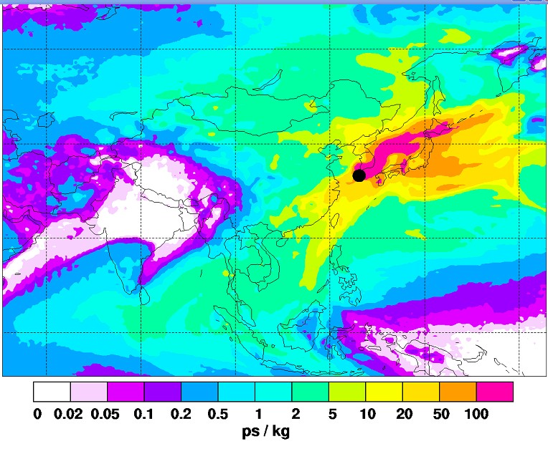

ECMWF footprint for 200806
