Atmospheric transport, a major pathway of microplastics to remote regions

N. Evangeliou^{1,}*, H. Grythe¹, Z. Klimont², C. Heyes², S. Eckhardt¹, S. Lopez-Aparicio¹, A. Stohl^{1,3}

¹Norwegian Institute for Air Research (NILU), Instituttveien 18, 2007 Kjeller, Norway.
²International Institute for Applied Systems Analysis (IIASA), 2361 Laxenburg, Austria.
³Now at: Department of Meteorology and Geophysics, University of Vienna, UZA II,
Althanstraße 14, 1090 Vienna, Austria

* Corresponding author: N. Evangeliou (Nikolaos.Evangeliou@nilu.no)

Supplementary information

All figures have been created using the open access general-purpose programming language Python version 3.

Snow concentrations were calculated using daily fields of sea-ice area fraction and total snowfall from European Centre for Medium Range Weather Forecast (ECMWF), which are all open access (see Data availability). All continental regions and marine/oceanic regions described in the manuscript are also provided (see Data availability). Mountain regions were defined using operational snow depth data from ECMWF (see Data availability), only where snow depth was positive throughout the year.
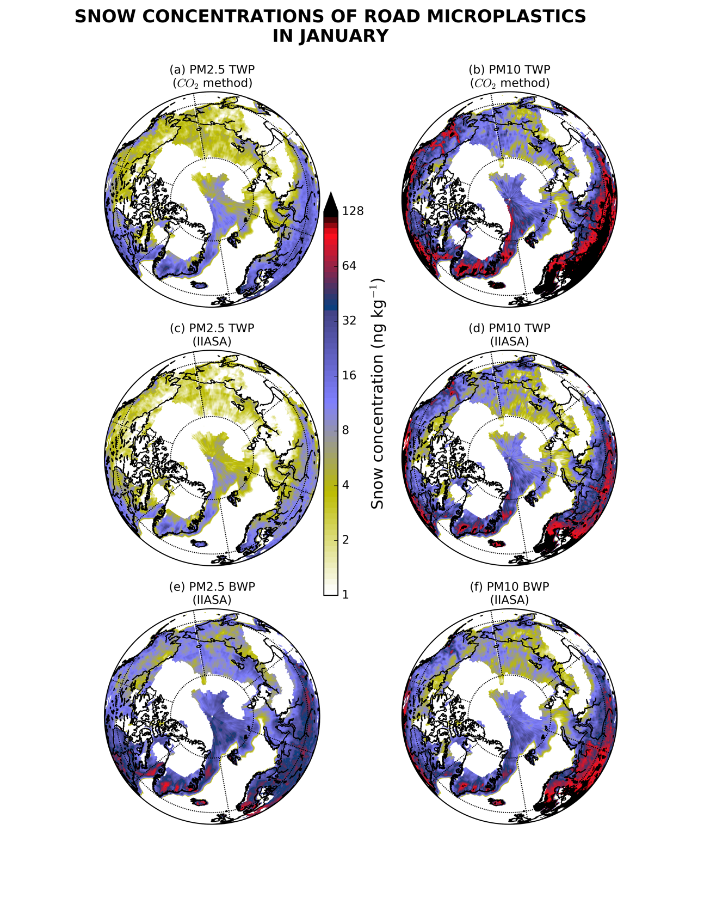
Fig. S 1. Monthly (12) snow concentrations of road microplastic particles in the Arctic snow. Total snowfall and snow depth were adopted from European Centre for Medium Range Weather Forecast (ECMWF). The concentrations were calculated using daily modelled deposition of road microplastics and daily fields of total snowfall (in m of water equivalent) from ECMWF operational fields and only over land (using a land-sea mask) and/or sea-ice (using sea-ice area fraction from ECMWF). The annual average snow concentrations were calculated only for months where snowfall was more than 90% of total precipitation (see Methods).
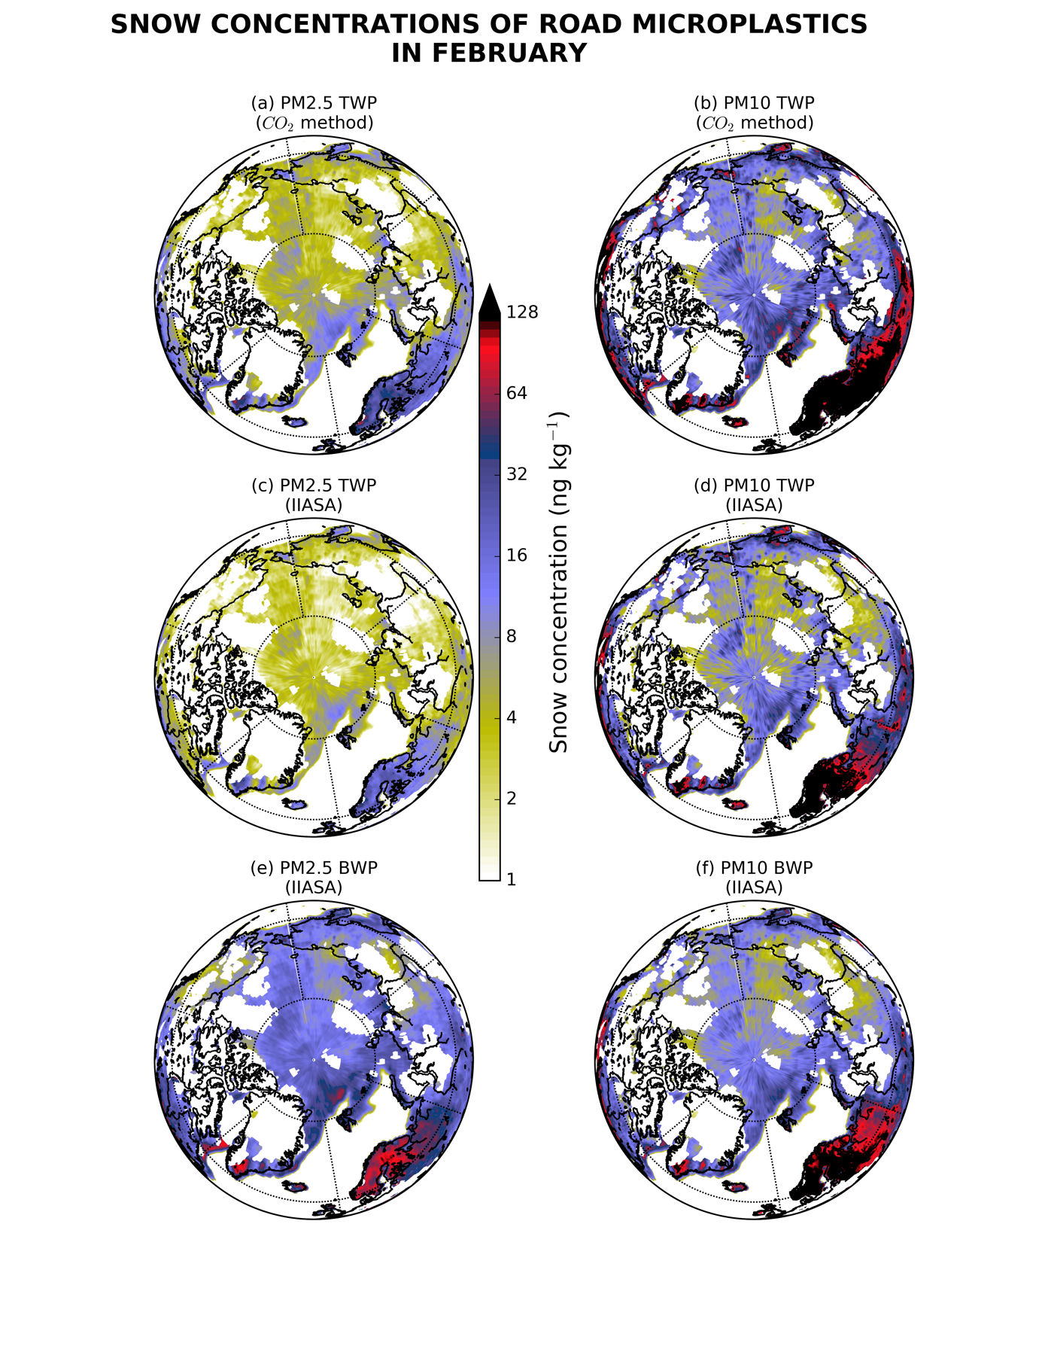
Fig. S 1. Continued.
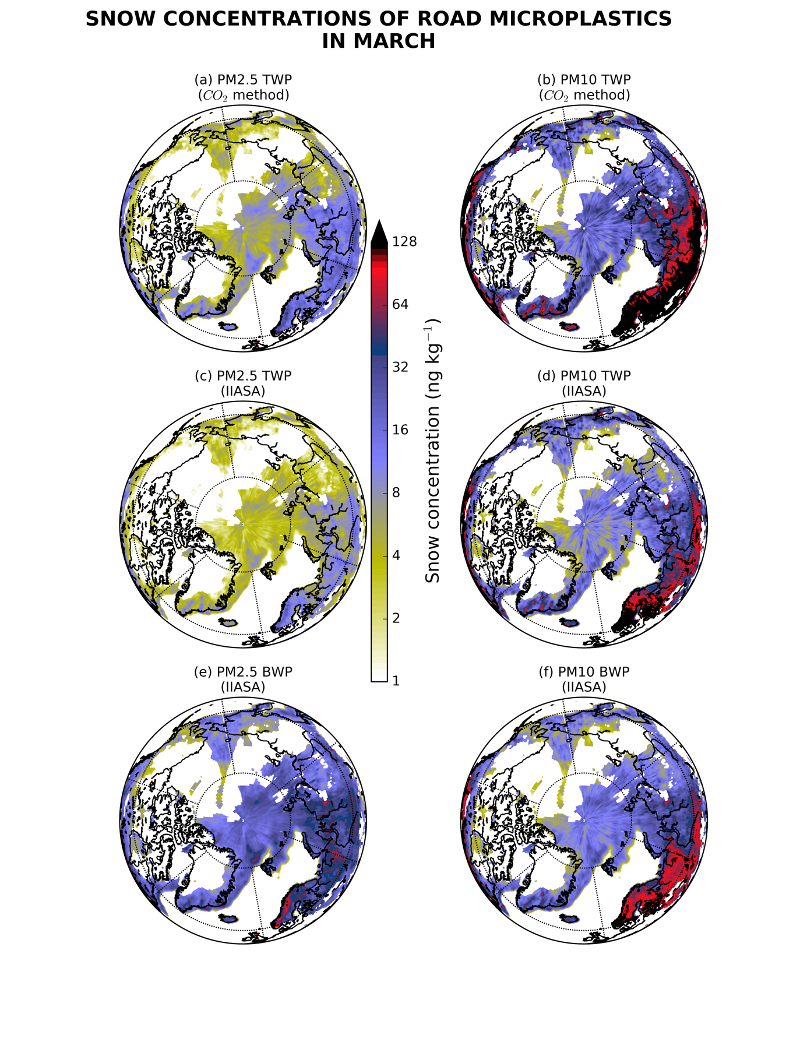
Fig. S 1. Continued.
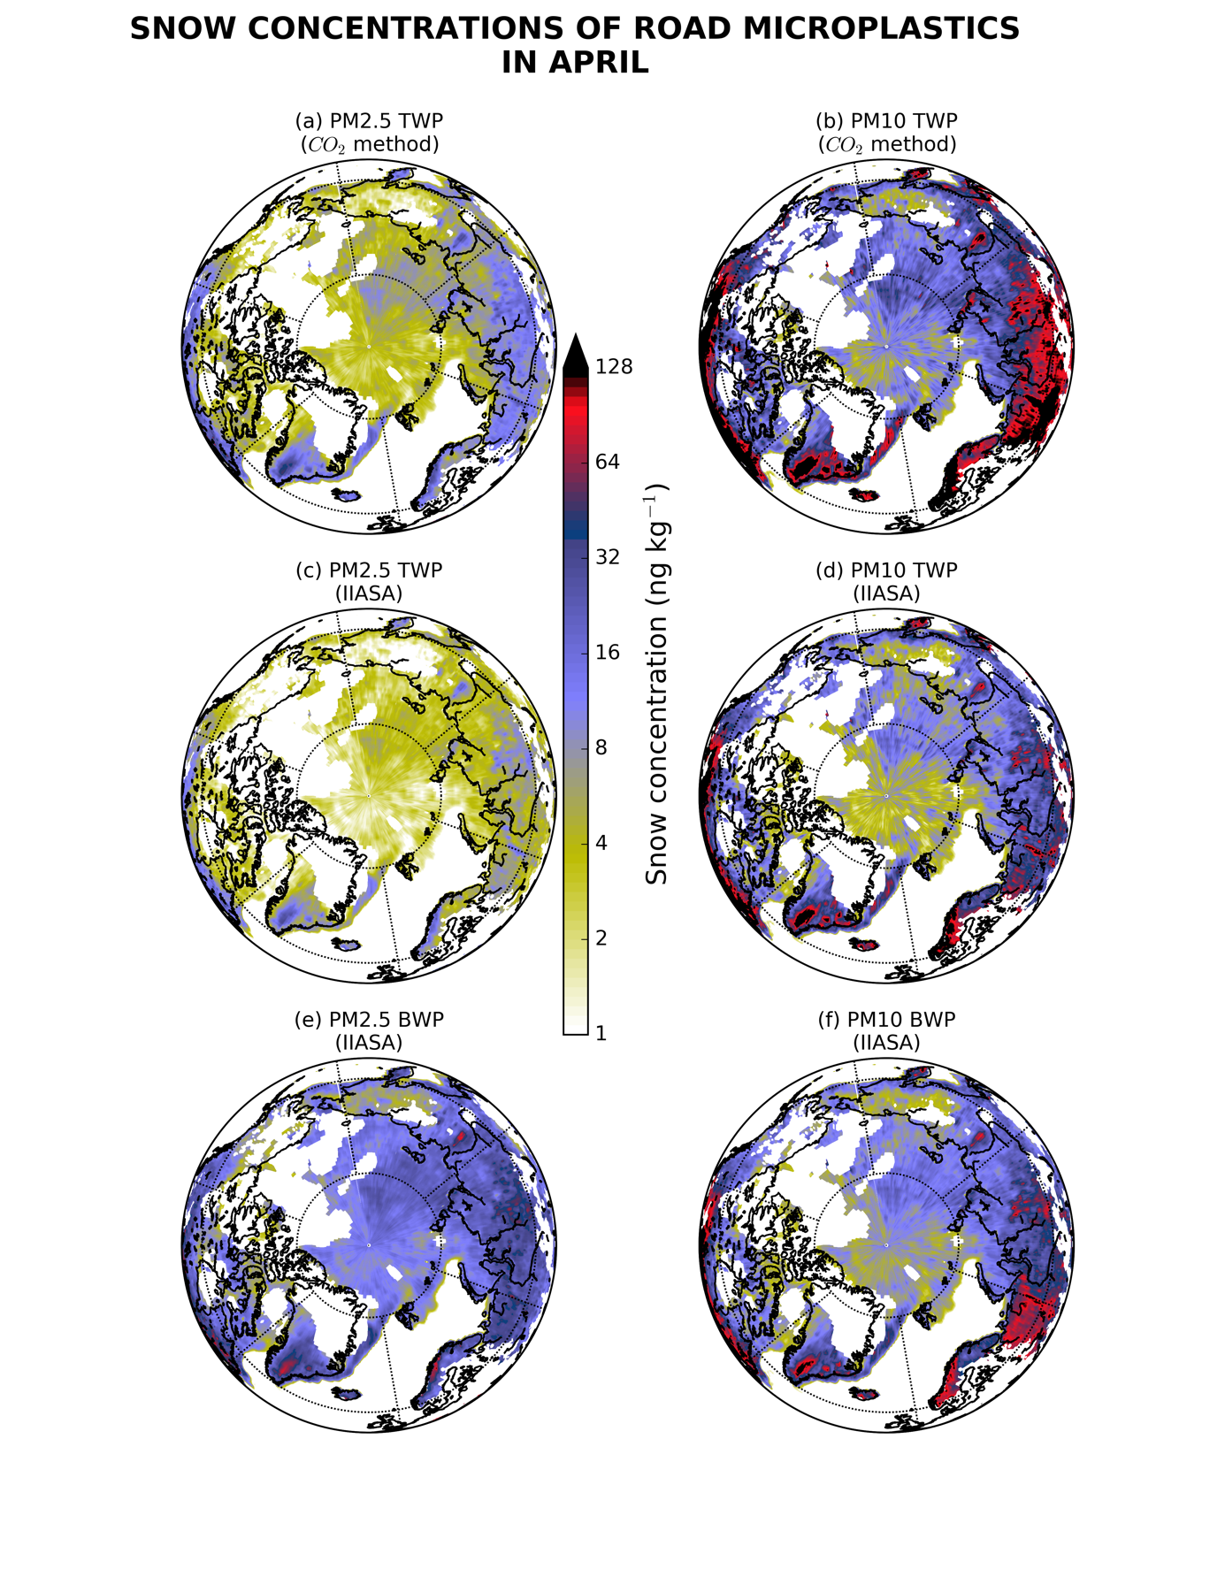
Fig. S 1. Continued.
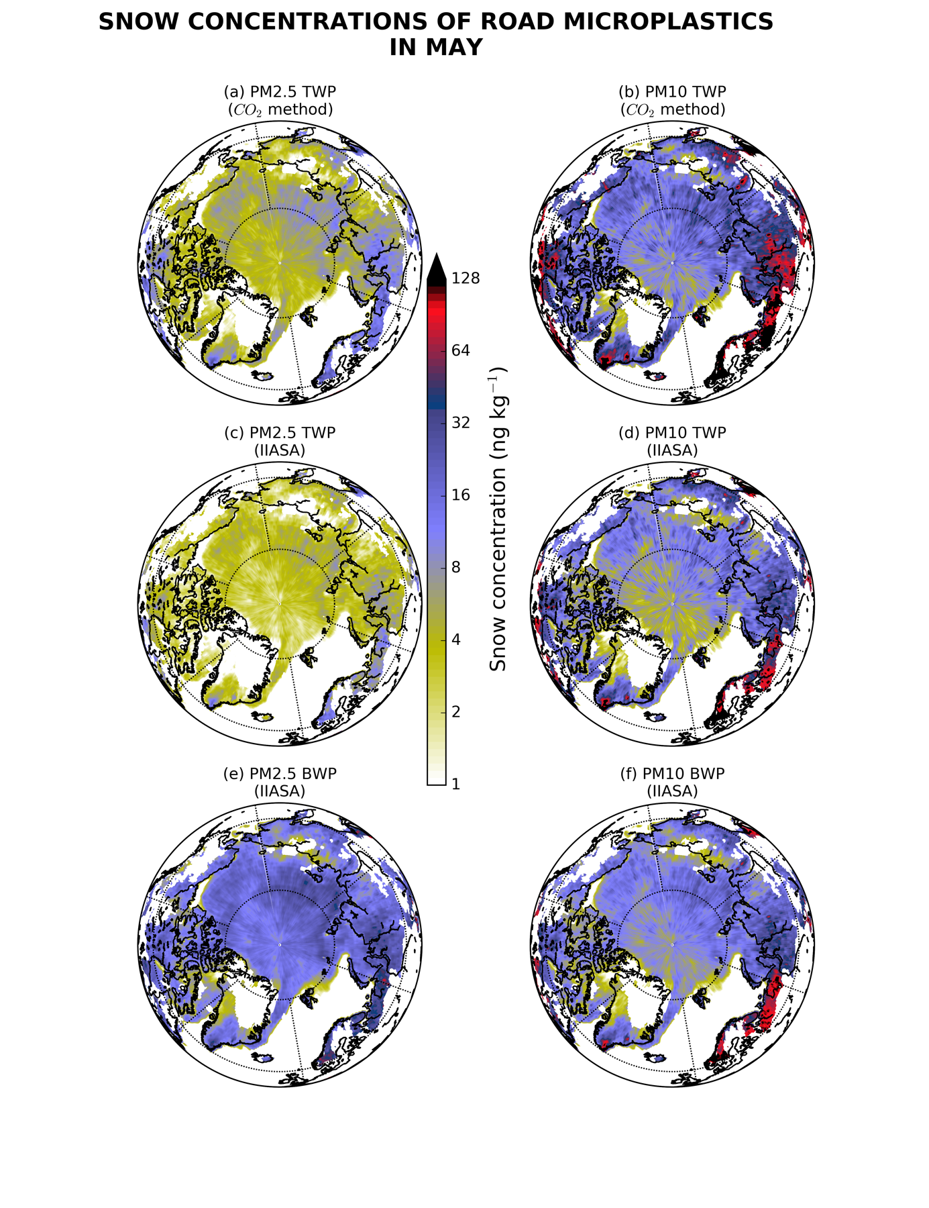
Fig. S 1. Continued.
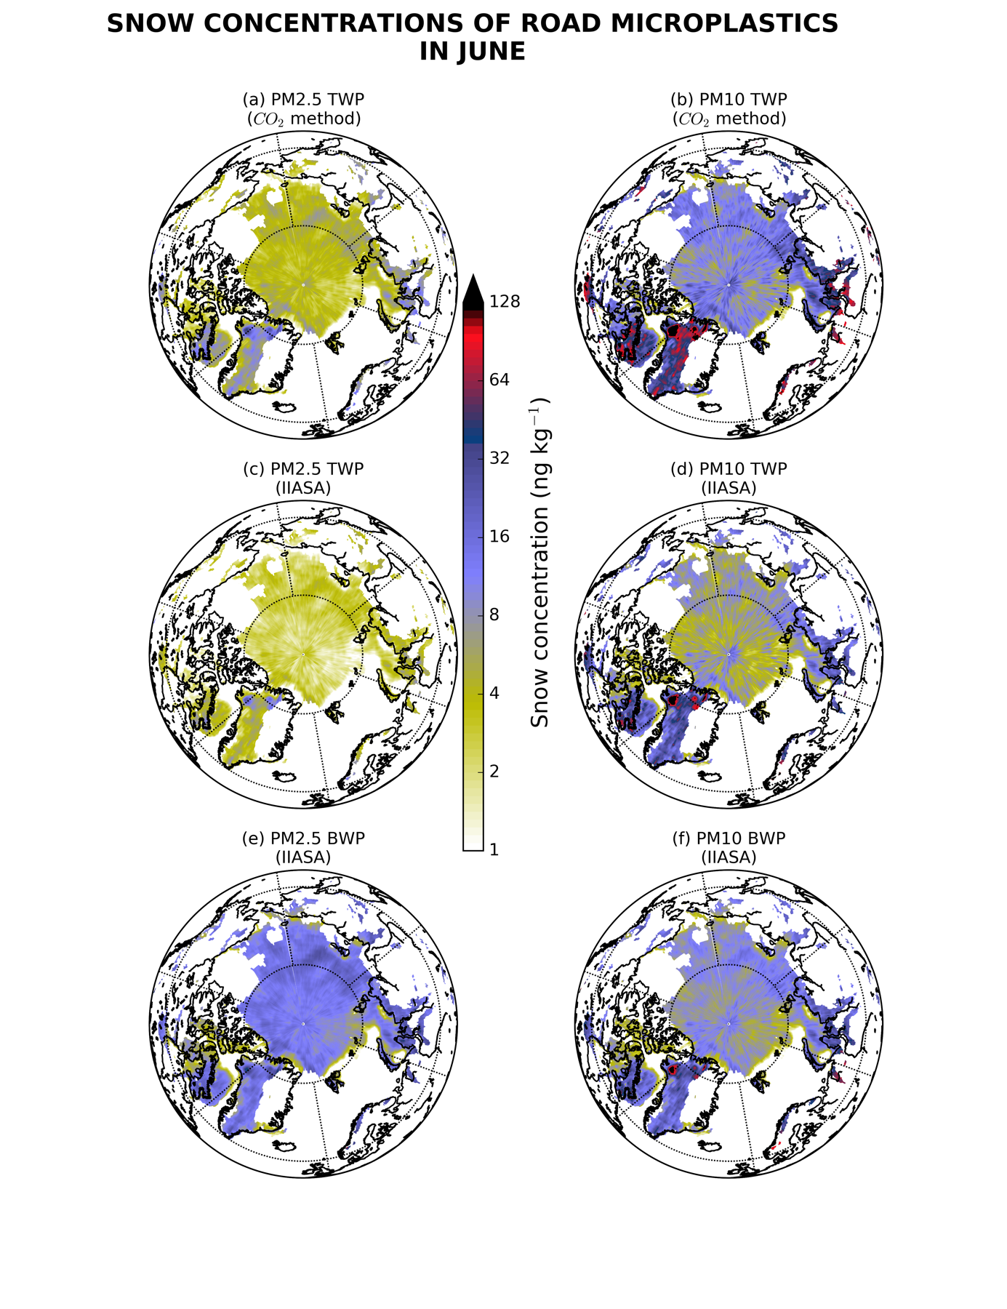
Fig. S 1. Continued.
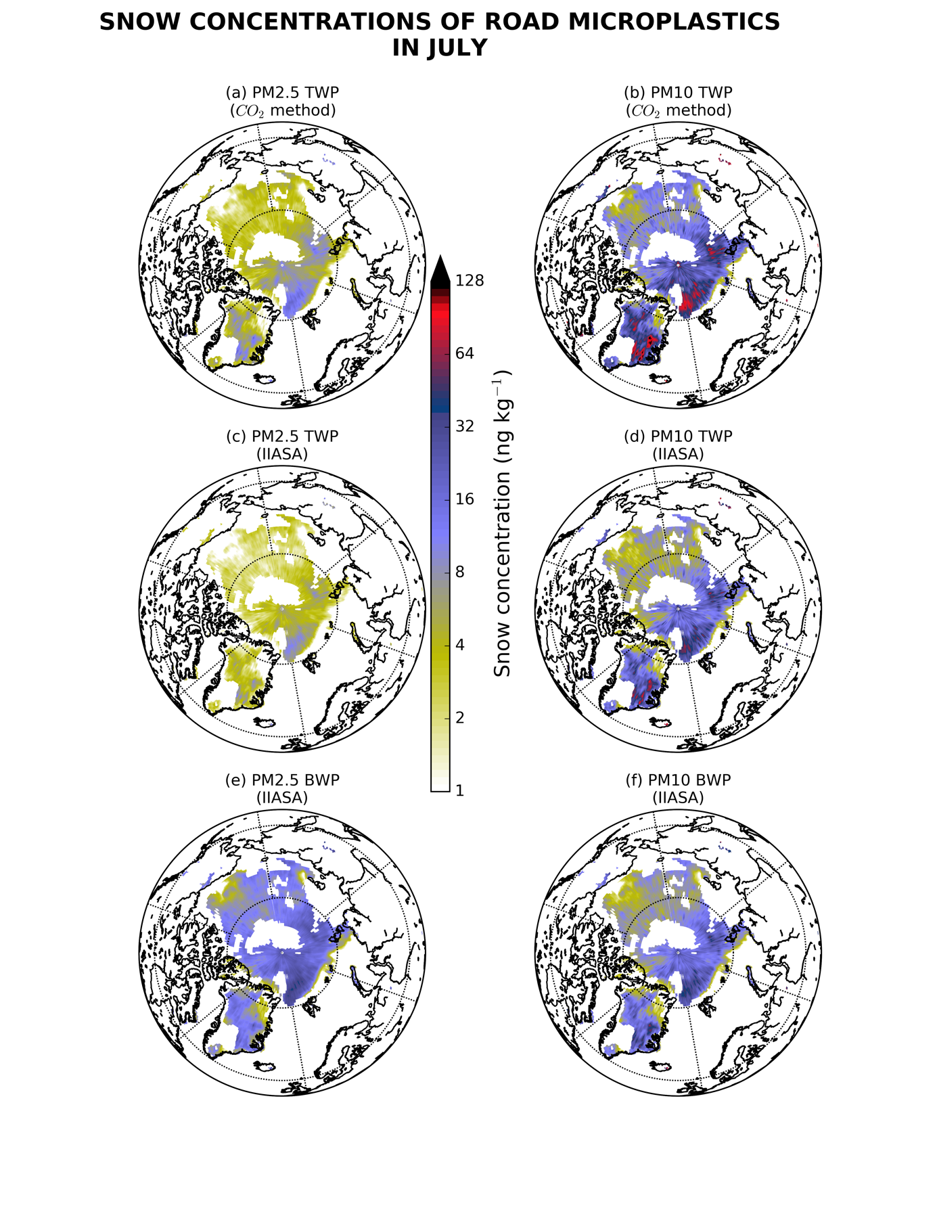
Fig. S 1. Continued.
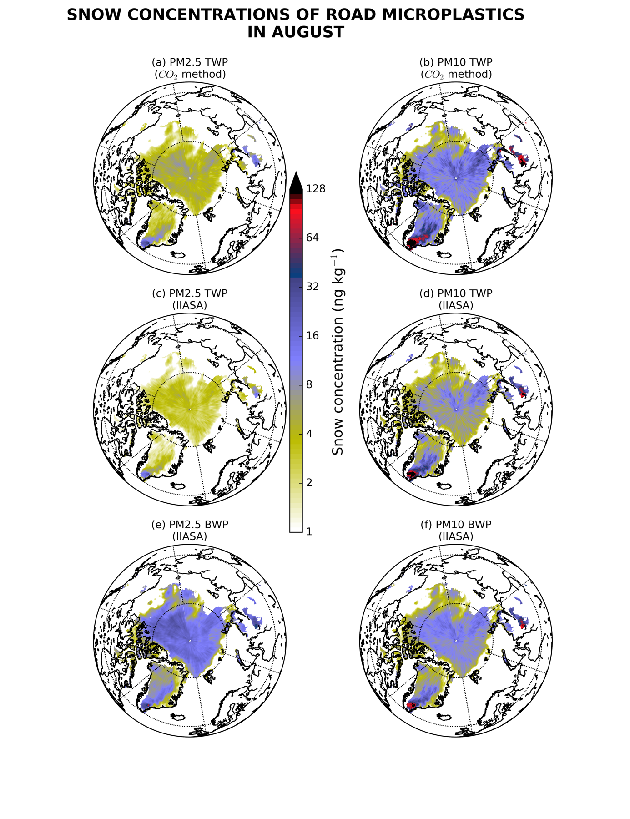
Fig. S 1. Continued.
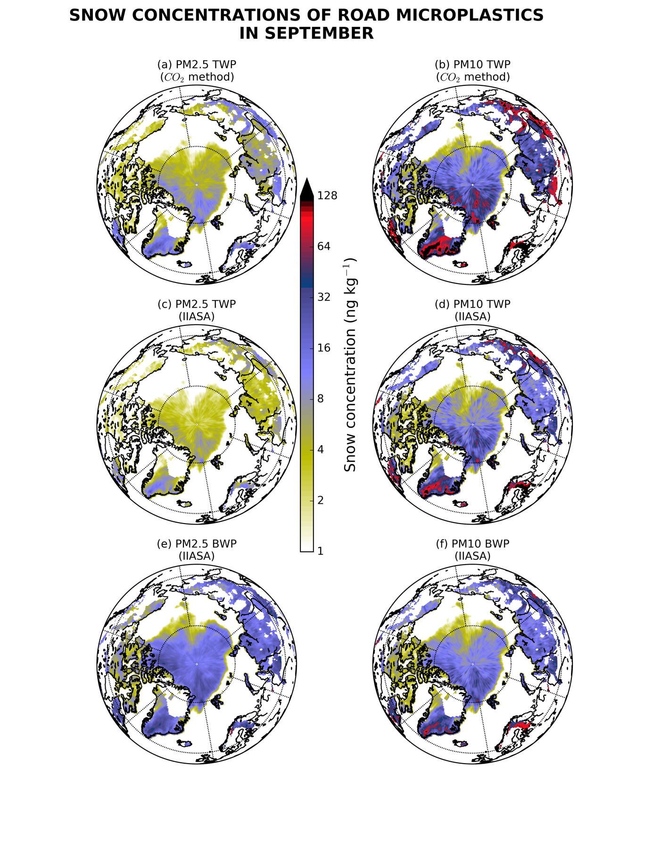
Fig. S 1. Continued.
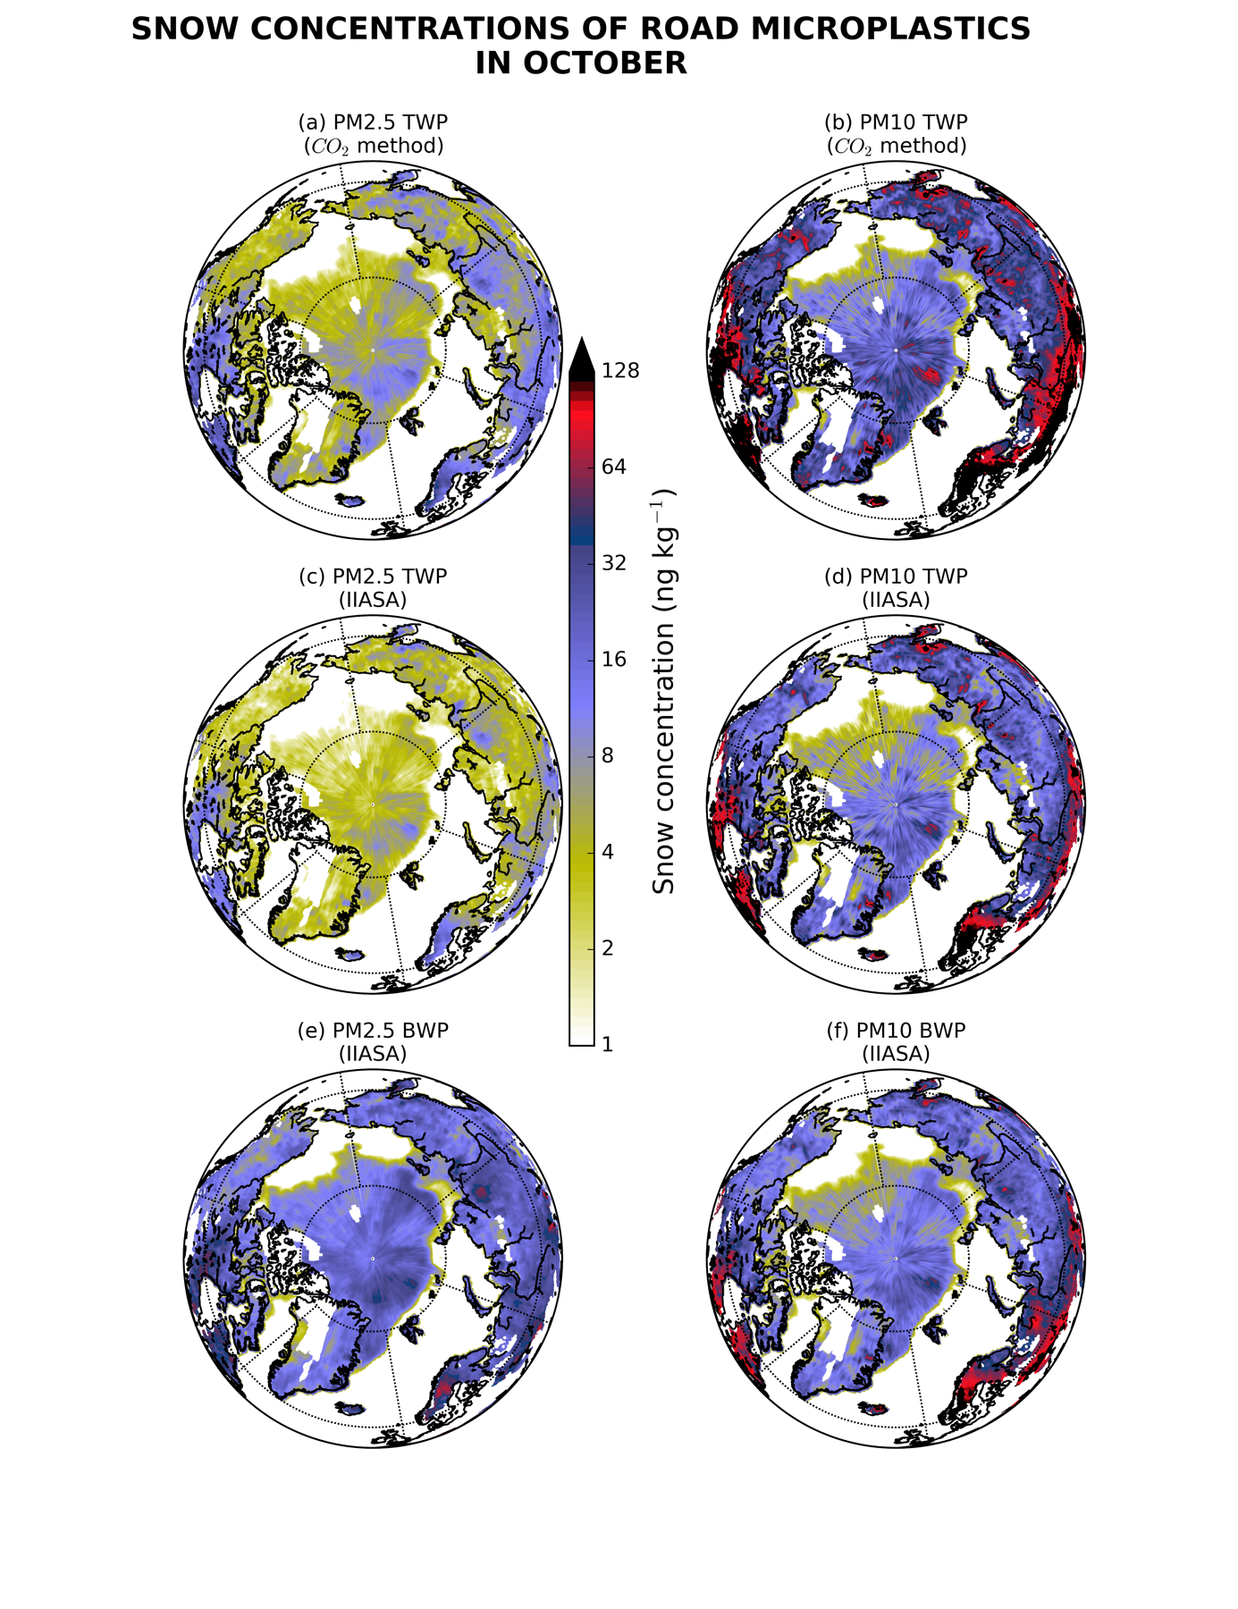
Fig. S 1. Continued.
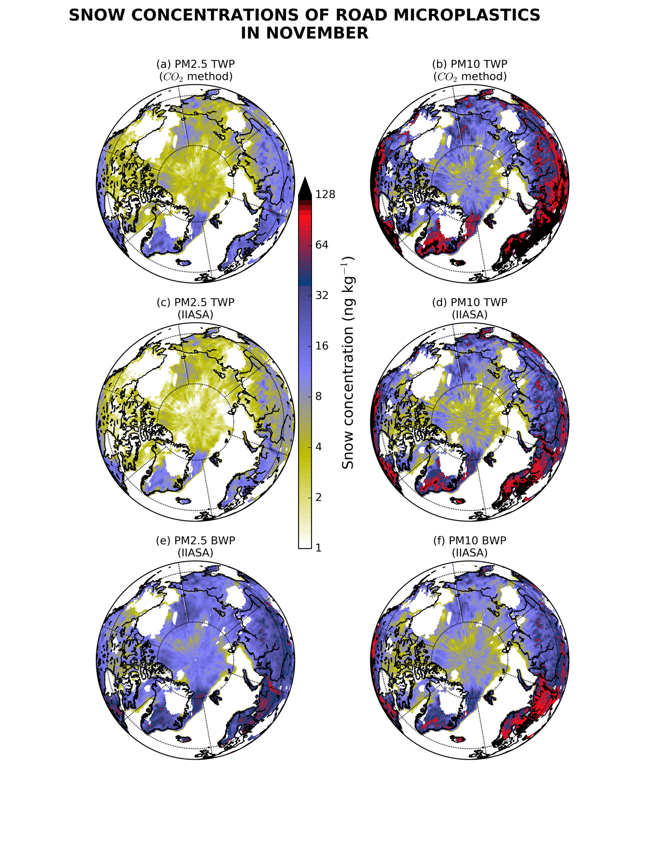
Fig. S 1. Continued.
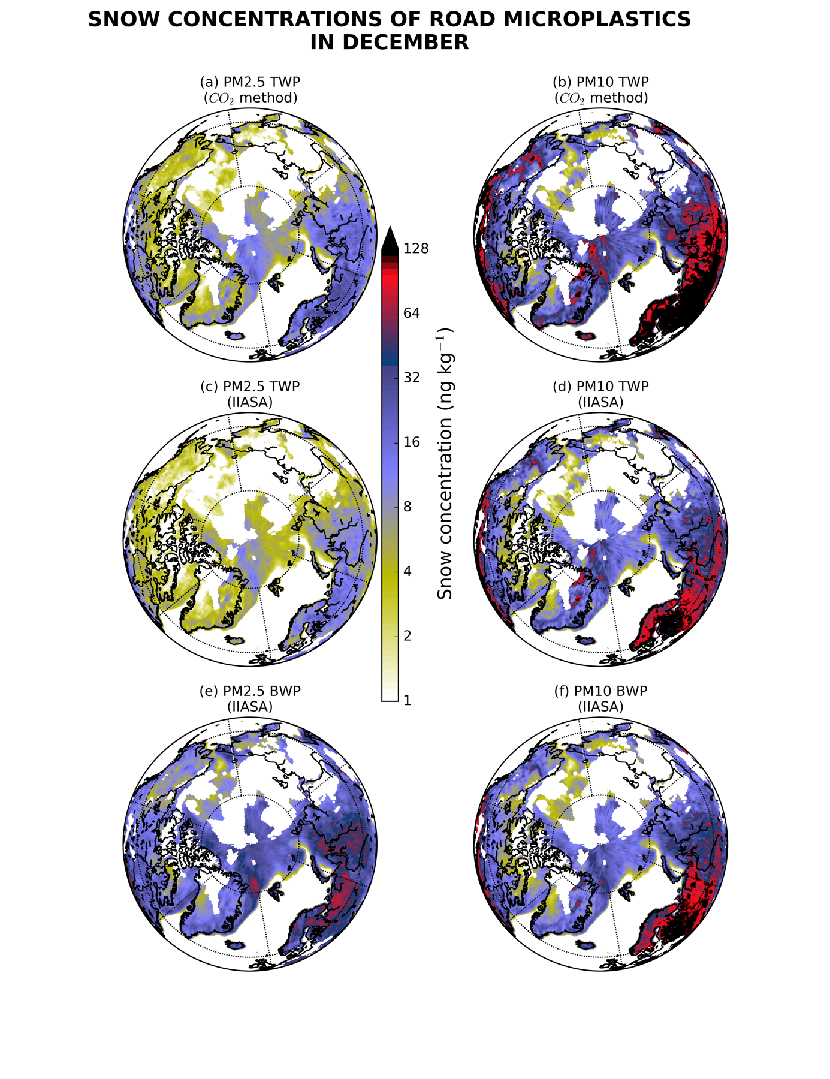
Fig. S 1. Continued.
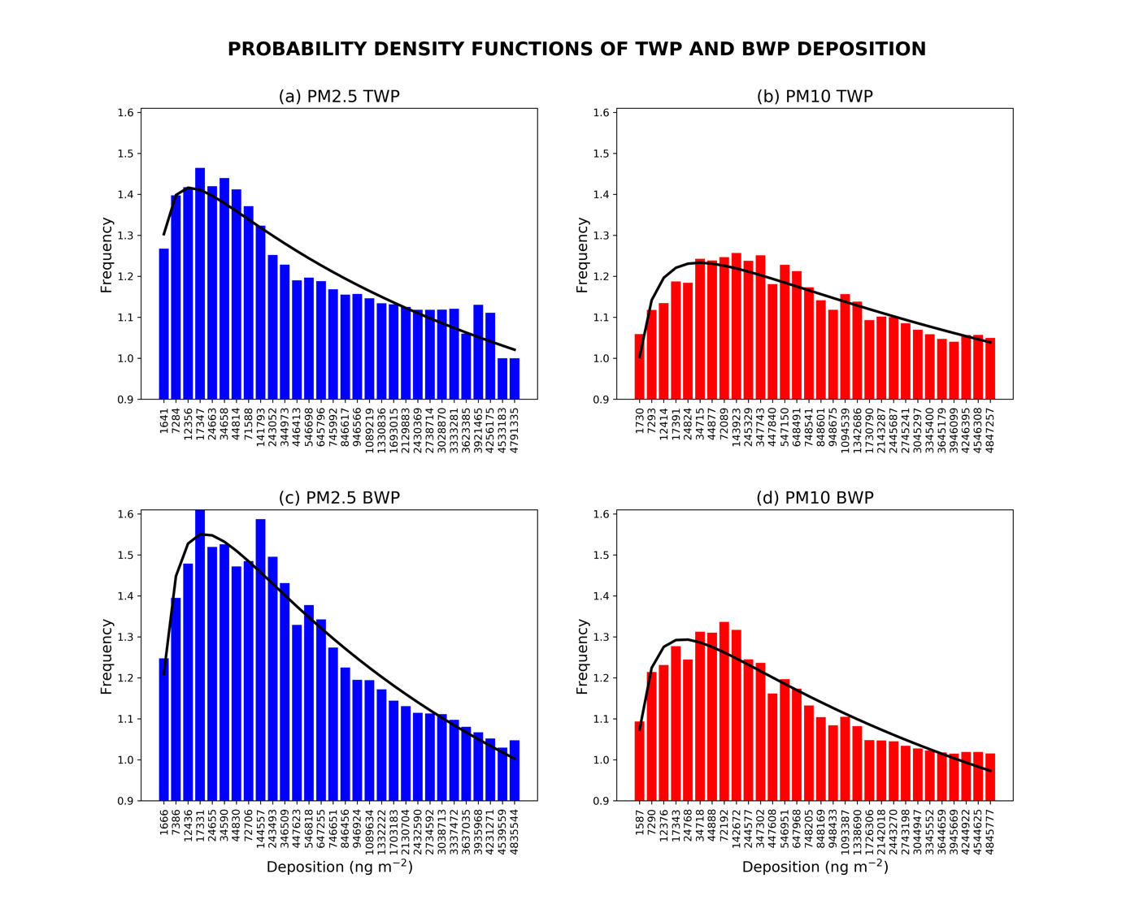
Fig. S 2. Probability density functions (PDF) of deposition of TWPs and BWPs for both PM2.5 and PM10 sizes. Note that PDF is based on a model ensemble of 120 members that includes five (5) members with different assumptions on the airborne fraction in the emissions (see Methods), eight (8) members assuming different particle size distribution in the atmospheric dispersion (Extended Data Table 1) and three (3) members with different scavenging coefficients expressing the CCN/IN efficiency (Extended Data Fig. 3).

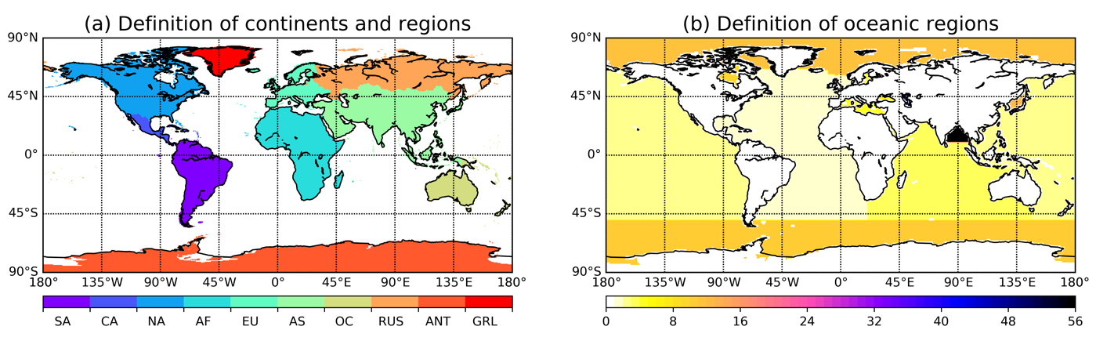
Fig. S3. (a) Masked continents used in the present study for South America (SA), Central America (CA), North America (NA), Africa (AF), Europe (EU), Asia (AS), Oceania (OC), Russia (RUS), Antarctica (ANT) and Greenland (GRL). (b) Masks of oceanic regions used in the present study. Values between 1 and 56 include Atlantic Ocean, Pacific Ocean, Indian Ocean, Mediterranean Sea, Baltic Sea, Black Sea, Red Sea, Persian Gulf, Hudson Bay, Southern Ocean, Arctic Ocean, Sea of Japan, Kara Sea, Sulu Sea, Baffin Bay, East Mediterranean, West Mediterranean, Sea of Okhotsk, Banda Sea, Caribbean Sea, Andaman Basin, North Caribbean, Gulf of Mexico, Beaufort Sea, South China Sea, Barents Sea, Celebes Sea, Aleutian Basin, Fiji Basin, North American Basin, West European Basin, Southeast Indian Basin, Coral Sea, East Indian Basin, Central Indian Basin, Southwest Atlantic Basin, Southeast Atlantic Basin, Southeast Pacific Basin, Guatemala Basin, East Caroline Basin, Marianas Basin, Philippine Sea, Arabian Sea, Chile Basin, Somali Basin, Mascarene Basin, Crozet Basin, Guinea Basin, Brazil Basin, Argentine Basin, Tasman Sea, Atlantic Indian Basin, Caspian Sea, Sulu Sea II, Venezuela Basin, Bay of Bengal, Java Sea, East Indian Atlantic Basin. Note that most of the smaller regions have been overwritten and are not visible.

