EMEP/CCC-Report 4/2024

VOC measurements 2022

Authors: Sverre Solberg (NILU), Anja Claude (Deutscher Wetterdienst), Stefan Reimann (EMPA), and Sam-Erik Walker (NILU)

EMEP/CCC-Report 4/2024

EMEP Co-operative programme for monitoring and evaluation of the long-range transmission of air pollutants in Europe
VOC measurements 2022

Sverre Solberg¹, Anja Claude², Stefan Reimann³, and Sam-Erik Walker¹
Affiliation:
- Stiftelsen NILU, Kjeller, Norway
- Deutscher Wetterdienst, Hohenpeissenberg, Germany
- Swiss Federal Laboratories for Materials Science and Technology (Empa), Dübendorf, Switzerland

NILU, P.O. Box 100, NO-2027 Kjeller, Norway
Chemical Co-ordinator Centre of EMEP (CCC)

EMEP/CCC-Report 4/2024
ISBN 978-82-425-3174-2
ISSN 2464-3920

Title
NILU
P.O. Box 100
NO-2027 Kjeller,
Norway
Chemical Co-ordinator Centre of EMEP (CCC)

Phone 63 89 80 00
nilu@nilu.no
www.nilu.no

Stiftelsen NILU
Org.no. 941 705 561
Certifications
NS-EN ISO 9001
NS-EN ISO 14001
Accreditation
NS-EN ISO/IEC 17025

Cover picture:
EMEP
VOC measurements 2022

Norwegian title
VOC malinger 2022

Author(s)
Sverre Solberg, Anja Claude, Stefan Reimann, and Sam-Erik Walker
Short summary (English)
This report documents the EMEP VOC monitoring carried out in 2022. The levels of the measured species in 2022 are presented as well as the 2022-status and history of the VOC programme. The geographical pattern of the species in Europe is discussed as well as the long-term trend during the last 20 years.
Short summary (Norwegian)
Denne rapporten dokumenterer EMEP VOC-overvåkingen utført i 2022. Nivåene av de målte komponentene i 2022 presenteres sammen med status i 2022 og historikken for VOC-programmet. Den geografiske fordelingen av komponentene i Europa diskuteres samt den langsiktige trenden de siste 20 årene.

Keywords
EMEP, VOC, NMHC, monitoring
Number of pages | Classification
65 | A-Open
Project leader | NILU project number
Wenche Aas | O-7726
Client/Report prepared for | Contact reference
United Nations Economic Commission for Europe (UNECE); https://projects.nilu.no/ccc/reports.html | MoU ECE/ENV/LRA/2011/001
Signature of the responsible person | Date
[Type name and title] | [dd.mm.yyyy]
© Stiftelsen NILU
Citation
Solberg, S., Claude, A., Reimann, S., Walker, S.-E. (2024). VOC measurements 2022. (EMEP/CCC report 4/2024). Kjeller: NILU.

Contents
Summary 5
1 Introduction 6
1.1 Historical background 6
2 Status of the measurement programme 7
2.1 The station network 7
3 VOC concentrations in 2022 13
3.1 General levels 13
3.2 Regional distribution of VOC 21
4 The EMEP Intensive Measurement Period (EIMP) 2022 25
5 Long-term trends in VOC 27
6 Acknowledgement 35
7 References 35
Appendix 1 Time series of daily means of VOCs measured in 2022 38

Summary
This report presents VOC (volatile organic compound) measurements carried out during 2022 at EMEP monitoring sites. In total, 19 sites reported VOC-data from EMEP VOC sites this year.
The monitoring of VOC has become more diverse with time in terms of methods and instrumentation. Starting in the early 1990s with standardized methods based on manual sampling in steel canisters and adsorption tubes with subsequent analyses at the lab, the methods now consist of a variety of instruments and measurement principles, including automated continuous monitors and manual flask samples.
Within the EU infrastructure project ACTRIS, data quality issues related to measurements of VOC are important topics. Most of the institutions providing VOC-data to EMEP are participating in the ACTRIS infrastructure project, either as formal partners or on a voluntary basis. Participation in ACTRIS means an extensive effort with data-checking including detailed discussions between the ACTRIS community and individual participants. There is no doubt that this extensive effort has benefited the EMEP-program substantially and has led to improved data quality in general.
In general, the levels in 2022 agree well with the previous 5-years period, but the lack of sites with long and consistent time series poses a substantial problem for making reliable long-term trend assessments of the VOC. Breaks in the time series are caused by shifts in instrumentation/method or stations being closed or moved etc. In this report, we have estimated the trends in individual NMHCs over the 2003-2022 period for one single station (Hohenpeißenberg), using a so-called GAM (generalized additive model), that removes the effect of anomalies in the meteorology.
The results indicate substantial reductions in the observed levels of the NMHCs over the 2003-2022 period at this site. Furthermore, significant differences in the trends for the various species are found. Strongest declines are found for benzene, toluene, ethene, and m-p-xylene which according to the AirGAM model dropped 55-65 % during this 20 year’s period. Next to this group, ethyne and i-pentane dropped around 45 % whereas for the other NMHCs a drop of the order of 10-30 % is seen. These trend numbers refer to the trends adjusted for variations in meteorology.
These reductions are in line with the emission data from the so-called EMEP-West region although a quantitative comparison species by species could not be done since the EMEP emission data are given for the sum of NMHC and not for individual substances.
In July 2022 a one-week intensive measurement campaign for VOC was carried out linked to a European heat wave. A large number of European institutions and stations were involved and contributed with an extensive suite of measurements from passive samplers and online monitors of various kinds.

VOC measurements 2022

Introduction

Historical background
The EMEP VOC monitoring programme was initiated at the EMEP Workshop on Measurements of Hydrocarbons/VOC in Lindau, 1989 (EMEP/CCC, 1990). A three-fold objective of the measurement programme was defined at the workshop:
- Establishing the current ambient concentrations
- Compliance monitoring (“Do the emission control programme lead to a reduction of atmospheric concentrations?”)
- Support to the transboundary oxidant modelling (prognostic and diagnostic)

The Workshop recommended that as a first step it would be sufficient with VOC monitoring at 10-15 rural sampling sites and taking two samples per week centred at noon GMT at each station. Collection in stainless steel canisters and analyses by high resolution gas chromatography was recommended for the detection of light hydrocarbons, whereas impregnated adsorbent tubes sampling combined with high performance liquid chromatography (HPLC) was recommended for the detection of carbonyls.
VOC measurements within EMEP started with the collection of grab samples of light hydrocarbons in mid-1992 and measurements of carbonyls in 1993. Initially, five stations were included in the monitoring programme: Rucava (LV0010), Košetice (CZ0003), Waldhof (DE0002), Tänikon (CH0032) and Donon (FR0008). Since then, the number and selection of VOC measurement sites have changed several times.
EMEP VOC measurements are reported annually and presented in reports for consideration by EMEP-TFMM and the EMEP Steering Body. Previous results from the EMEP VOC programme have been presented in annual reports (e.g. Solberg, 2023 and references therein). An EMEP expert meeting on VOC measurements was organised in Berlin, 1994 (EMEP/CCC, 1995), and an evaluation of the measurement programme was made in 1995 (Solberg et al., 1995).
VOC-data from the EMEP-network have been published and documented in numerous publications, e.g. Waked et al. (2016), Hellen et al. (2015), Hoerger et al. (2015), Malley et al. (2015), Tørseth et al. (2012), Worton et al. (2012), Sauvage et al. (2009), Plass-Dülmer et al. (2009), Plass-Dülmer et al. (2002), Hakola et al. (2006), Borbon et al. (2004), Solberg et al. (2001), and Solberg et al. (1996). Details about the VOC monitoring program are given in the EMEP annual reports such as Solberg (2023) and references therein.

Status of the measurement programme

The station network
The locations of the EMEP monitoring sites for VOC in 2022 are shown in Figure 1 and an overview of the measurement programme and the responsible laboratories is given in Table 1. In total, 19 measurement sites and 12 laboratories were included in the EMEP VOC program in 2022.
The measured VOCs consist of various groups of species which could be split into non-methane hydrocarbons hereafter named NMHC and oxygenated species hereafter named OVOC. Monitoring of NMHC is carried out at all sites except ES0001, whereas OVOC are measured at fewer sites.

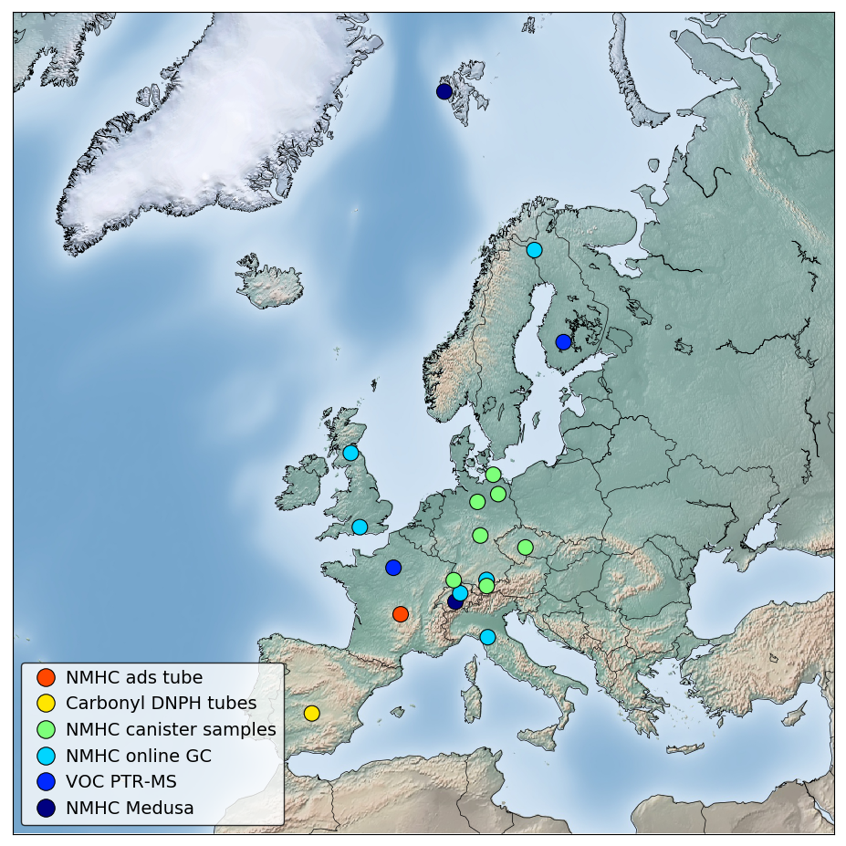
Figure 1: Monitoring sites for VOC in 2022.

The VOC monitoring at EMEP sites has become more diverse with time in terms of methods and instrumentation. This is illustrated in Figure 2. The EMEP VOC monitoring programme started in 1992 with one standardized method for NMHC based on manual sampling in steel canisters and subsequent lab analyses and another standardized method for sampling of OVOCs by DNPH tubes followed by analyses with HPLC in the lab. During the years is a variety of instruments and measurement principles have been applied, including PTR-MS, Medusa monitors, specialized online GC monitors and adsorption tubes for aromatic species.

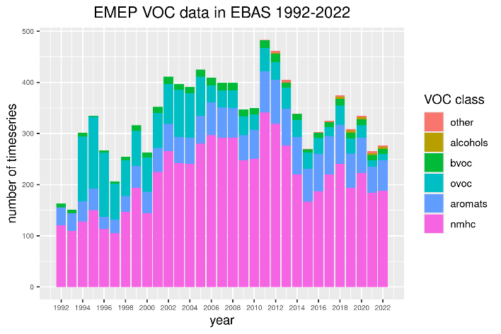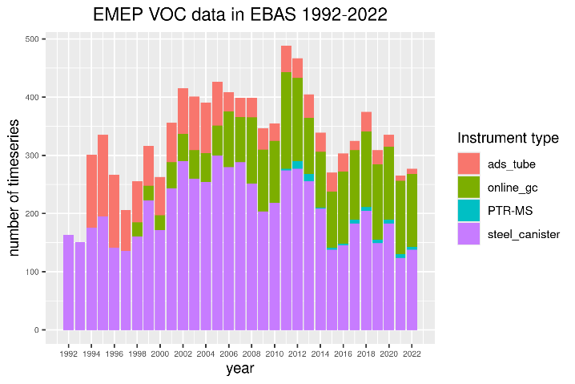
Figure 2: History of the VOC monitoring as a function of chemical group (left) and instrument (right).

The types of VOC species have also expanded from C₂-C₆ NMHC and a few light OVOCs in the start of the period to a very wide spectrum of species including terpenes, alcohols, C₇-C₉ NMHC, acetonitrile and numerous branched saturated and unsaturated NMHC as given in the Appendix.
For OVOC the original EMEP method based on sampling in DNPH adsorption tubes with subsequent lab analyses is still the method used at one site in Spain (ES0001). In addition, OVOC are now also measured by PTR-MS and by the GC-GC FID/FID system at Beromünster in Switzerland.
Although many sites have contributed to the EMEP VOC programme since the early 1990s, very few sites have long and continuous time series. This poses a substantial problem for making reliable long-term trend assessments of VOC at European background sites. Additionally, shifts in instrumentation imply breaks in the time series. At some sites these shifts are a matter of upgrading the GC monitor, with minor effects on the measured values, while at other sites they represent significant breaks in the data time series. The VOC network has also changed due to stations being closed or moved (like e.g. CH0005 that was replaced with CH0053 in 2018).
The history of the VOC station network is illustrated in Figure 3 showing the monitoring at the various sites as a function of time since the onset in 1992. The changing monitoring network with few sites having a long-term continuous time series is clearly seen from this figure and poses a major obstacle for doing long-term trend studies.

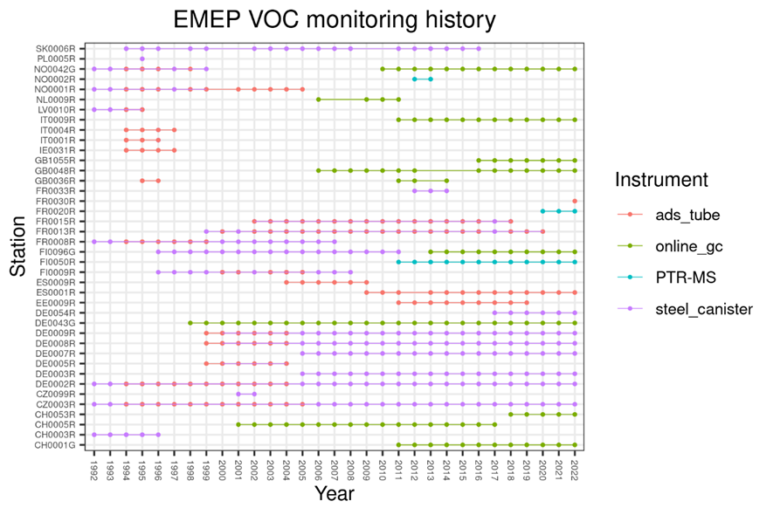
Figure 3: Monitoring history as a function of site 1992-2023.

All VOC data are reported annually to EBAS at NILU/EMEP-CCC through the EBAS submission tool (https://ebas-submit-tool.nilu.no/). For sites taking part in ACTRIS (see Table 1), the initial data submission is followed by a rigorous data quality checking procedure through an issue tracker (https://mantis.nilu.no/), involving a dedicated QA tool that is based on ratios of species (e.g. ethane:propane) and comparisons of the levels at different sites. Based on the results from this tool, the ACTRIS topic centre adds comments and questions to the data series followed by a discussion with the data provider and NILU/EMEP-CCC regarding outliers, unexpected shifts in the data etc and then, finally, which data to invalidate or flag. Since this discussion is done in an issue tracker, the history of bugs, outliers and breaks in the time series is easily available at a later stage.
This QA system has been in operation for some years and have clearly led to an improvement in the overall data quality of the part of the monitoring program included in ACTRIS. The ACTRIS community is open to include non-ACTRIS sites in this exercise which has been the case for e.g. the sites run by UBA in Germany, although not for 2022-data. Unfortunately, the QA tool has not been designed for secondary species as the OVOC data.
An example of the QA tool for data from CH0001 (Jungfraujoch) is given in Figure 4, showing submitted data for propane and n-butane for 2022 together with previous years of data. The marked outliers in the plot were inspected by the data providers and were finally flagged due to instrumental problems.

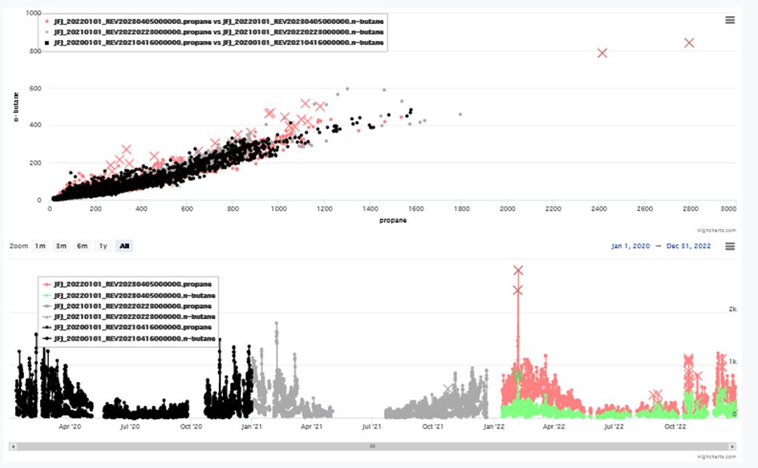
Figure 4: Example of the so-called «@VOC@ tool» used for quality checking of the submitted NMHC data within ACTRIS. This example shows data from CH0001 (Jungfraujoch) as copied from the issue tracker.
The EMEP VOC monitoring sites are by definition located in rural background areas but in practice the sites are exposed to more nearby emissions at a varying extent. The data from Chilbolton observatory, located in southern England, reflect the influence of populated areas in the whole of southern England, including road traffic emissions, and show a number of short-term (hourly) spikes in the data. Data from Auchencorth Moss in Scotland, a rural location around 20 km south of Edinburgh also show very spiky hourly time series with peak levels of propane, n-butane and other species. The high concentrations at that site are mainly seen during periods with winds from the northern sector, pointing to fresh anthropogenic emissions from the urban area around Edinburgh as well as from petroleum refineries in the same direction. It turns out that for both these sites, most of the spikes are of short duration while daily average levels seem fine.
NMHC data for the sites from UBA in Germany, i.e. Waldhof, Schauinsland, Neuglobsow, Schmücke, Zingst, and Zugspitze have been subject to problems in 2022 as in previous years. This concerns alkenes with three or more C-atoms (propene and higher) but also aromatics (o-xylene) and some higher alkanes. All dubious data have been invalidated by NILU in 2022 as in preceding years. Due to late data delivery, data from the UBA sites for 2022 could not be included in the ACTRIS QA procedure.
As in previous years, NMHC data from San Pablo (ES0001) for 2022 have been submitted to NILU but are not included in this report. The reason for this is, as discussed in previous annual reports, that the data show levels that differ substantially from expected values indicating major problems with the sampling or chemical analyses. Recently, there has been a dialogue between NILU and MMA about this prevailing issue, but the case is not settled.
Table 1: VOC monitoring at EMEP sites in 2022. The columns give the station names, site code, and the sampling frequencies for hydrocarbons (HC) and carbonyl compounds (Carb). The institute responsible for the chemical analyses is also given. Whether the station is part of the ACTRIS-2 project is also indicated.
Station | Code | HC¹⁾ | Institute²⁾ | Carb¹⁾ | Method | ACTRIS | Comment
Zeppelin Mtn. | NO0042 | cont | NILU | - | MEDUSA | y
Pallas | FI0096 | cont | FMI | - | GC/MS | y
Hyytiälä | FI0050 | cont | UHel | - | PTR-MS | y
Auchencorth Moss | GB0048 | cont | Ricardo | - | GC/MS | y
Chilbolton Obs. | GB1055 | cont | Ricardo | - | GC/MS | y
Waldhof | DE0002 | reg | UBA | - | canisters | n | twice/week
Schauinsland | DE0003 | reg | UBA | - | “ | n | “
Neuglobsow | DE0007 | reg | UBA | - | “ | n | “
Schmücke | DE0008 | reg | UBA | - | “ | n | “
Zingst | DE0009 | reg | UBA | - | “ | n | “
Zugspitze | DE0054 | reg | UBA | - | “ | n | “
Hohenpeissenberg | DE0043 | daily | DWD | - | GC/FID | y | twice/day
Košetice | CZ0003 | reg | CHMI | - | canisters | y | twice/week
Jungfraujoch | CH0001 | cont | EMPA | - | MEDUSA | y
Beromünster | CH0053 | cont | EMPA | - | GC/FID | y
SIRTA | FR0020 | cont | LSCE-CNRS-CEA |  | PTR-MS | y
Puy de Dome | FR0030 | reg | CNRS-LaMP | - | ads-tube | y | aromatics
Mt. Cimone | IT0009 | cont | UU | - | GC/MS | y
San Pablo | ES0001 | - | MMA | reg | DNPH | n | twice/week
1) reg = regularly (2-3 samples per week), cont = continuously
2) CHMI = Czech Hydrometeorological Institute
DWD = Deutscher Wetterdienst
IMT LD = Institut Mines Telecom Lille Douai
EMPA = Swiss Federal Lab. for Materials Testing and Research
FMI = Finnish Meteorological Institute
UHel = Univ. Helsinki
UBA = Umweltbundesamt (Germany)
UU = University of Urbino
MMA = Minestrio de Medio Ambiente
LSCE-CNRS-CEA = Laboratoire des Sciences du Climat et de l'Environnement
CNRS-LaMP = Laboratoire de Meteorologie Physique

VOC concentrations in 2022

General levels
Time series plots of the diurnal means of all compounds at all stations during 2022 are given in the Appendix. Figure 5 shows the spread of data values for all station and species in 2022 in box and whisker plots together with the corresponding data during the preceding 5-years period (2017-2021). The sites are arranged from north to south going from left to right in the panels. Thus, the panels in Figure 2 indicate both the north-to-south differences, the deviation of the 2022 concentration levels relative to the previous five years’ climatology as well as the spread in 2022 data at each site separately.
In general, the 2022 data show similar mean levels and distribution compared to previous years with some exceptions. For 1-3-butadiene and 2-methylpentane it seems the data from the UBA sites were substantially higher in 2022 compared to previous years. It turns out that the data for these species were invalidated in the years before 2020, and thus the high levels of 2022 could be an artefact due to the data validation.
For FR0020 (SIRTA) the amount of EBAS data in the years before 2022 are scattered, so the discrepancies seen when comparing 2022 to the historical data could be hampered by poor data capture. Apart from that, the levels in 2022 agree very well with the levels in the previous 5-years period in general although with a few exceptions.

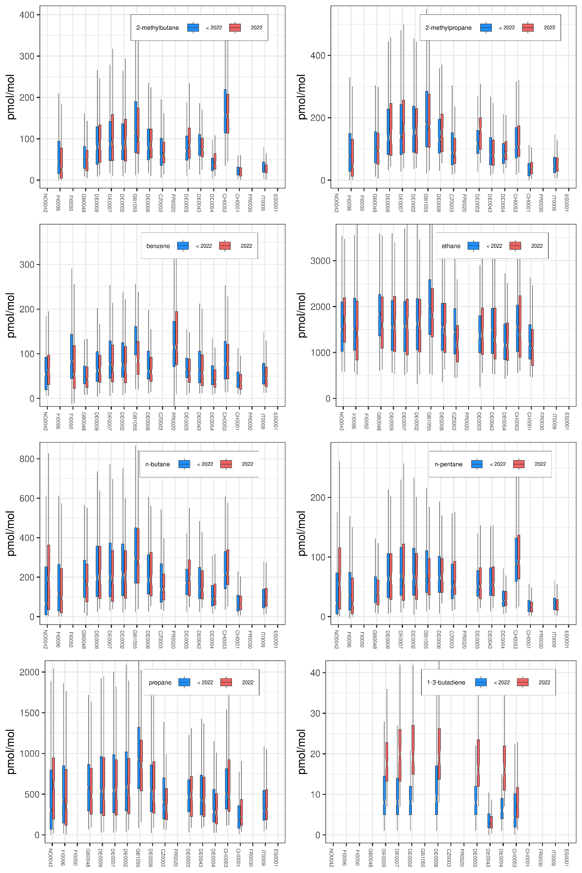
Figure 5: Box- and whisker-diagrams for VOCs based on all measurements in 2022 (blue) compared to the levels during 2017-2021. The boxes enclose the 25- and 75-percentile with the median marked inside.
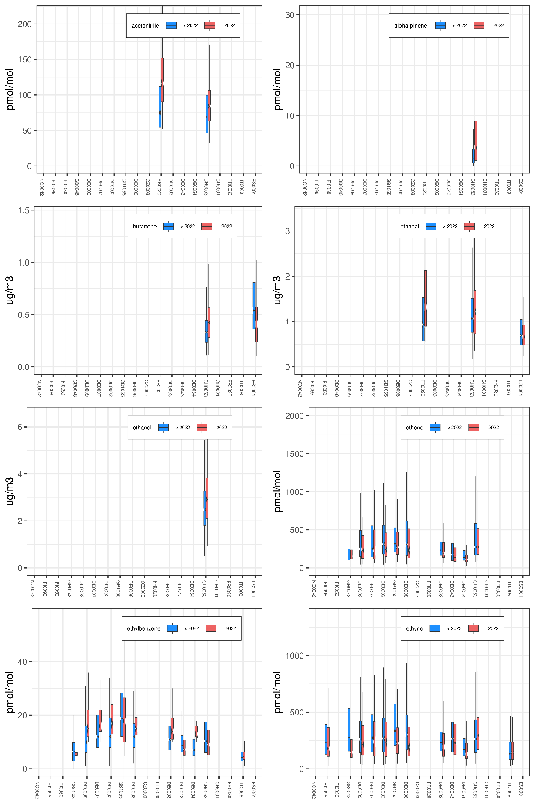
Figure 5 (cont.).

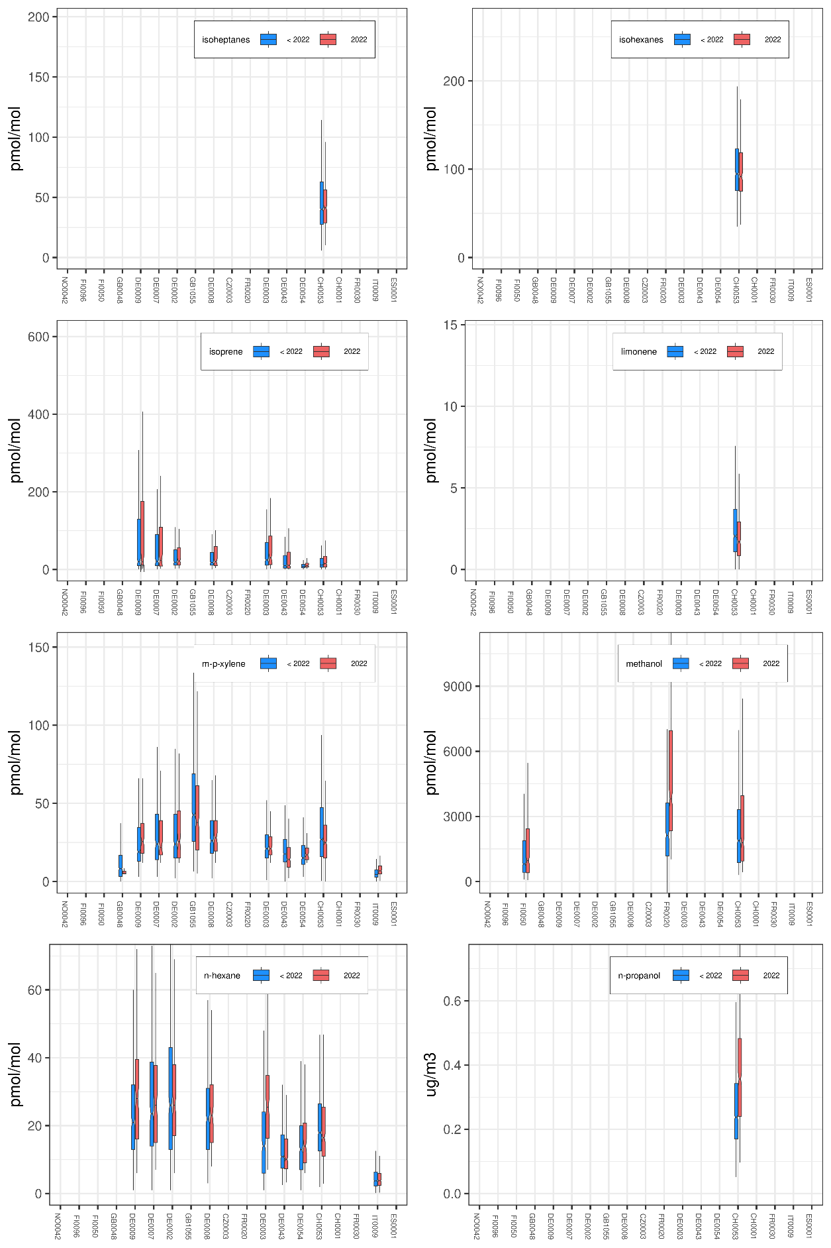
Figure 5 (cont.).

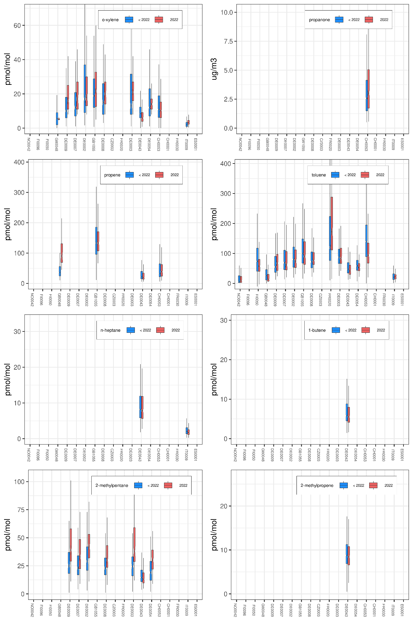
Figure 5 (cont.).

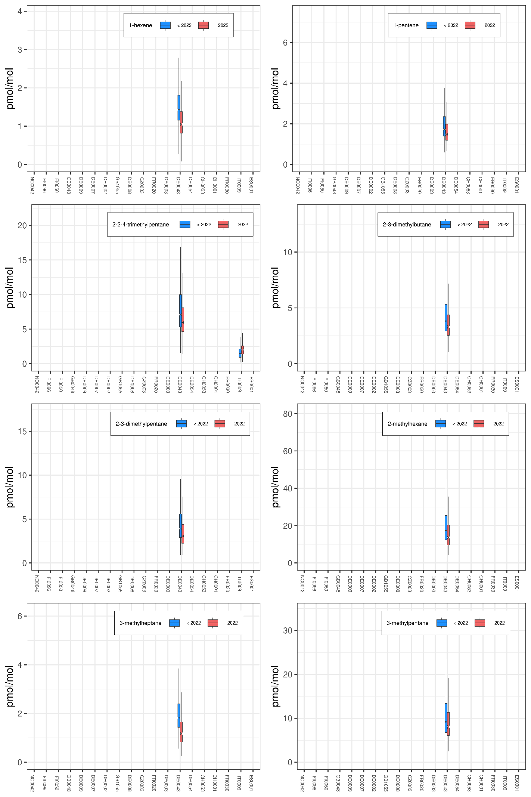
Figure 5 (cont.).

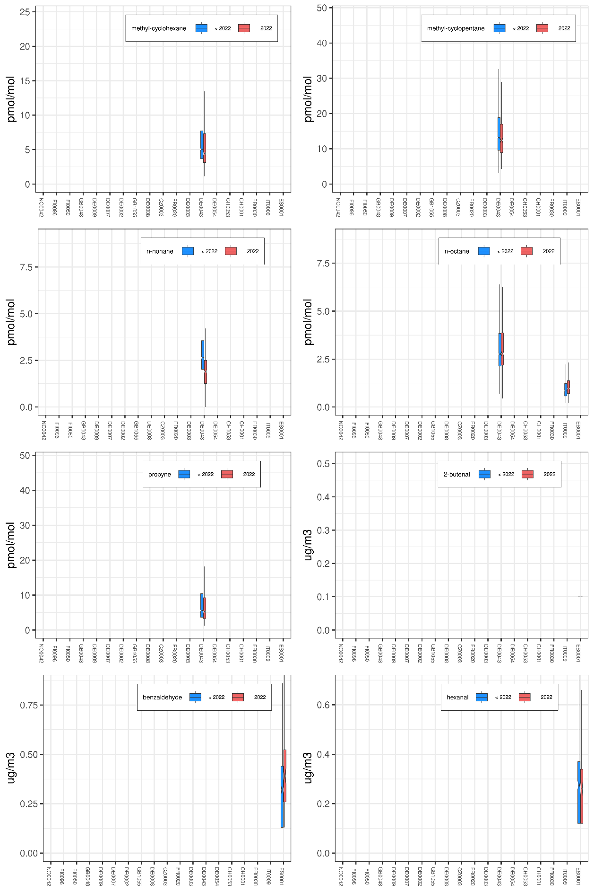
Figure 5 (cont.).

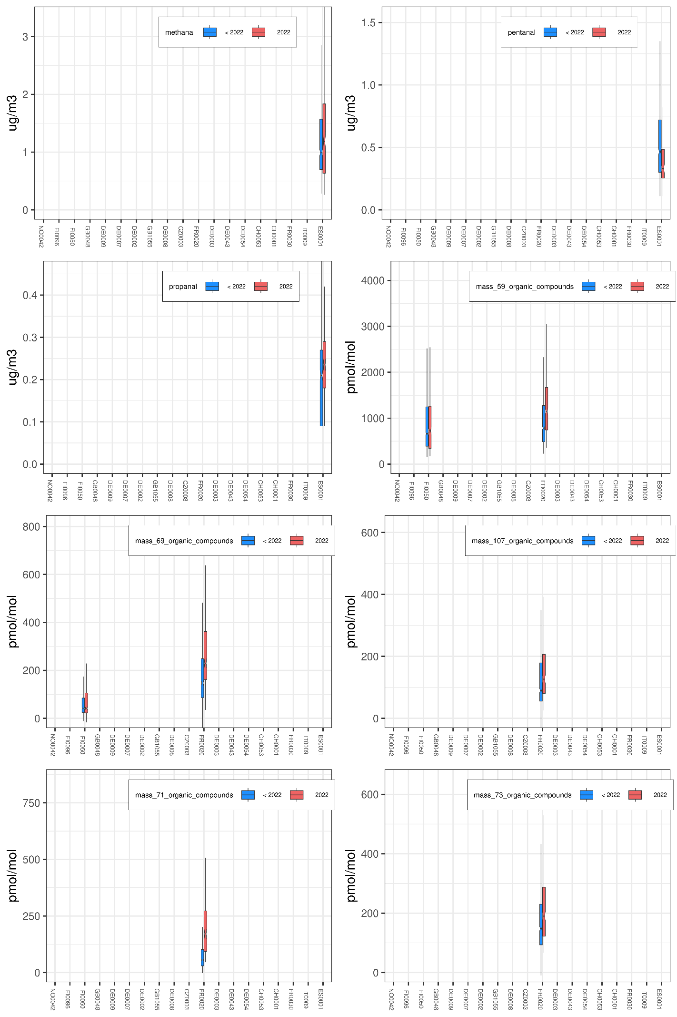
Figure 5 (cont.).

Regional distribution of VOC
Figure 6 shows maps with the stations’ annual median concentrations of VOCs in 2022. Note that since the steel canisters are all sampled at daytime (normally at noon), a bias could be inherent in these plots when compared with the 24 h daily average values from online GCs. A bias for other species is also likely to be seen at a varying extent. Some of the mountain stations (Zugspitze, Hohenpeissenberg and Mt Cimone) are influenced by diurnal venting of the planetary boundary layer and will receive upslope polluted air masses at daytime when the vertical mixing is sufficiently strong and cleaner free tropospheric air masses at night. The station at Jungfraujoch (3578 m asl) will on the other hand most of the time be located in the free troposphere, above the planetary boundary layer.
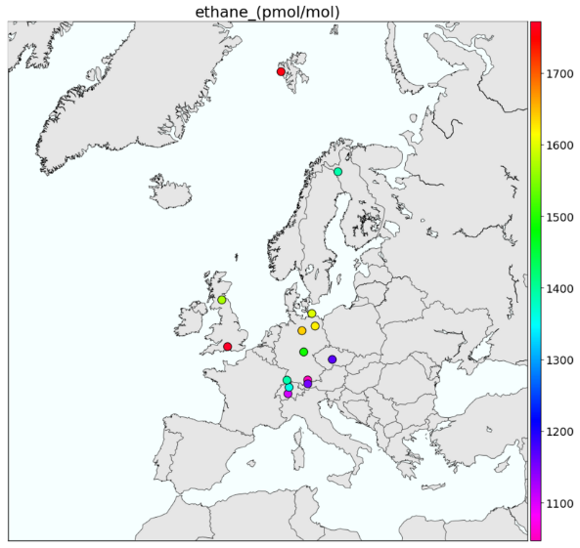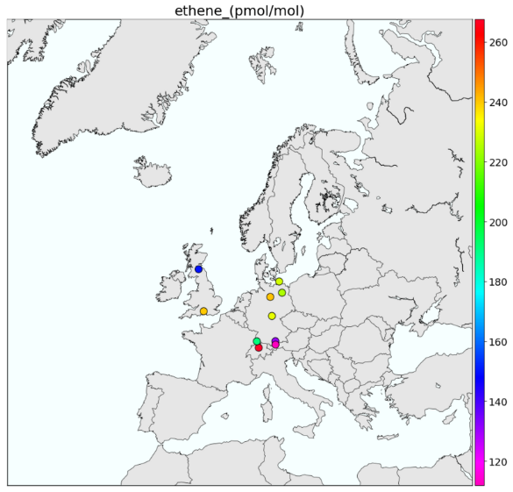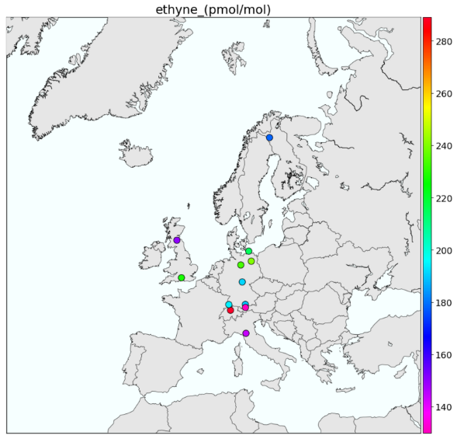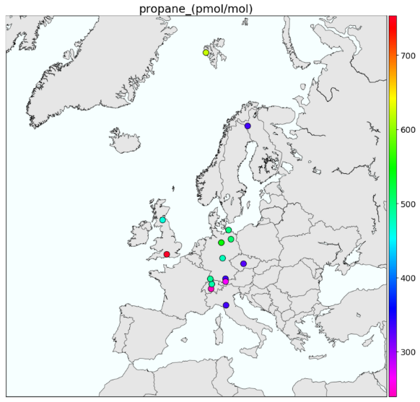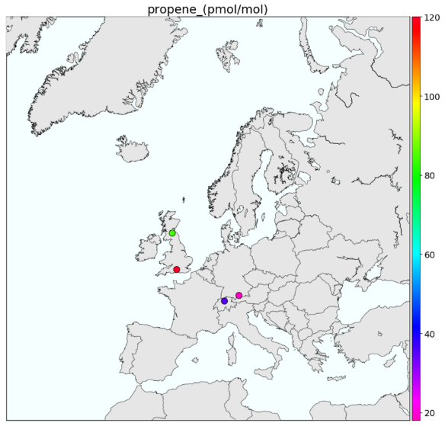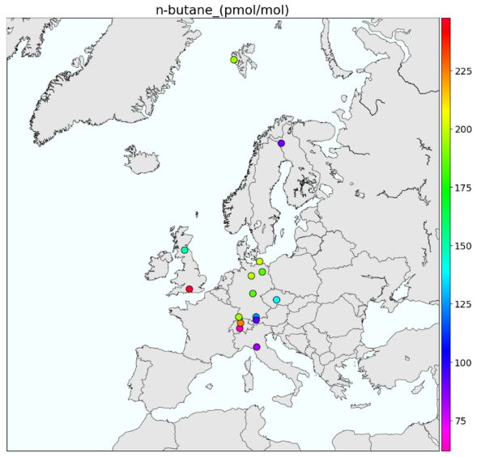
Figure 6: Annual median concentration of VOCs in 2022.

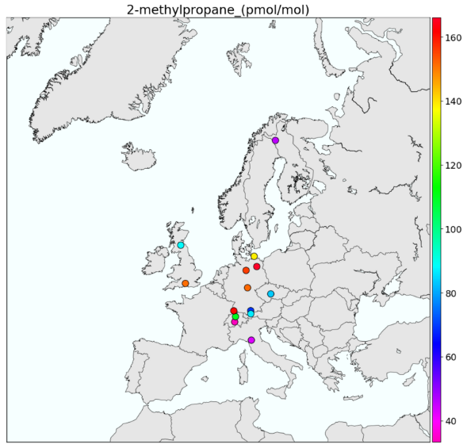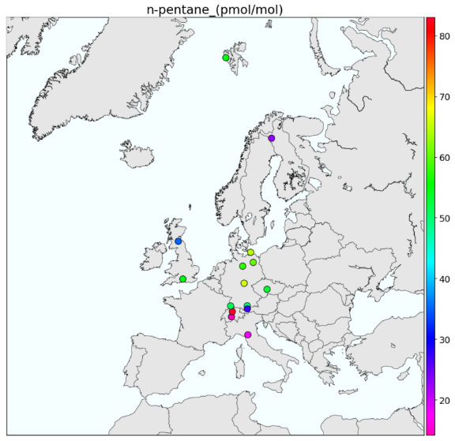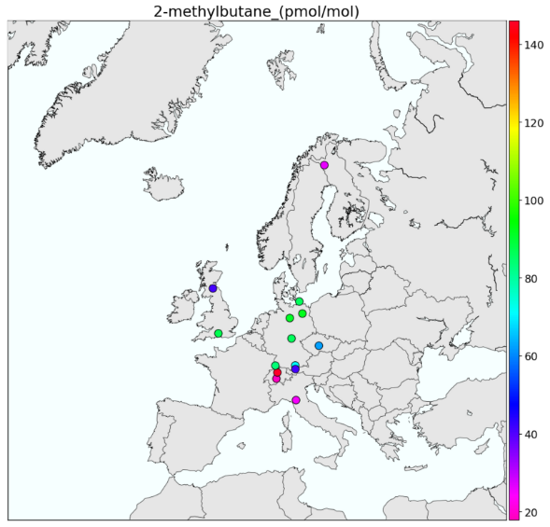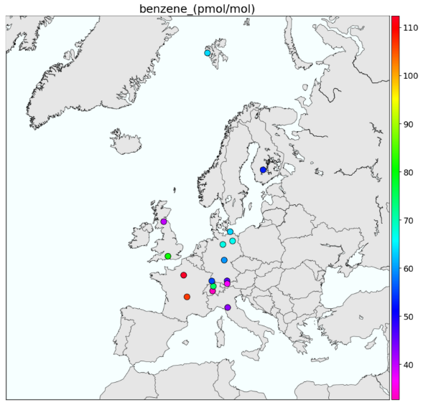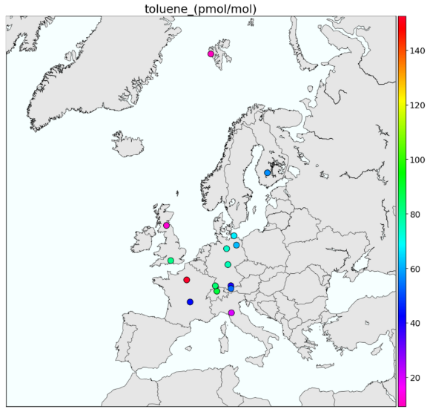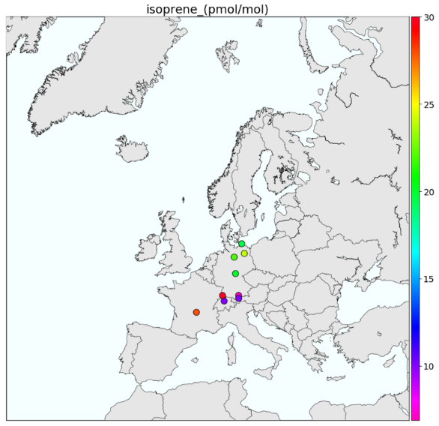
Figure 6 (cont.).

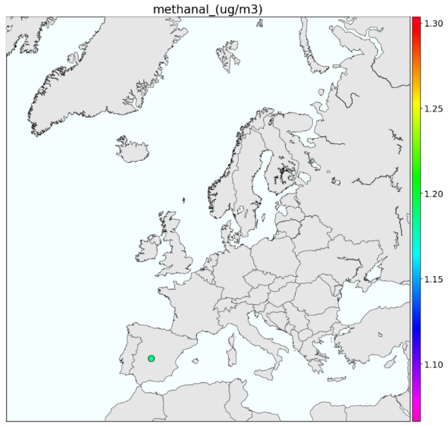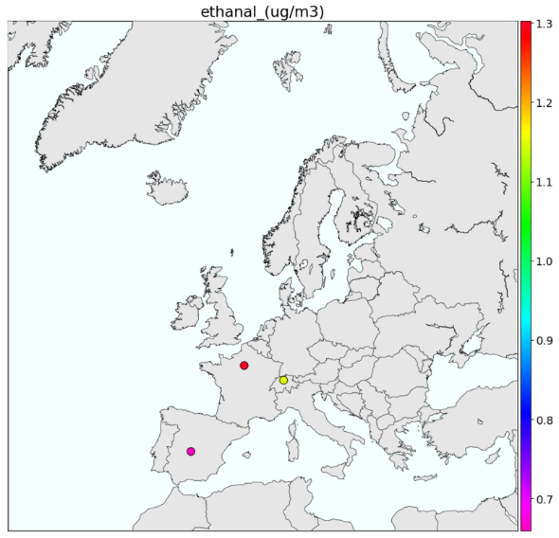
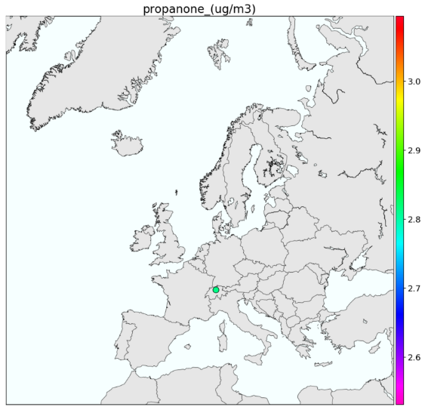
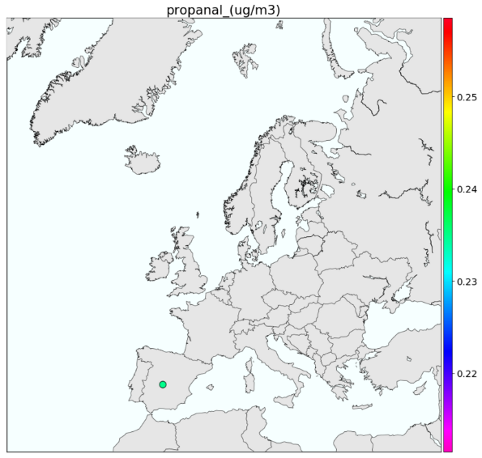

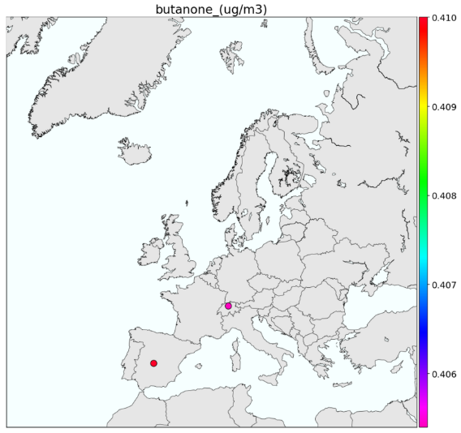

Figure 6 (cont.).

The EMEP Intensive Measurement Period (EIMP) 2022
One week of intensive measurements of a range of VOCs (NMHC, OVOC, terpenes etc) and biogenic organic aerosol tracers were conducted during a summer heat wave 12- 19 July 2022 (https://projects.nilu.no/ccc/tfmm/EIMPsummer2022/EIMP2022_index.html). The campaign was sponsored by Energy Systems Integration Group (ESIG) and has been documented in Fagerli et al. (2023). The motivation was to investigate the relevance and importance of difference ozone precursors during heat waves.
A European heat wave was very well predicted followed by surface monitoring of VOCs by a variety of methods at the sites as indicated in Figure 7. Parties contributed with their own measurements and in addition manual devices for sampling VOCs were distributed and subsequently analysed at centralized laboratories. Four different laboratories were responsible of distributing the devices and analyse these for NMH, OVOCs, terpenes, and organic tracers.
The daily max ozone levels at EEA sites during the campaign are shown in Figure 8 showing that the area of high ozone levels gradually moved from the SW (Spain) north-eastwards during the period with peak levels in central Europe at the end of the campaign.

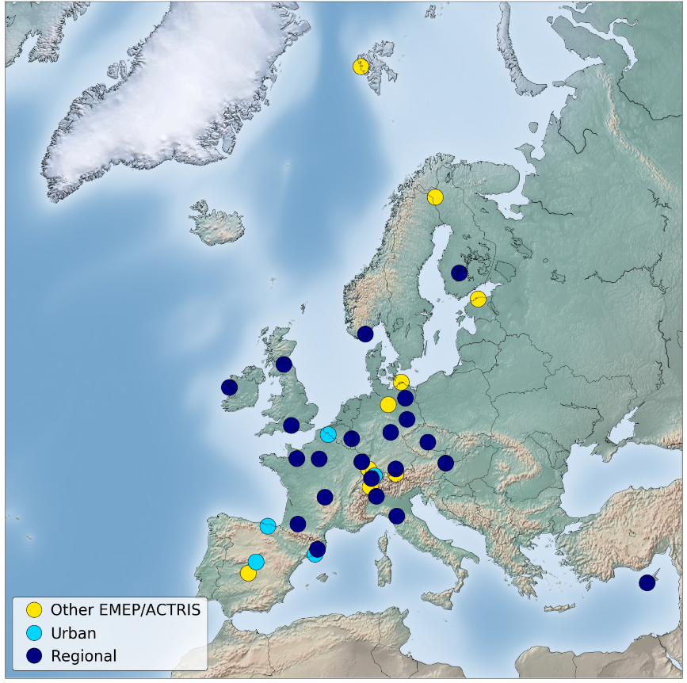
Figure 7: Sites measuring VOCs during the EIMP campaign in July 2022.

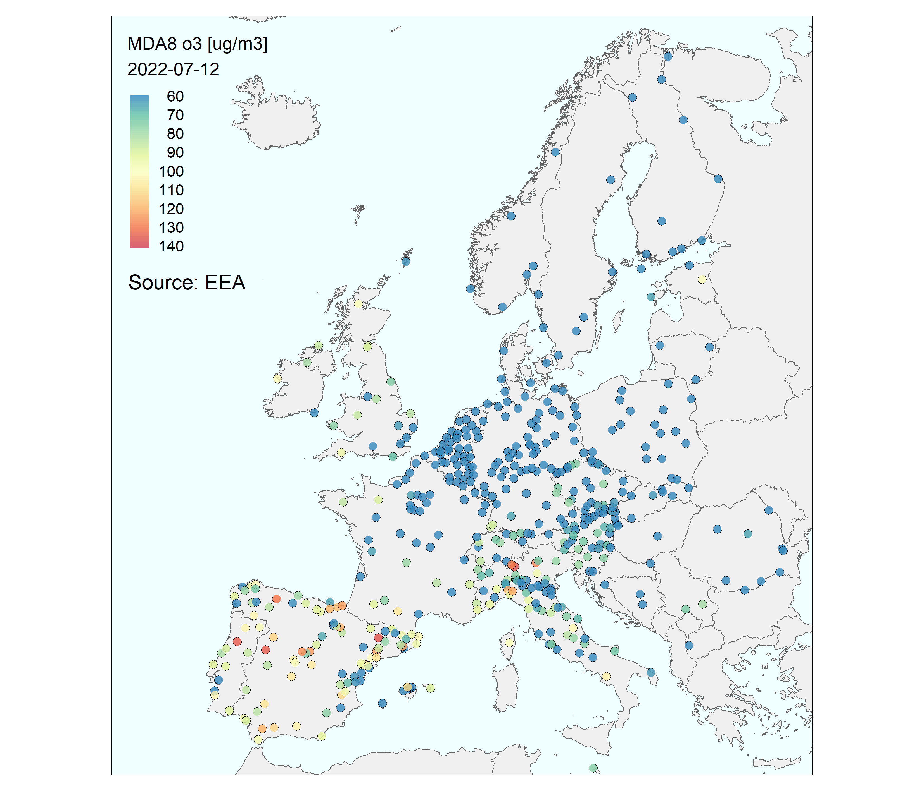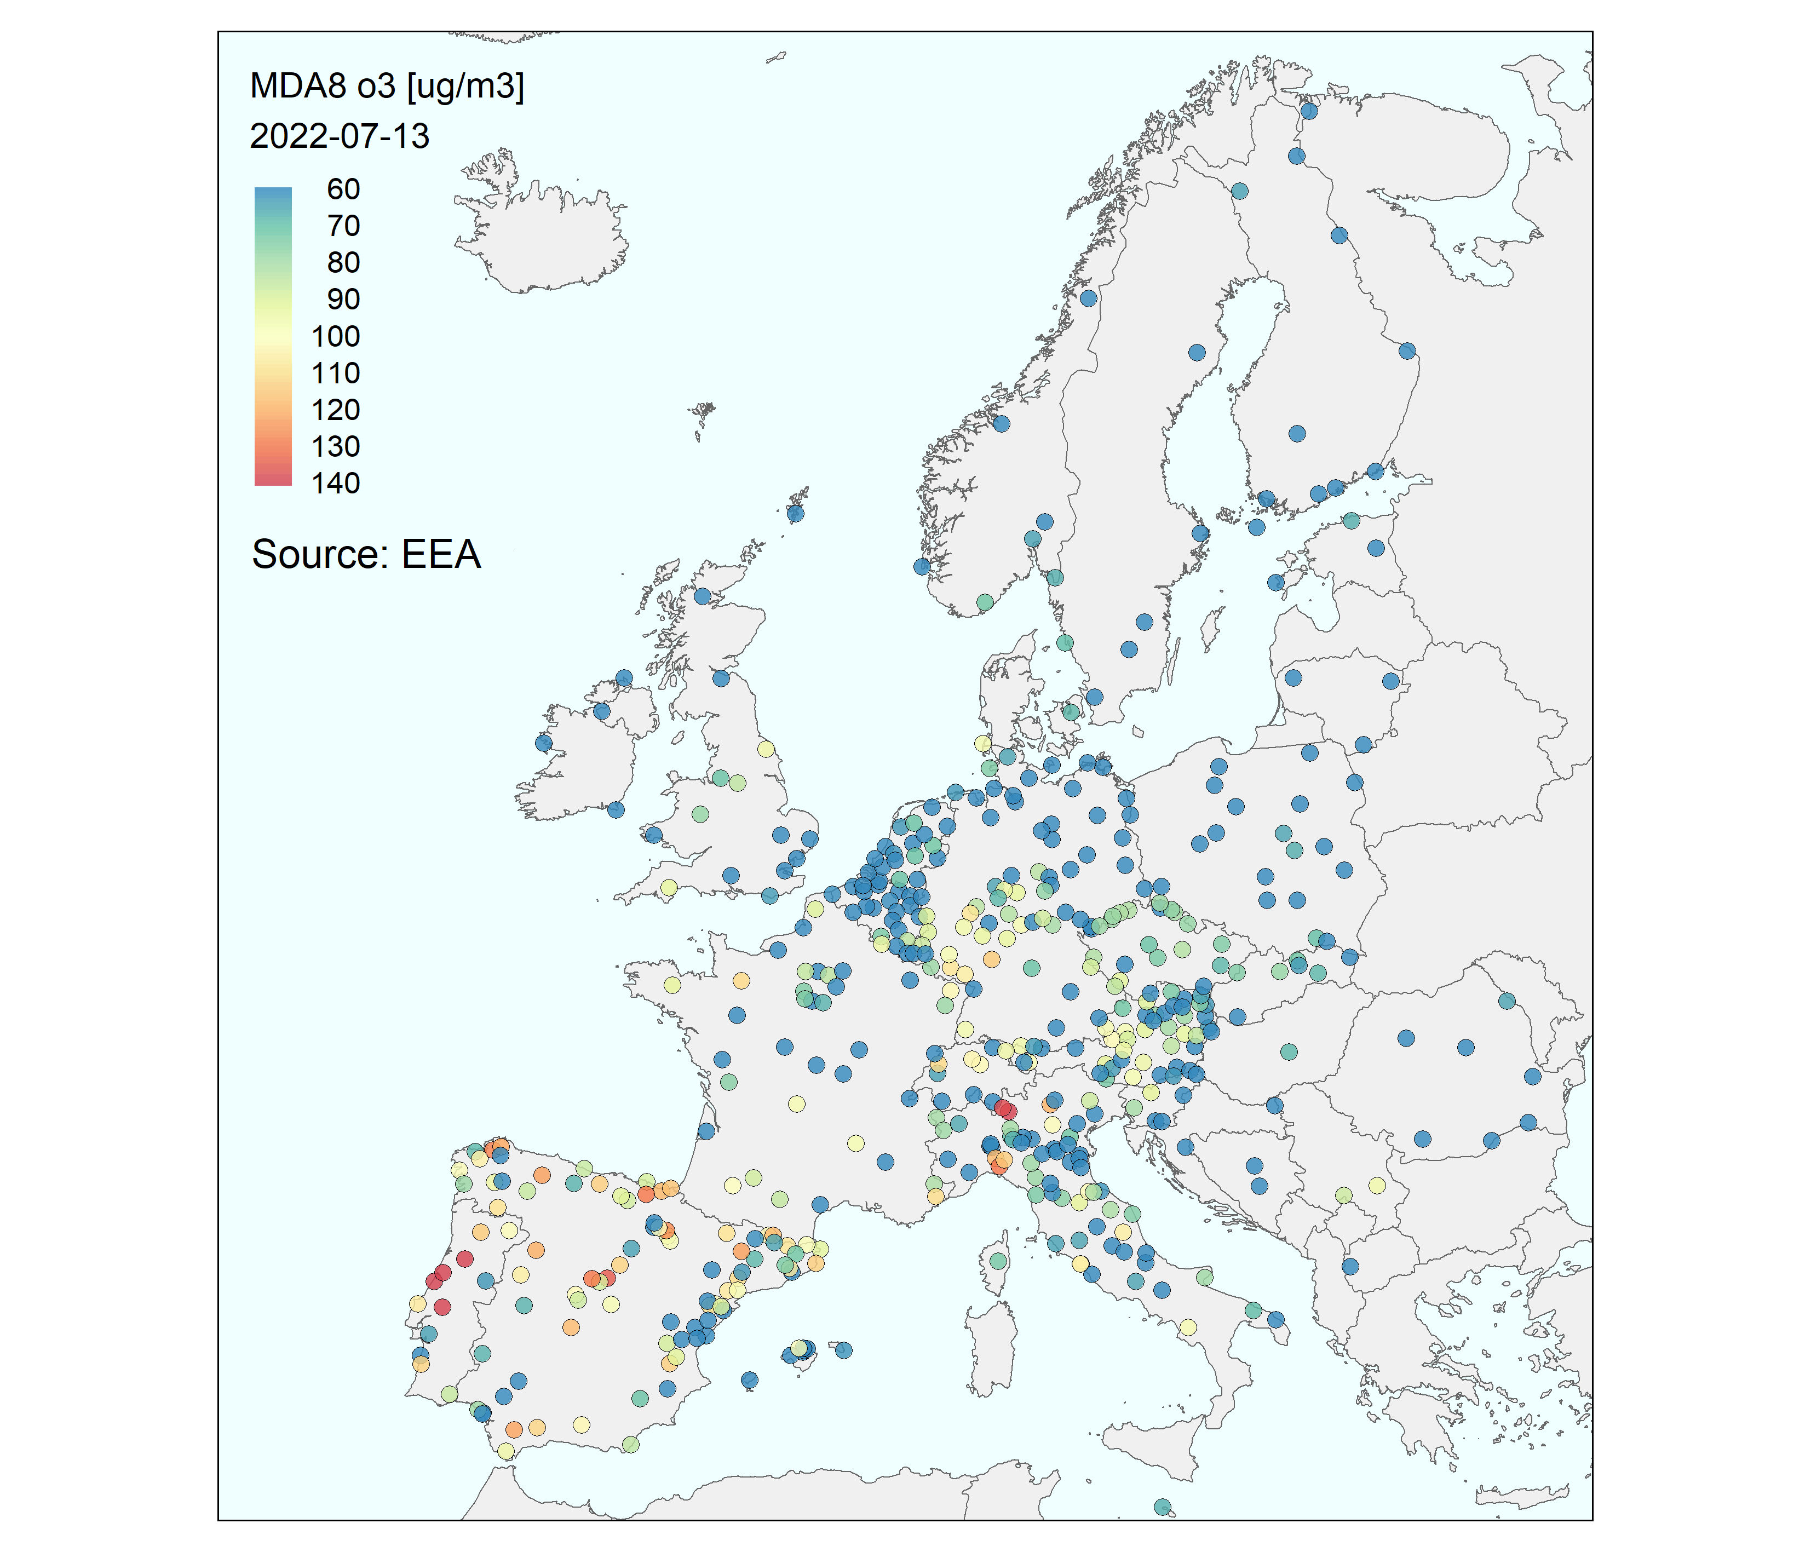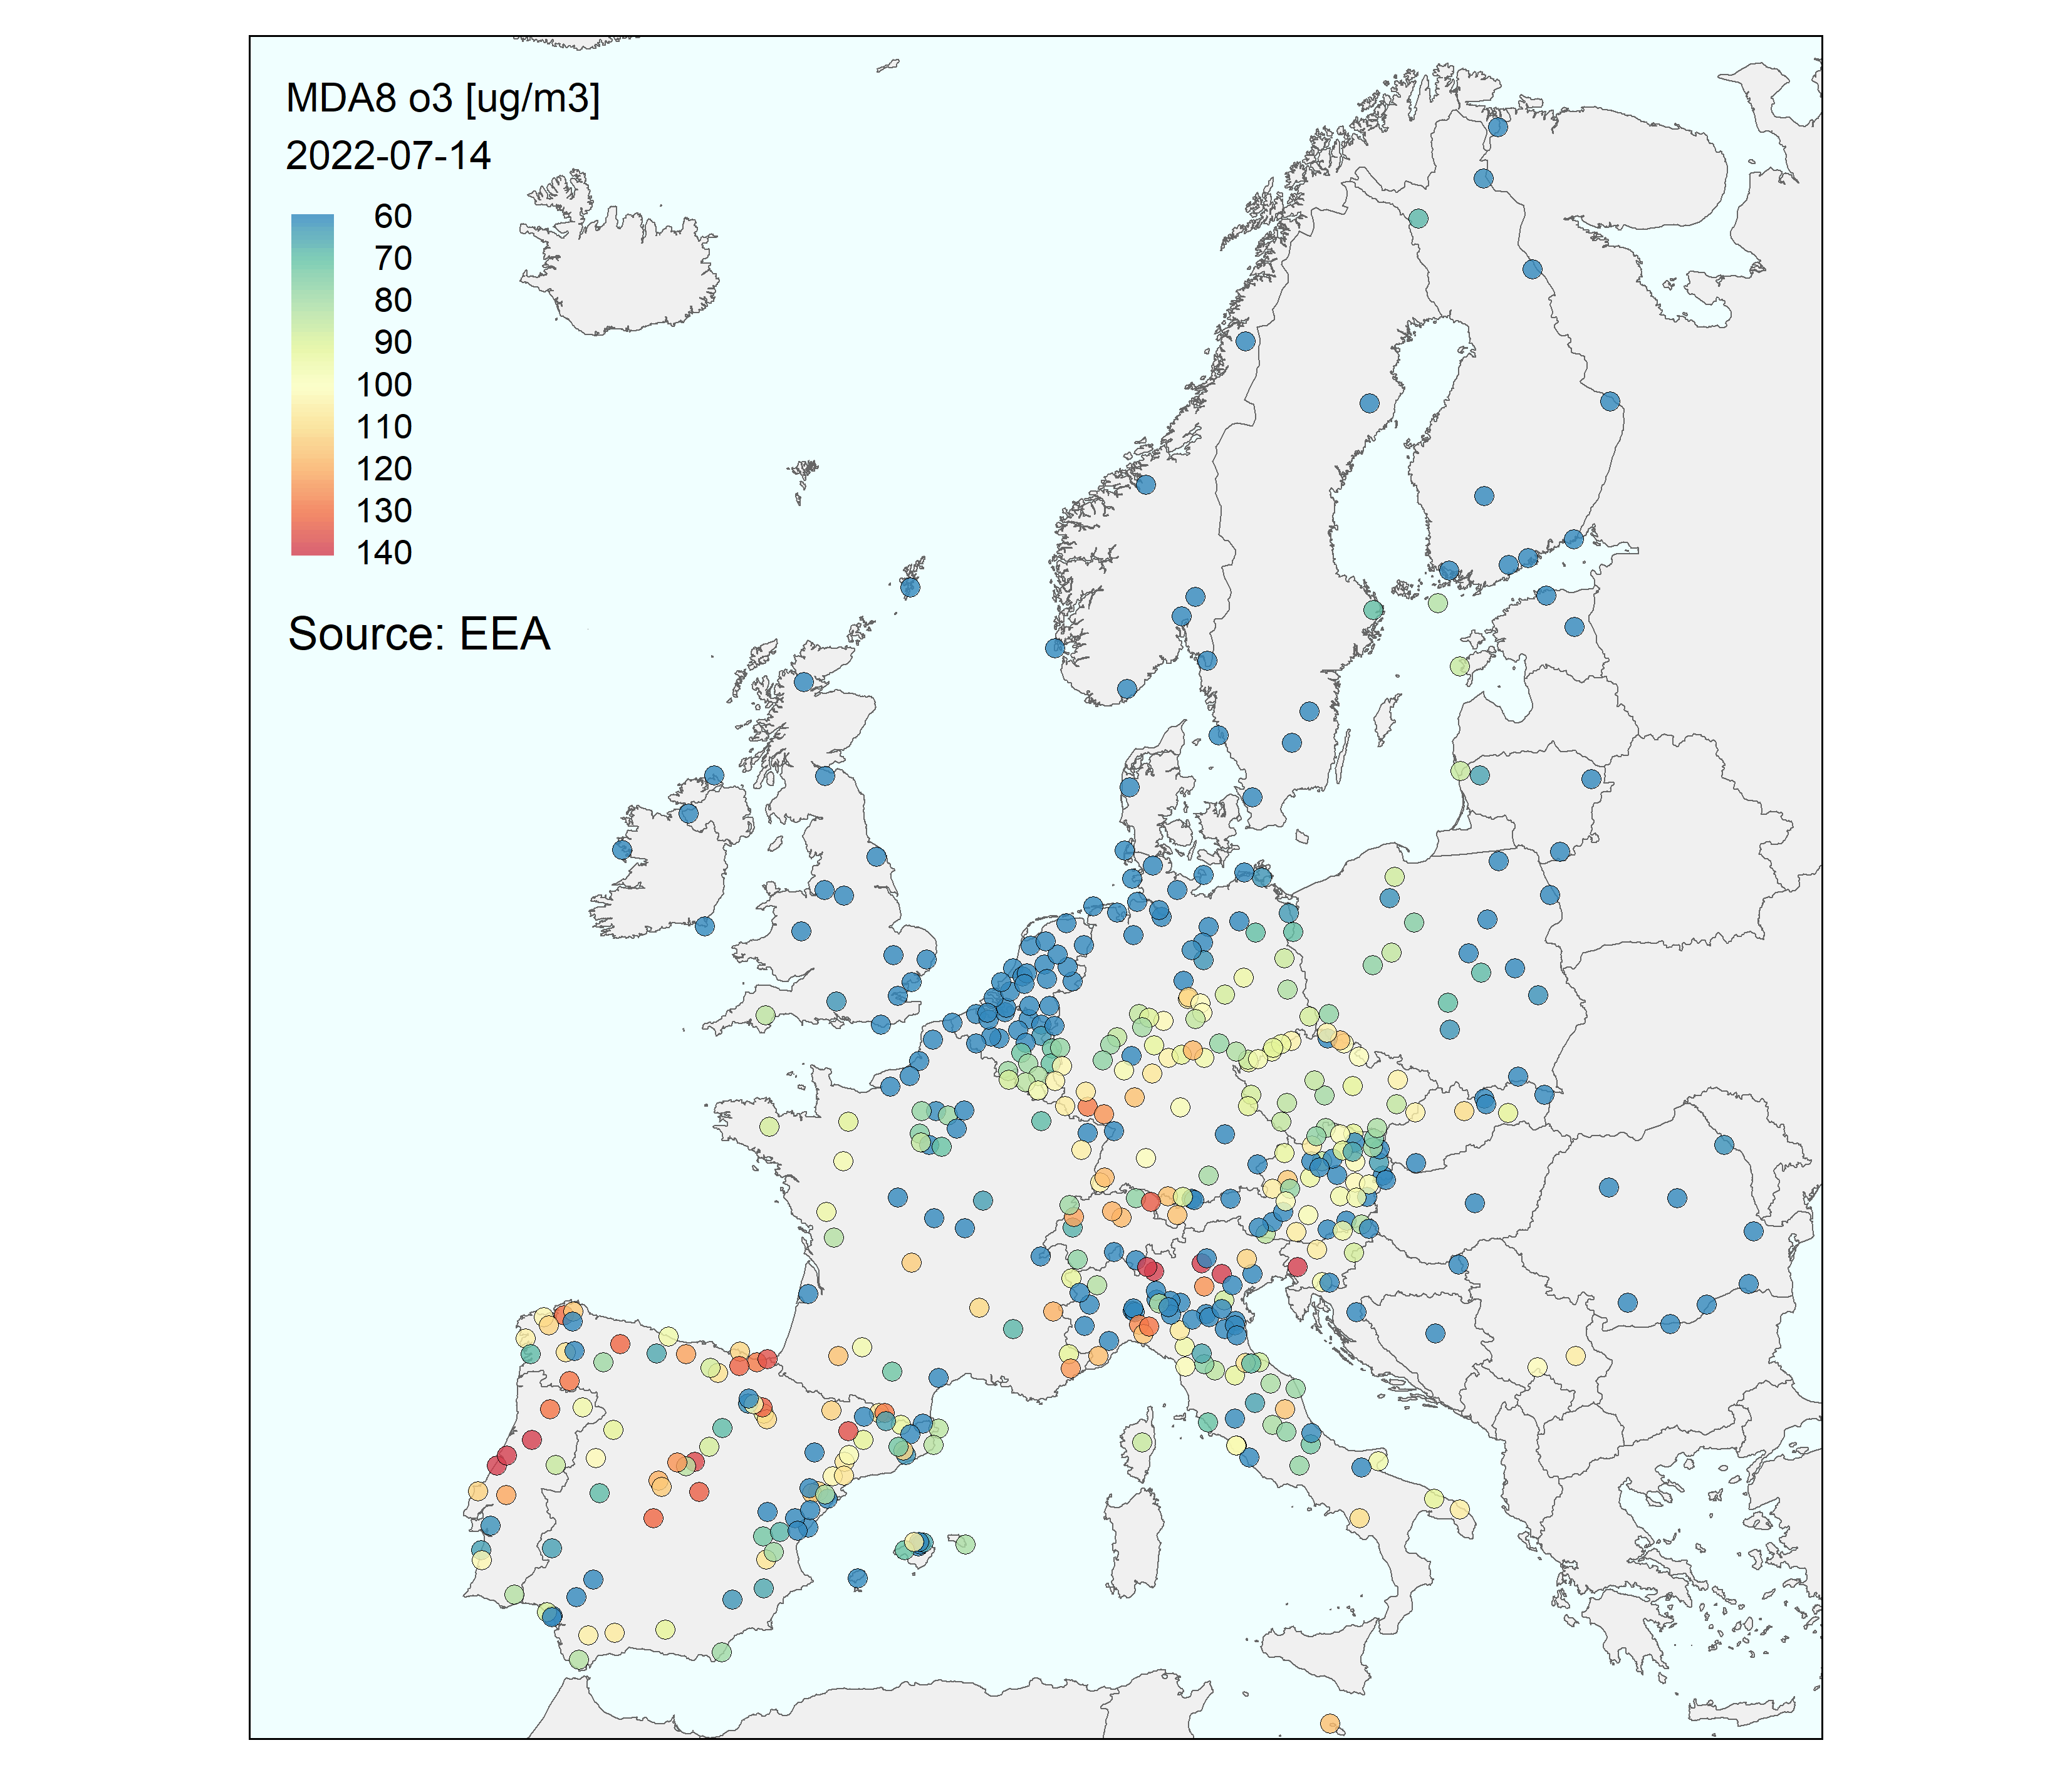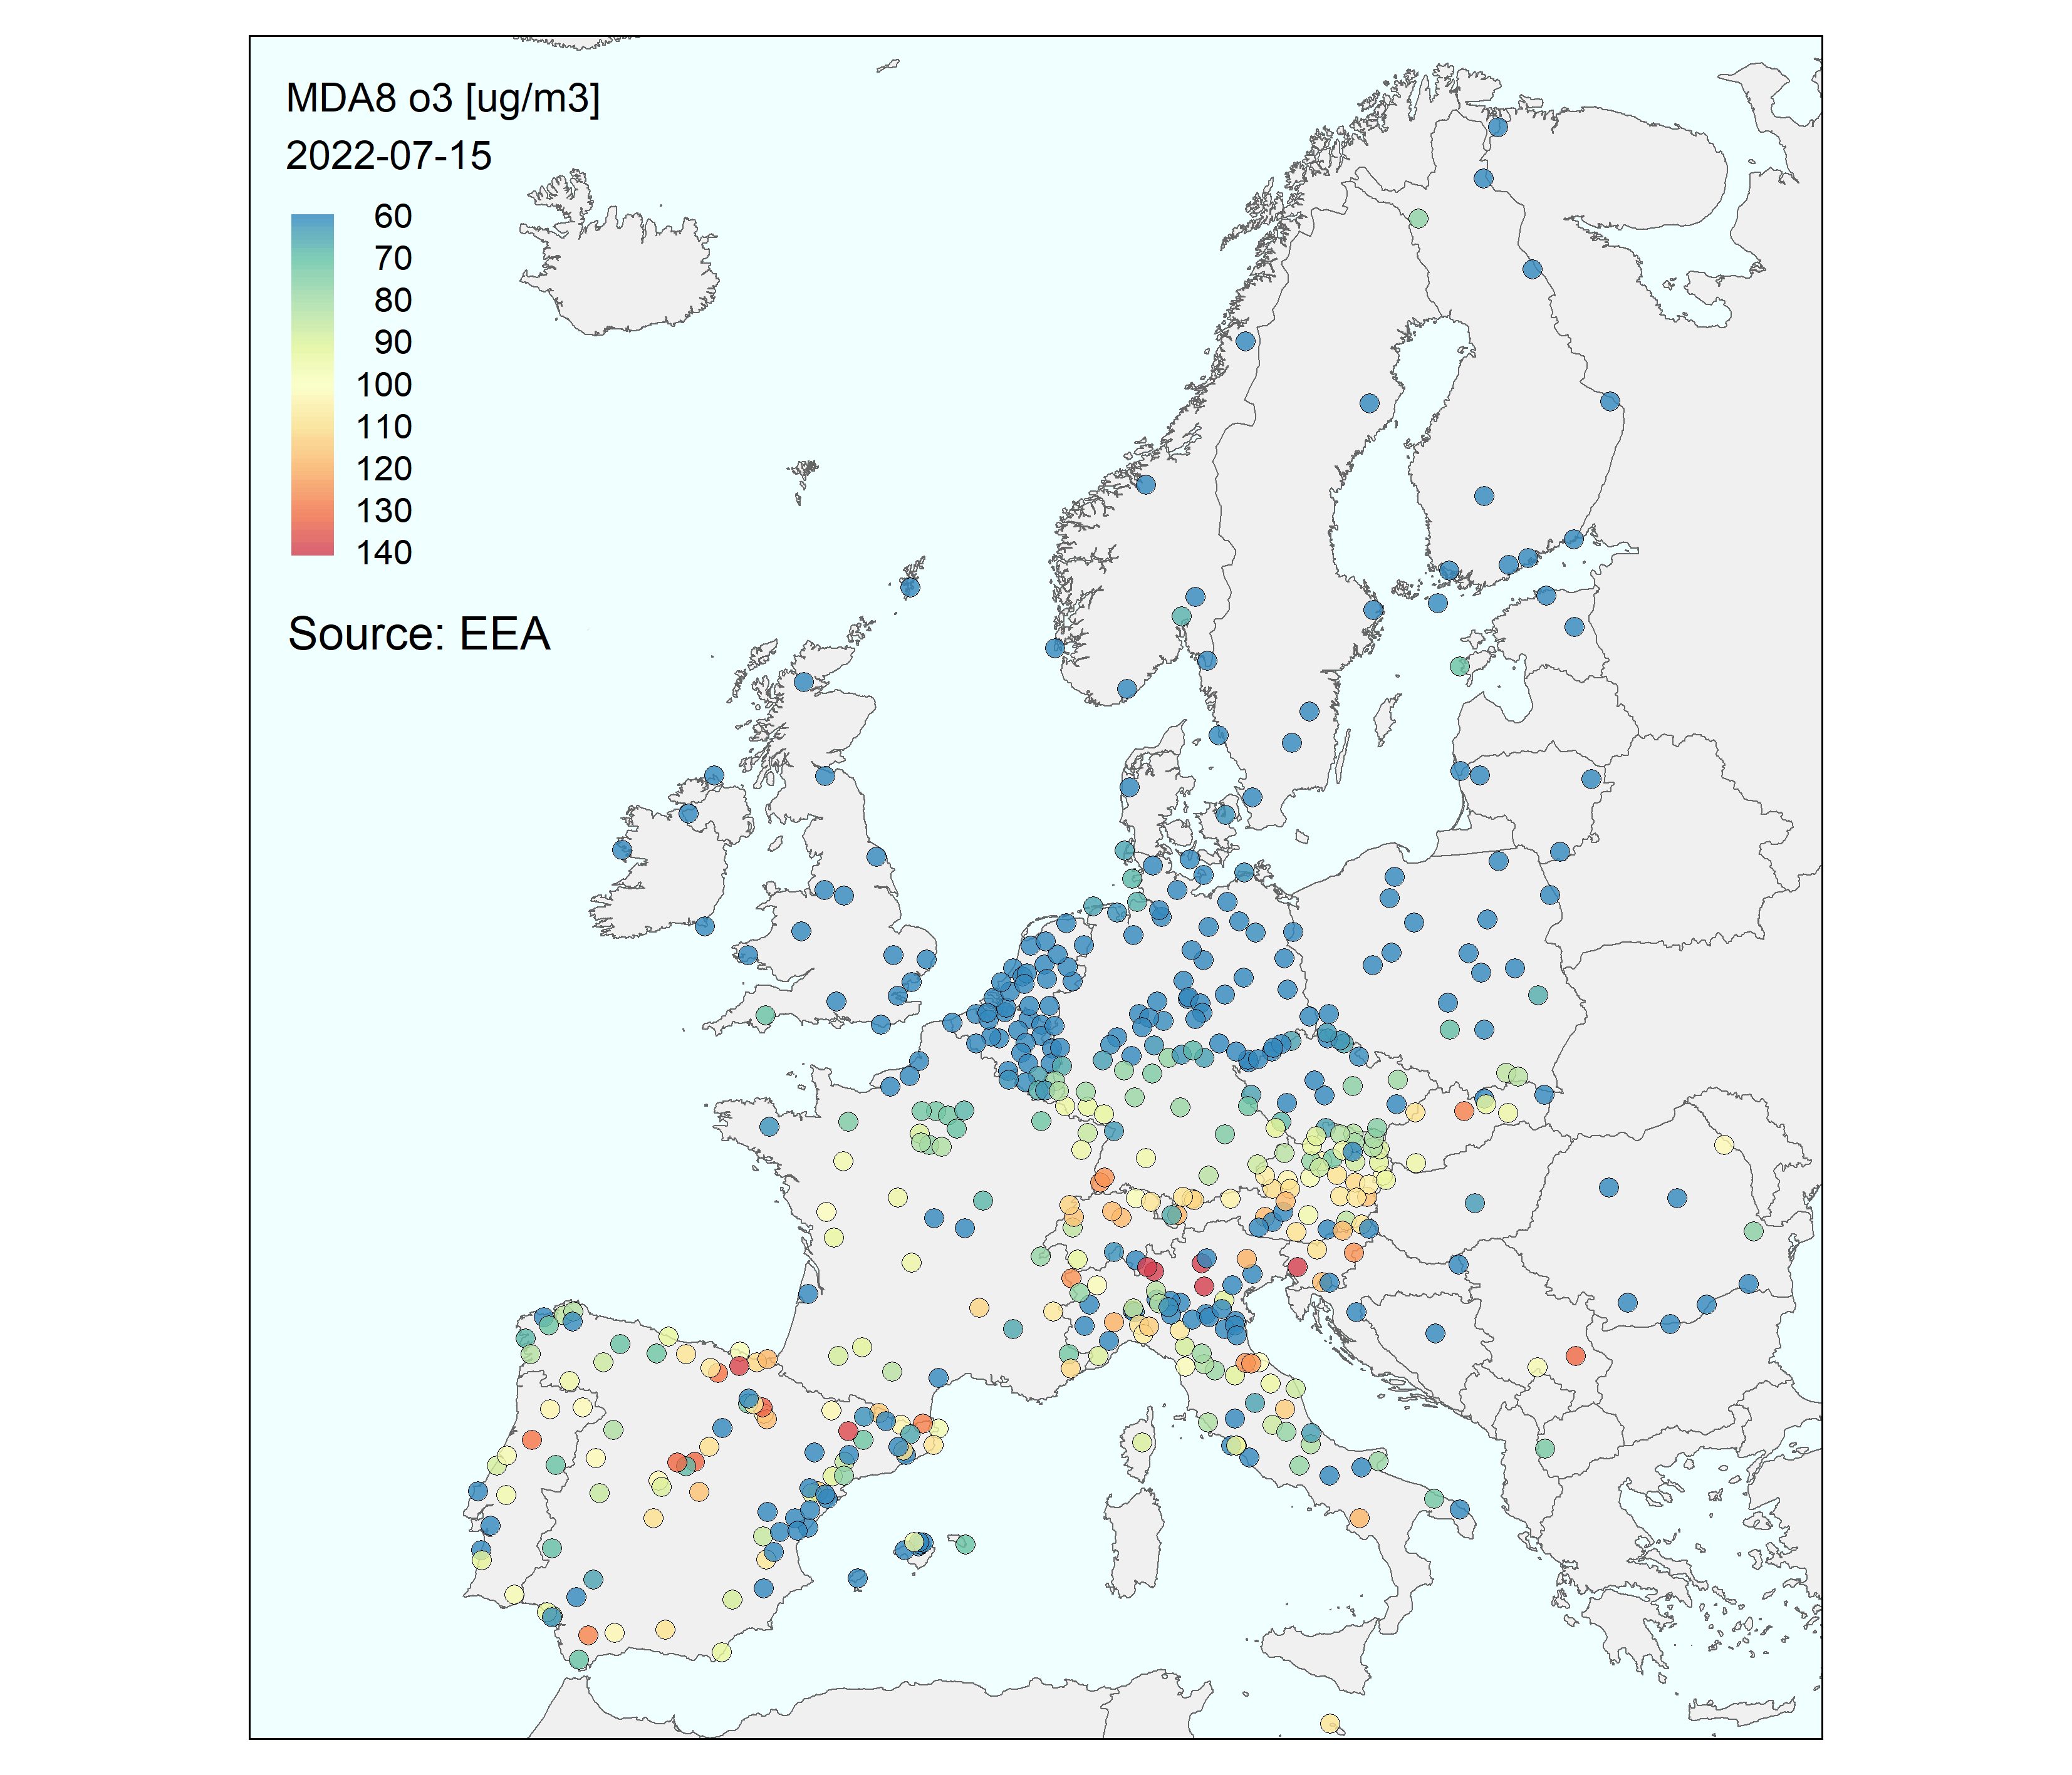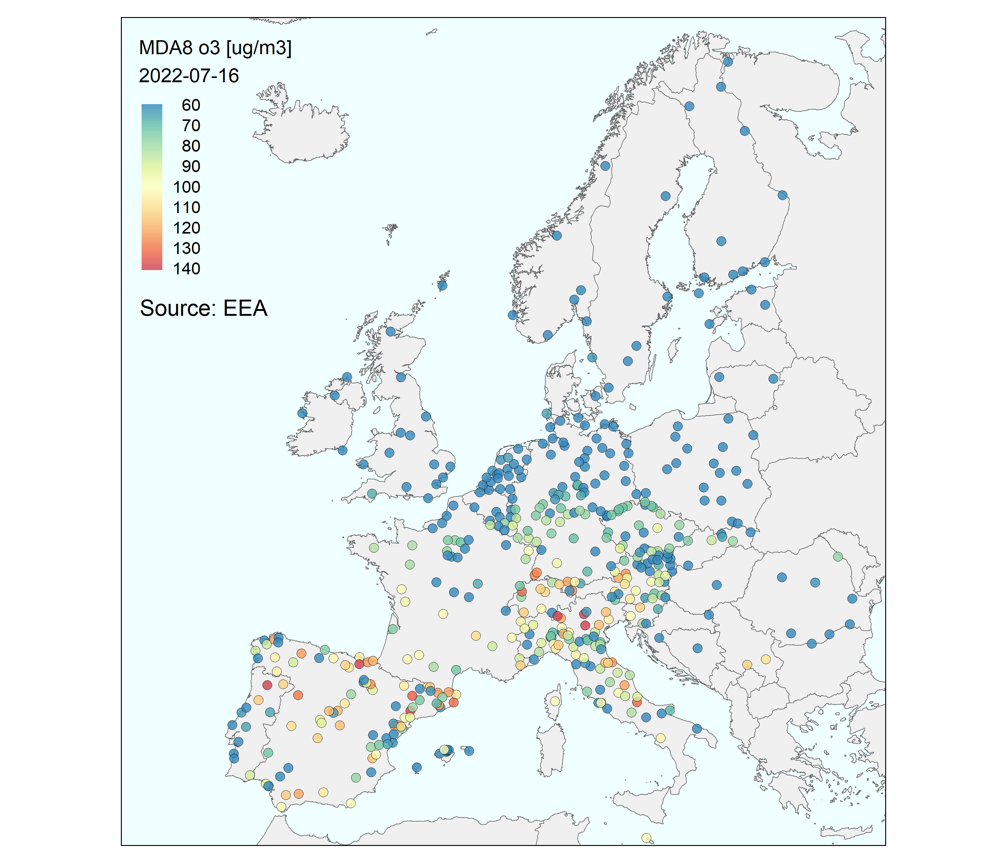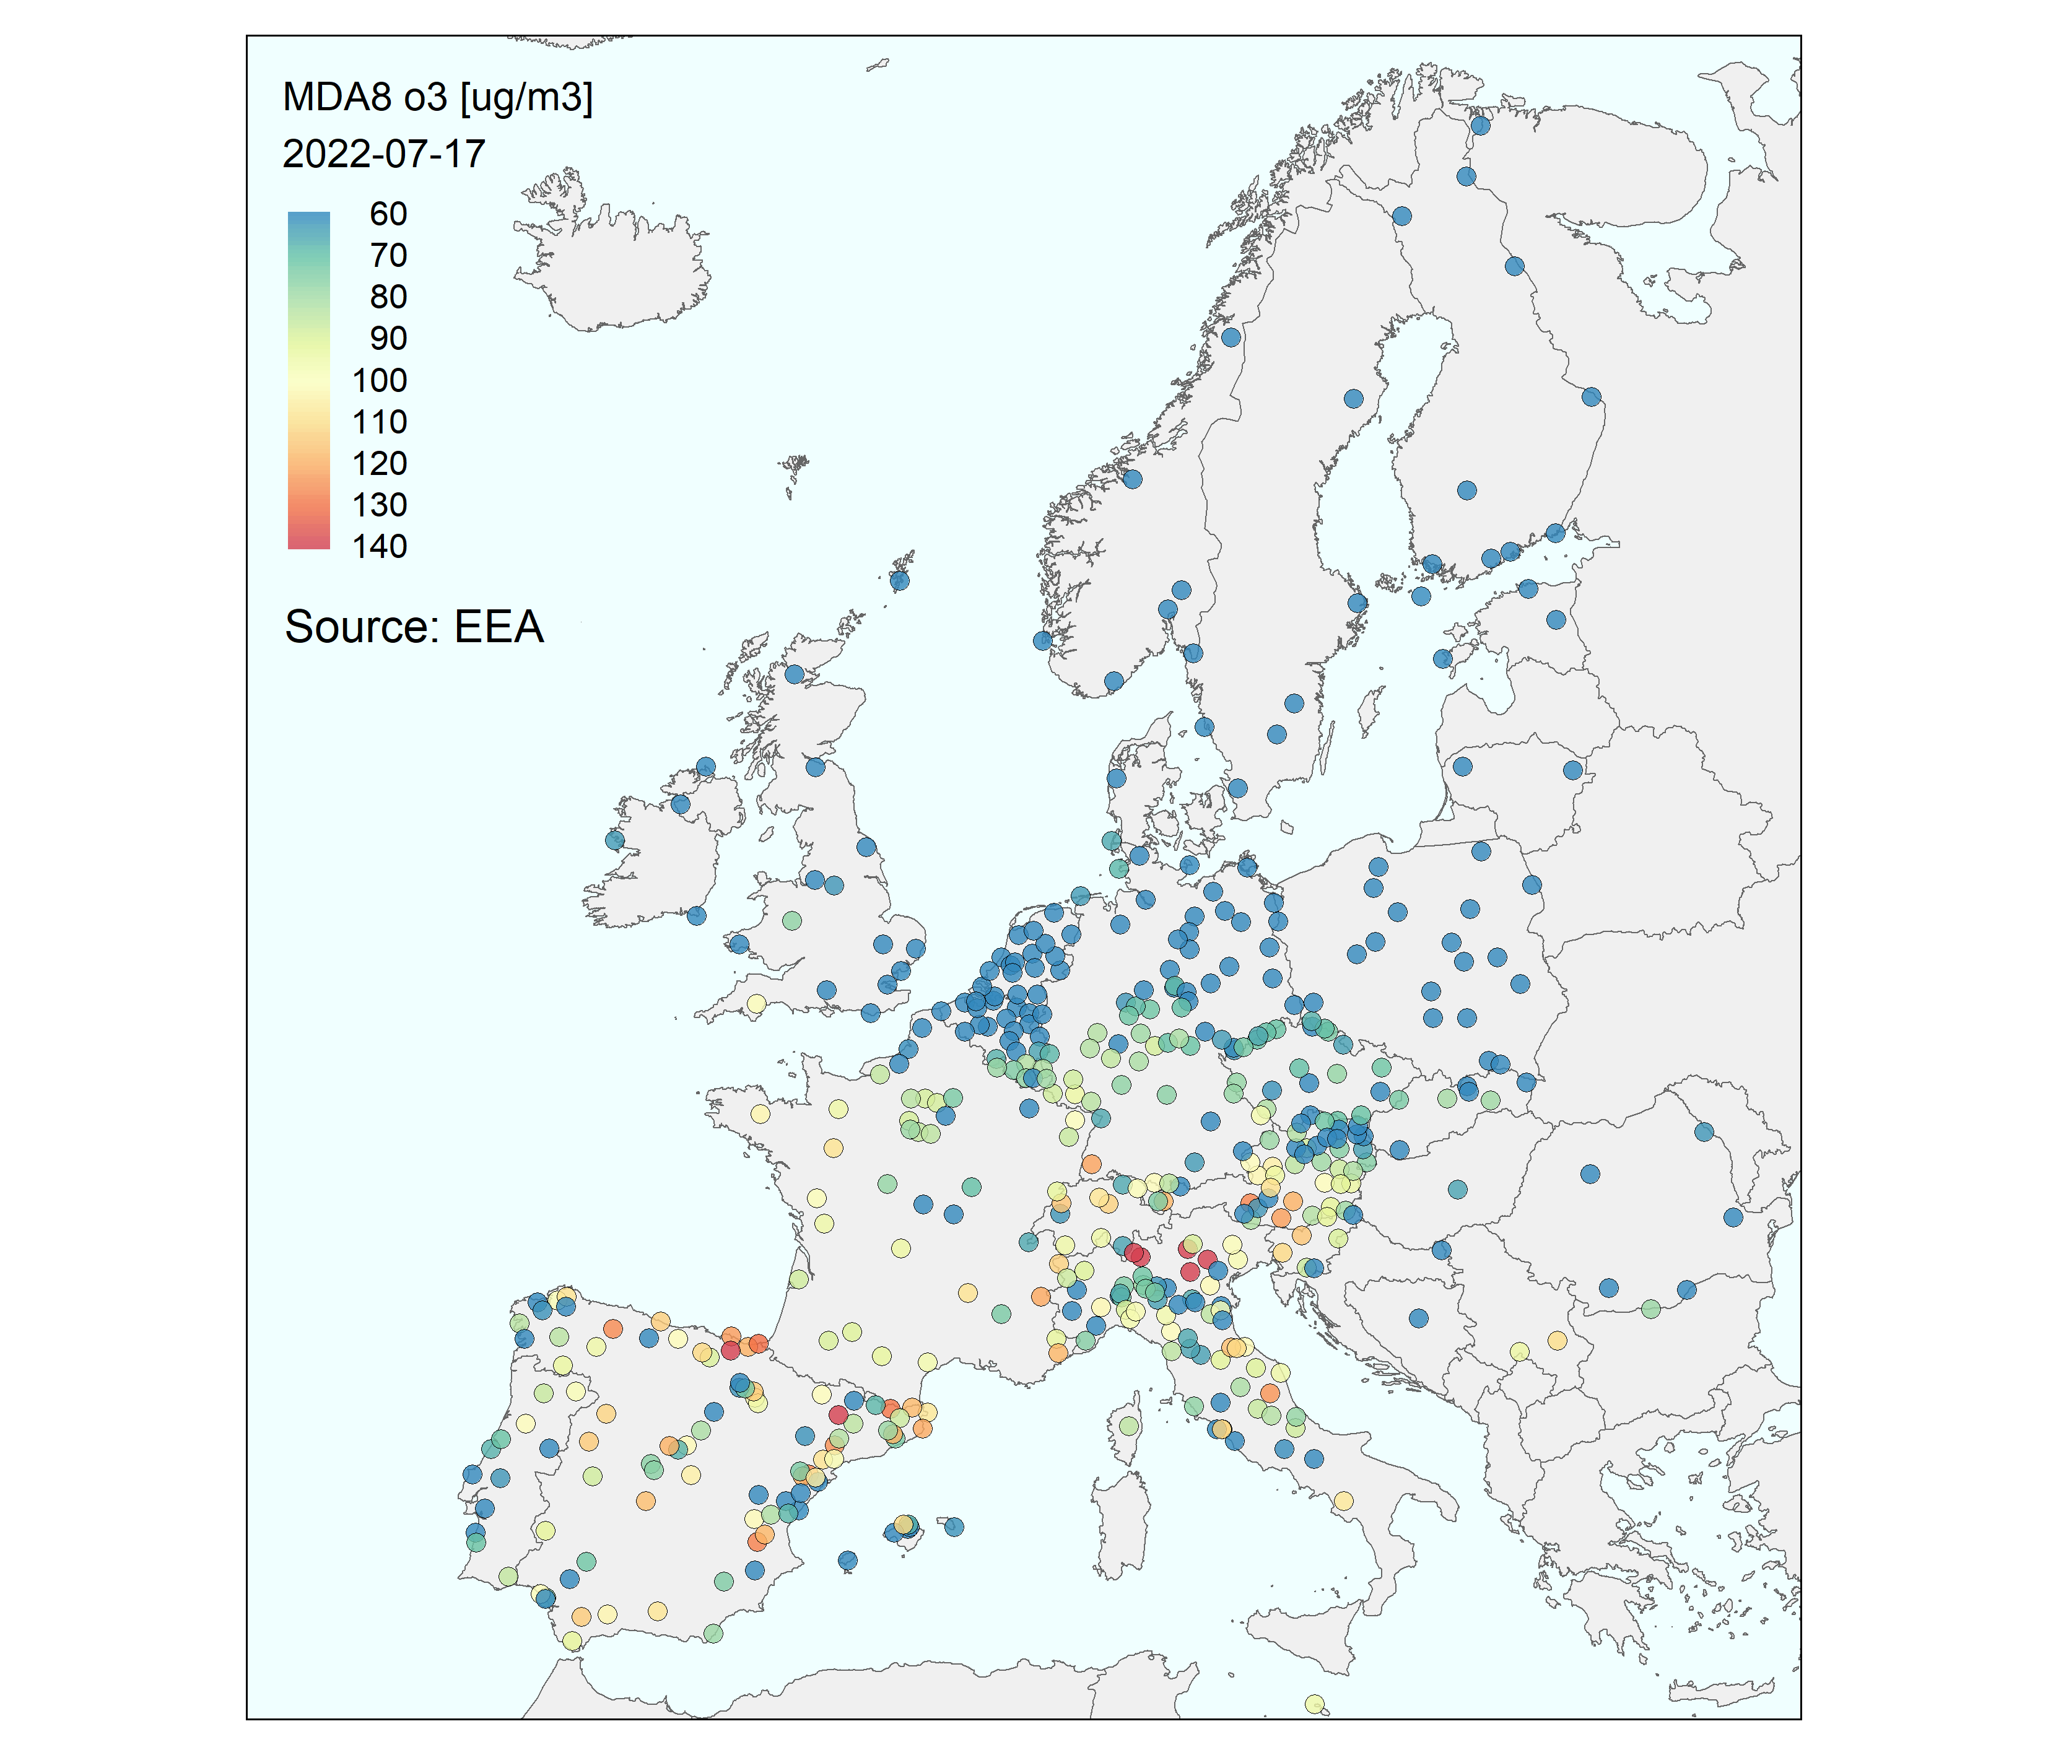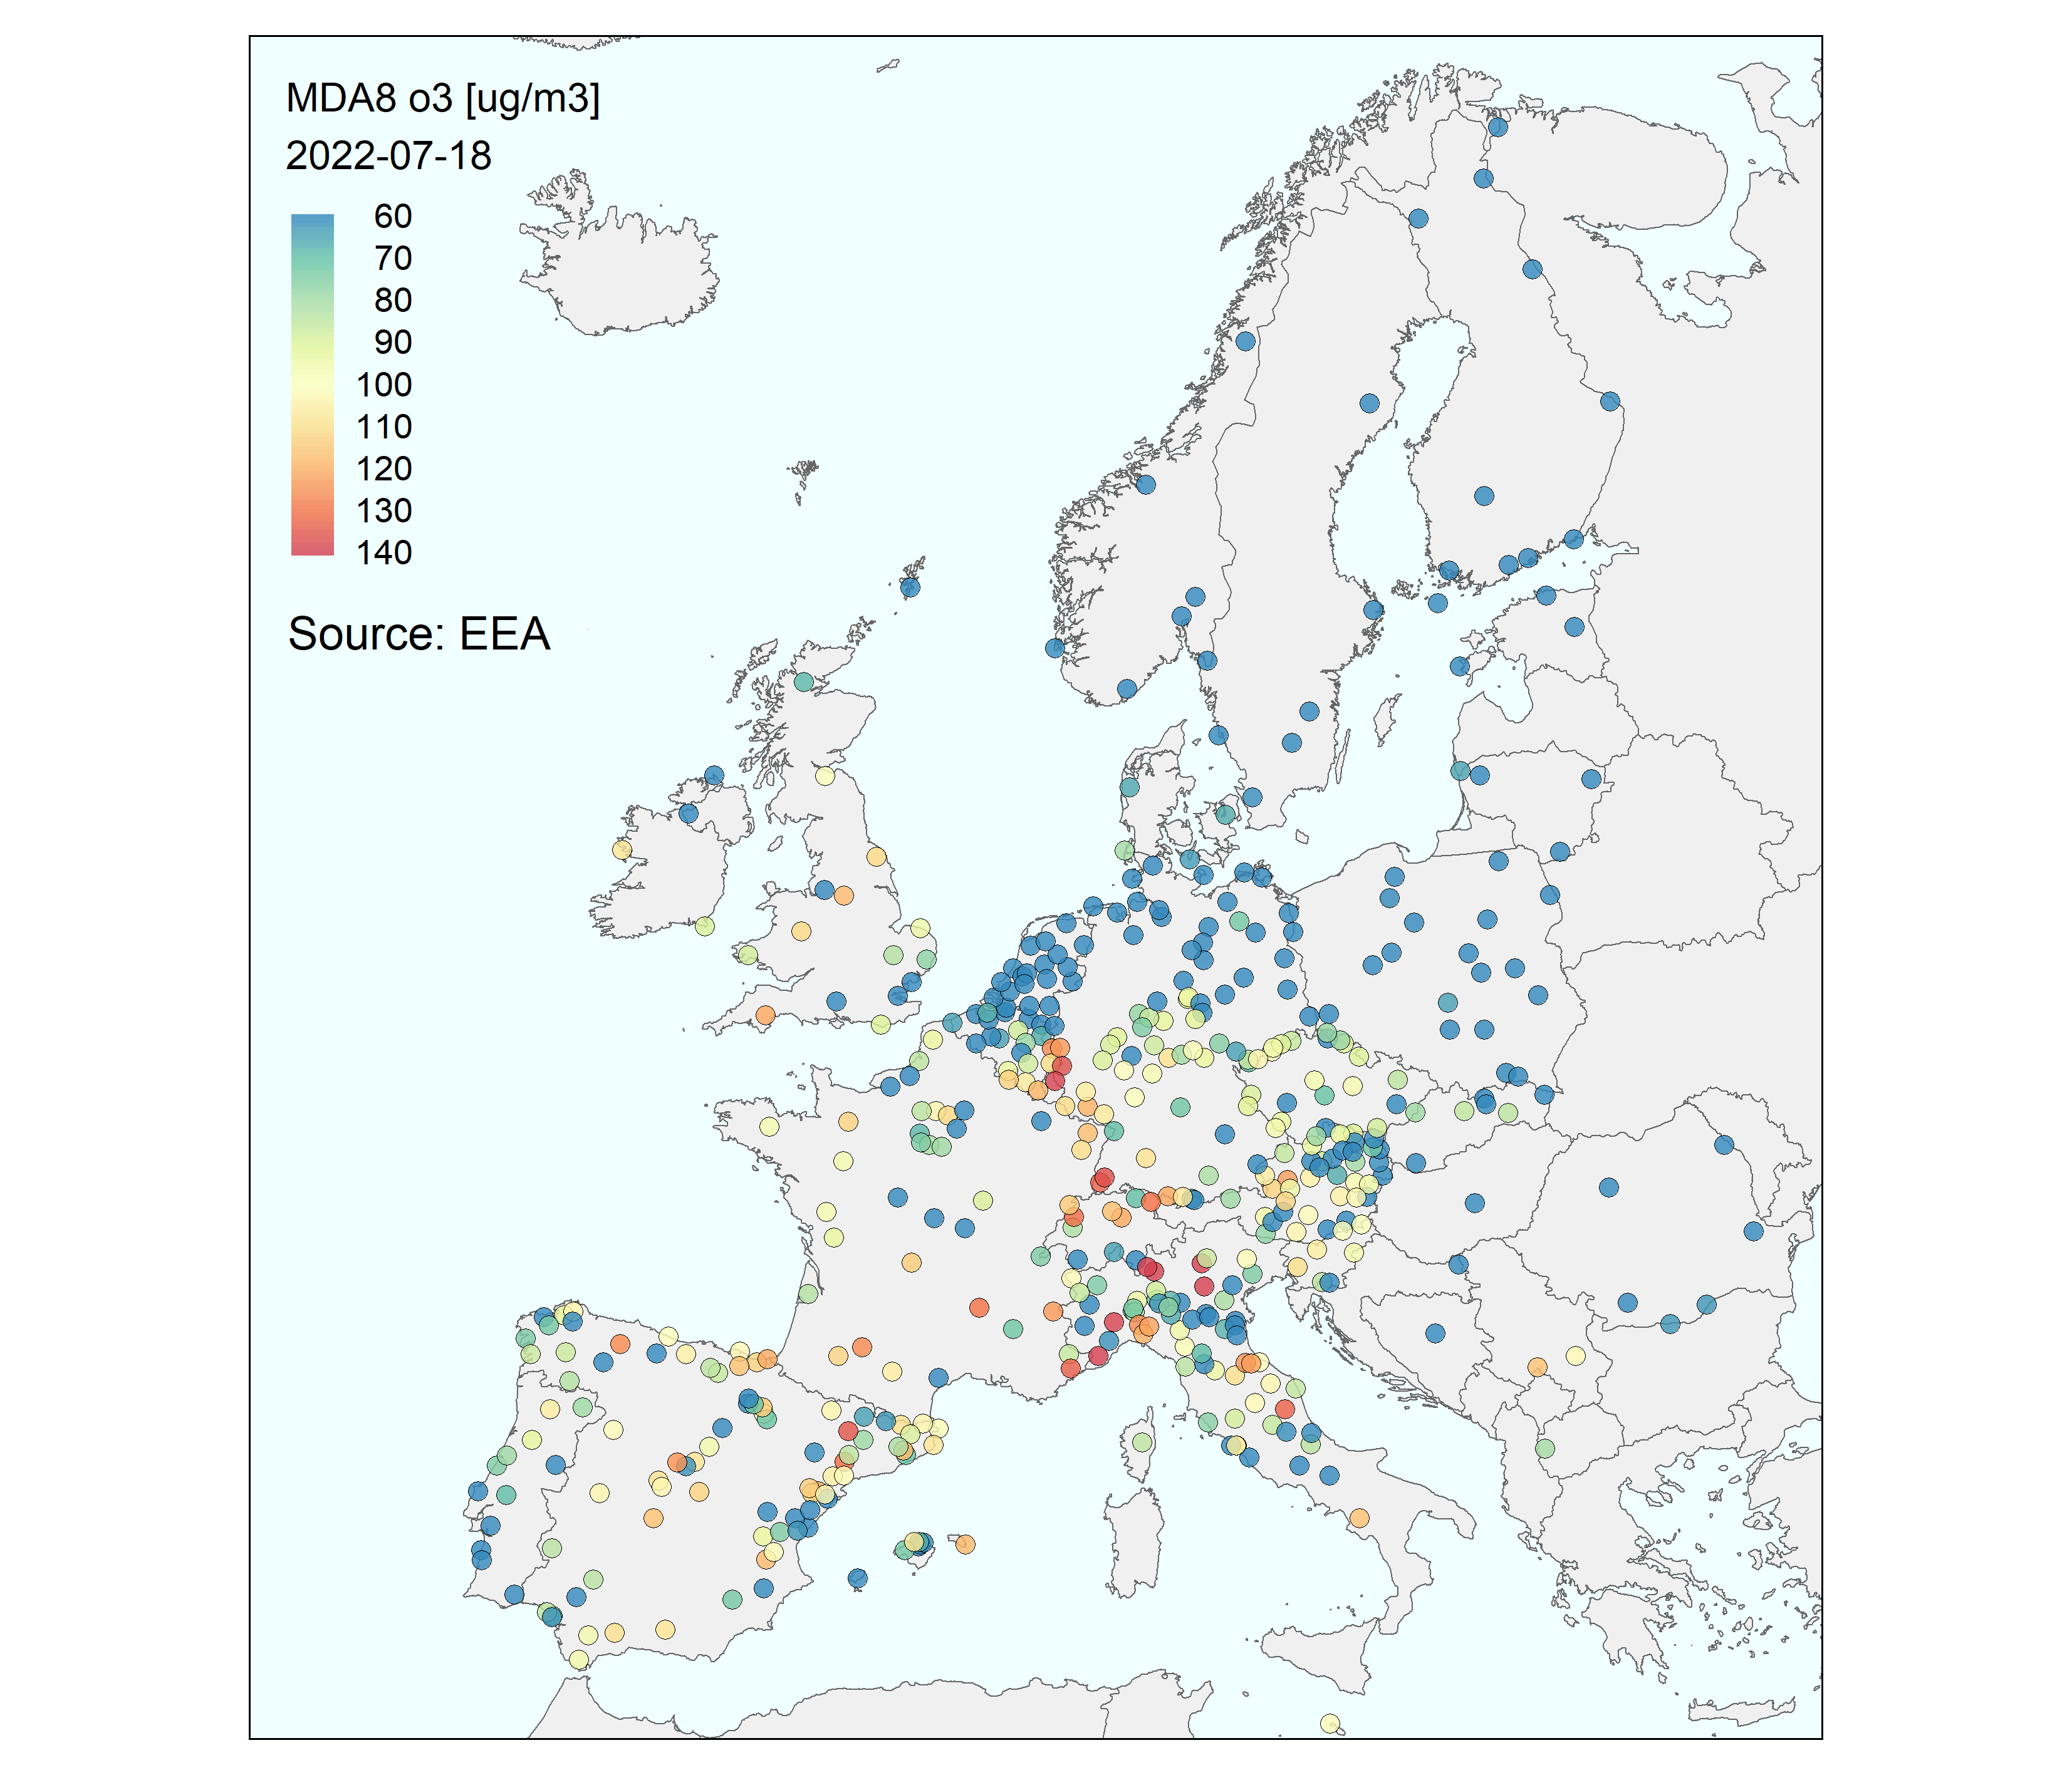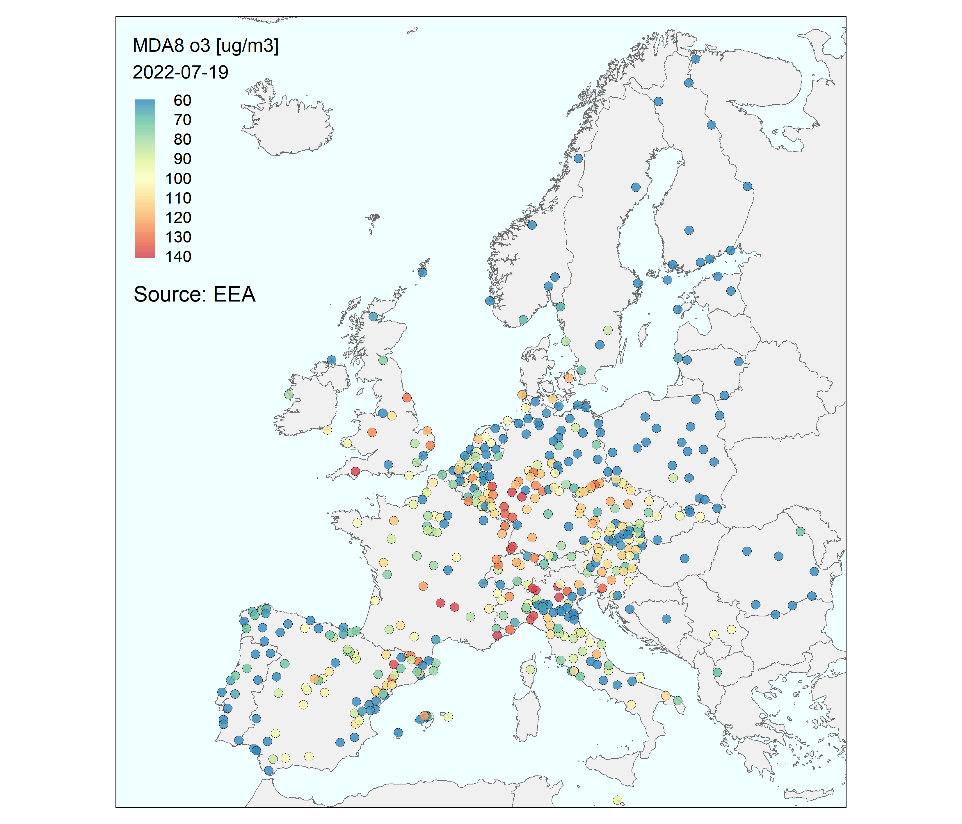
Figure 8: The daily max ozone levels at EEA sites during the EIMP campaign 2022.

The EIMP campaign has been documented in other EMEP reports and just a few highlights are given here. Figure 9 shows the stacked bar plots of the mean levels during the period of the C₂-C₅ NMHC and OVOC at the sites participating in the campaign. Ethane and ethene were important fractions of the NMHC at these sites while isoprene also constituted a major fraction at some sites, most pronounced at Ispra (IT0004) and Peyrusse Vieille (FR0013). The high contribution from isoprene agrees with the heat wave over the European continent during the campaign period. A major part of the OVOC is made up of methanal (formaldehyde), ethanal (acetaldehyde) and propanone (acetone) which could stem from both primary emission sources and secondary photochemical formation.

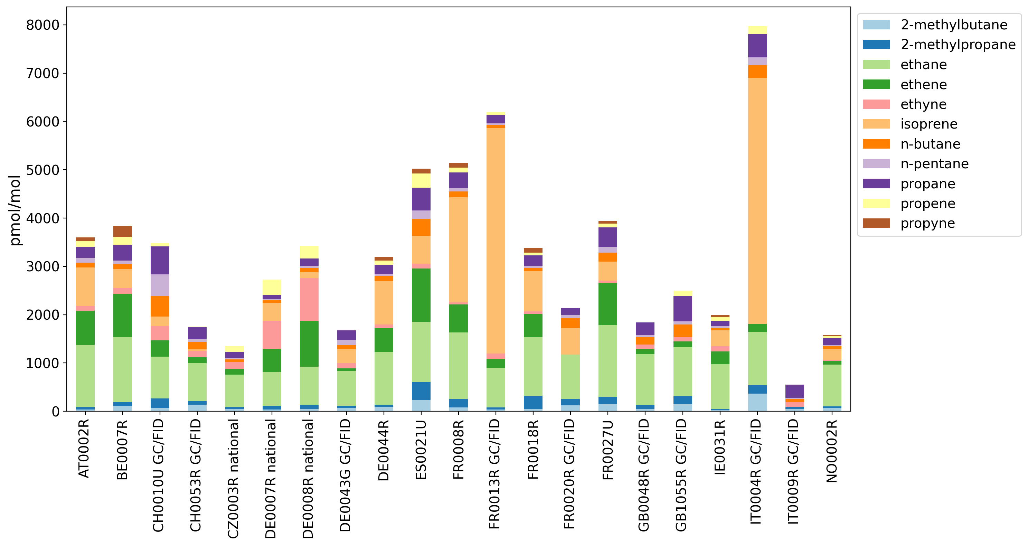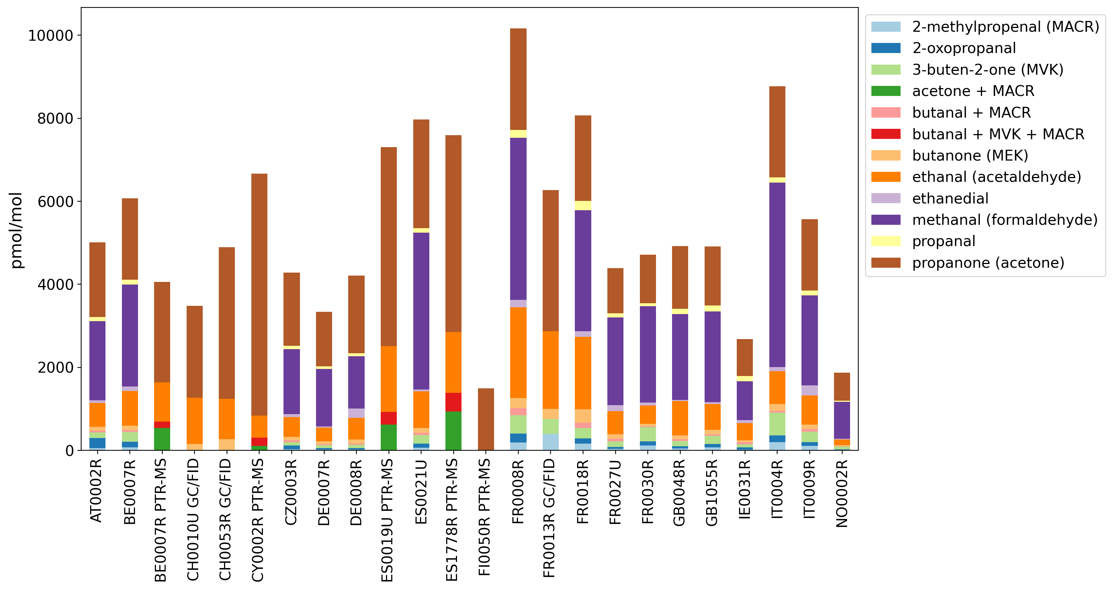
Figure 9: Measurements of C₂-C₅ NMHC (left) and OVOC (right) during the campaign.

The link between daily surface max temperature and the modelled and observed concentration of formaldehyde (methanal) at four sites during the campaign is in shown in Figure 10. The model data are based on the EMEP model applied in 2023. This indicates a very good agreement between the modelled and observed levels of formaldehyde as well as a clear link between temperature and elevated levels of formaldehyde. The good EMEP model performance for formaldehyde has been seen in previous studies, even for the former Lagrangian model (Solberg et al., 2001).

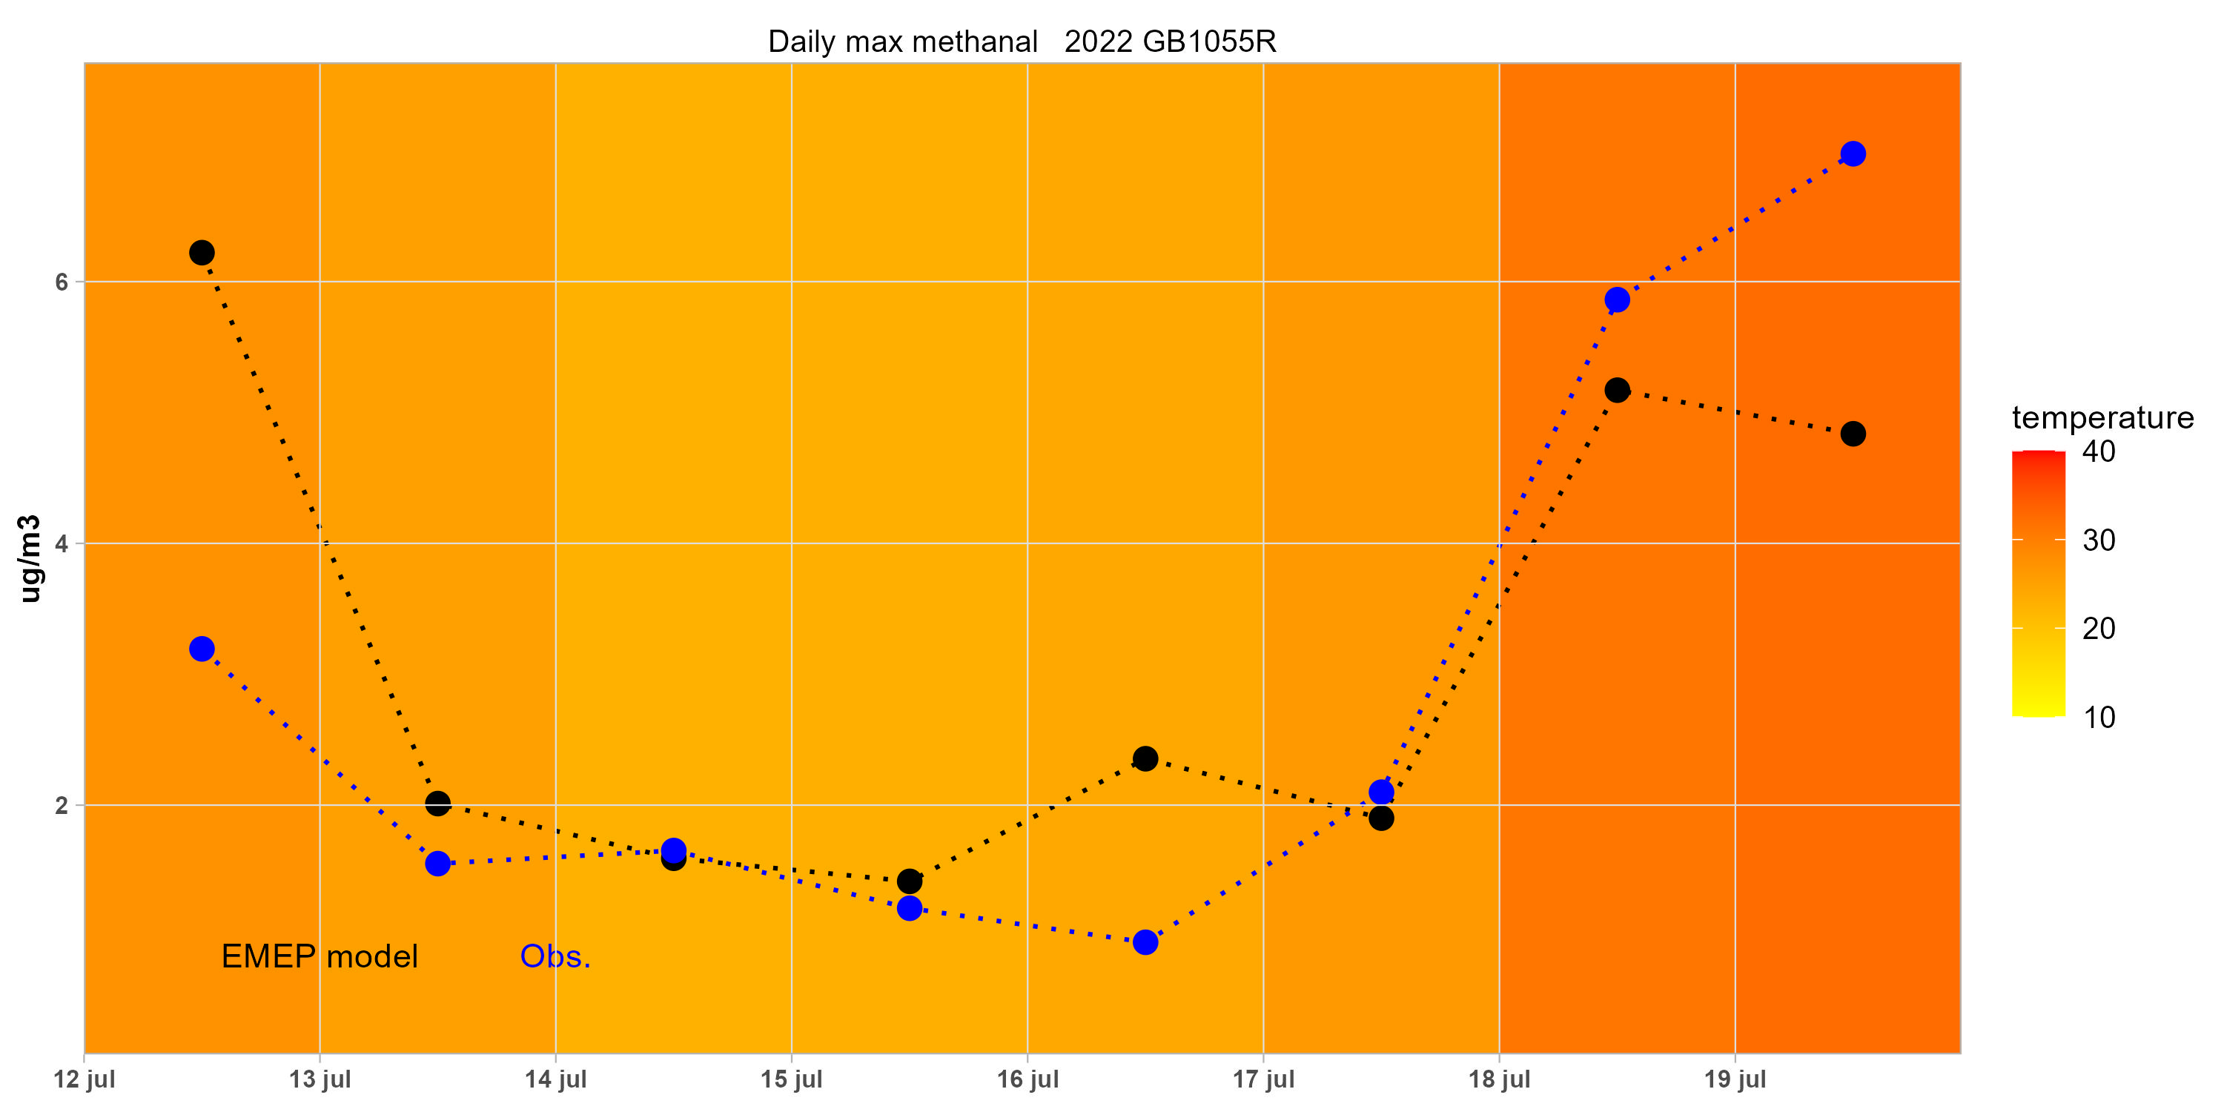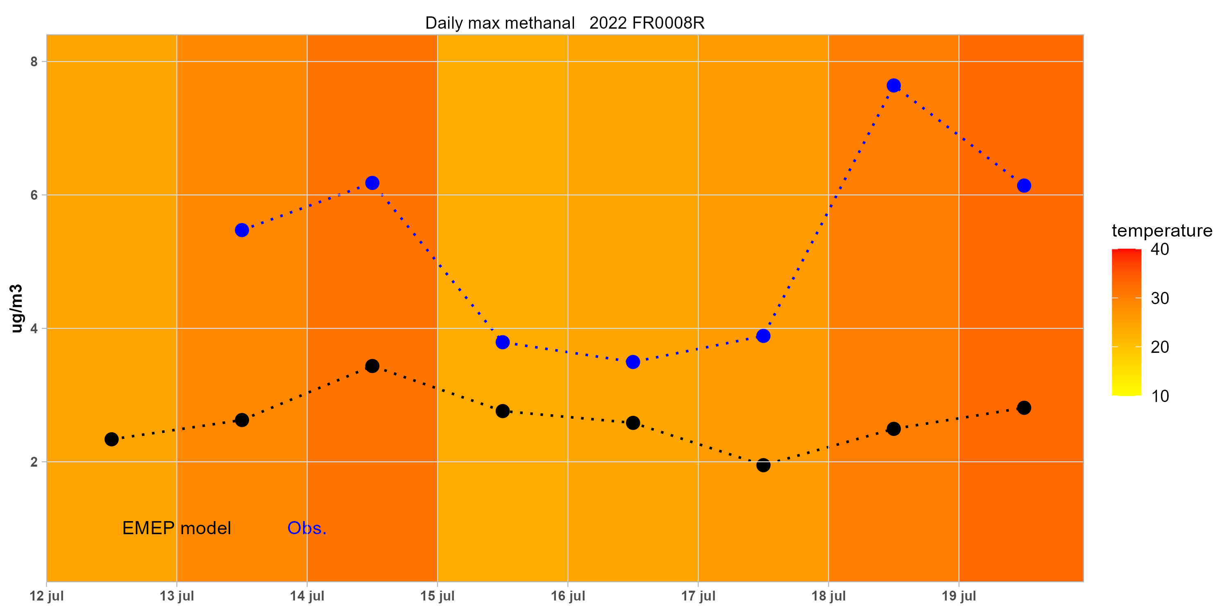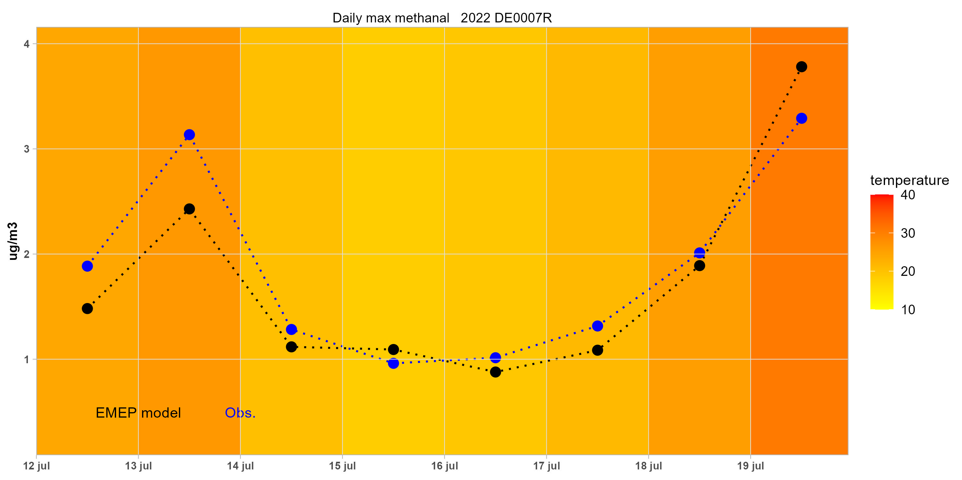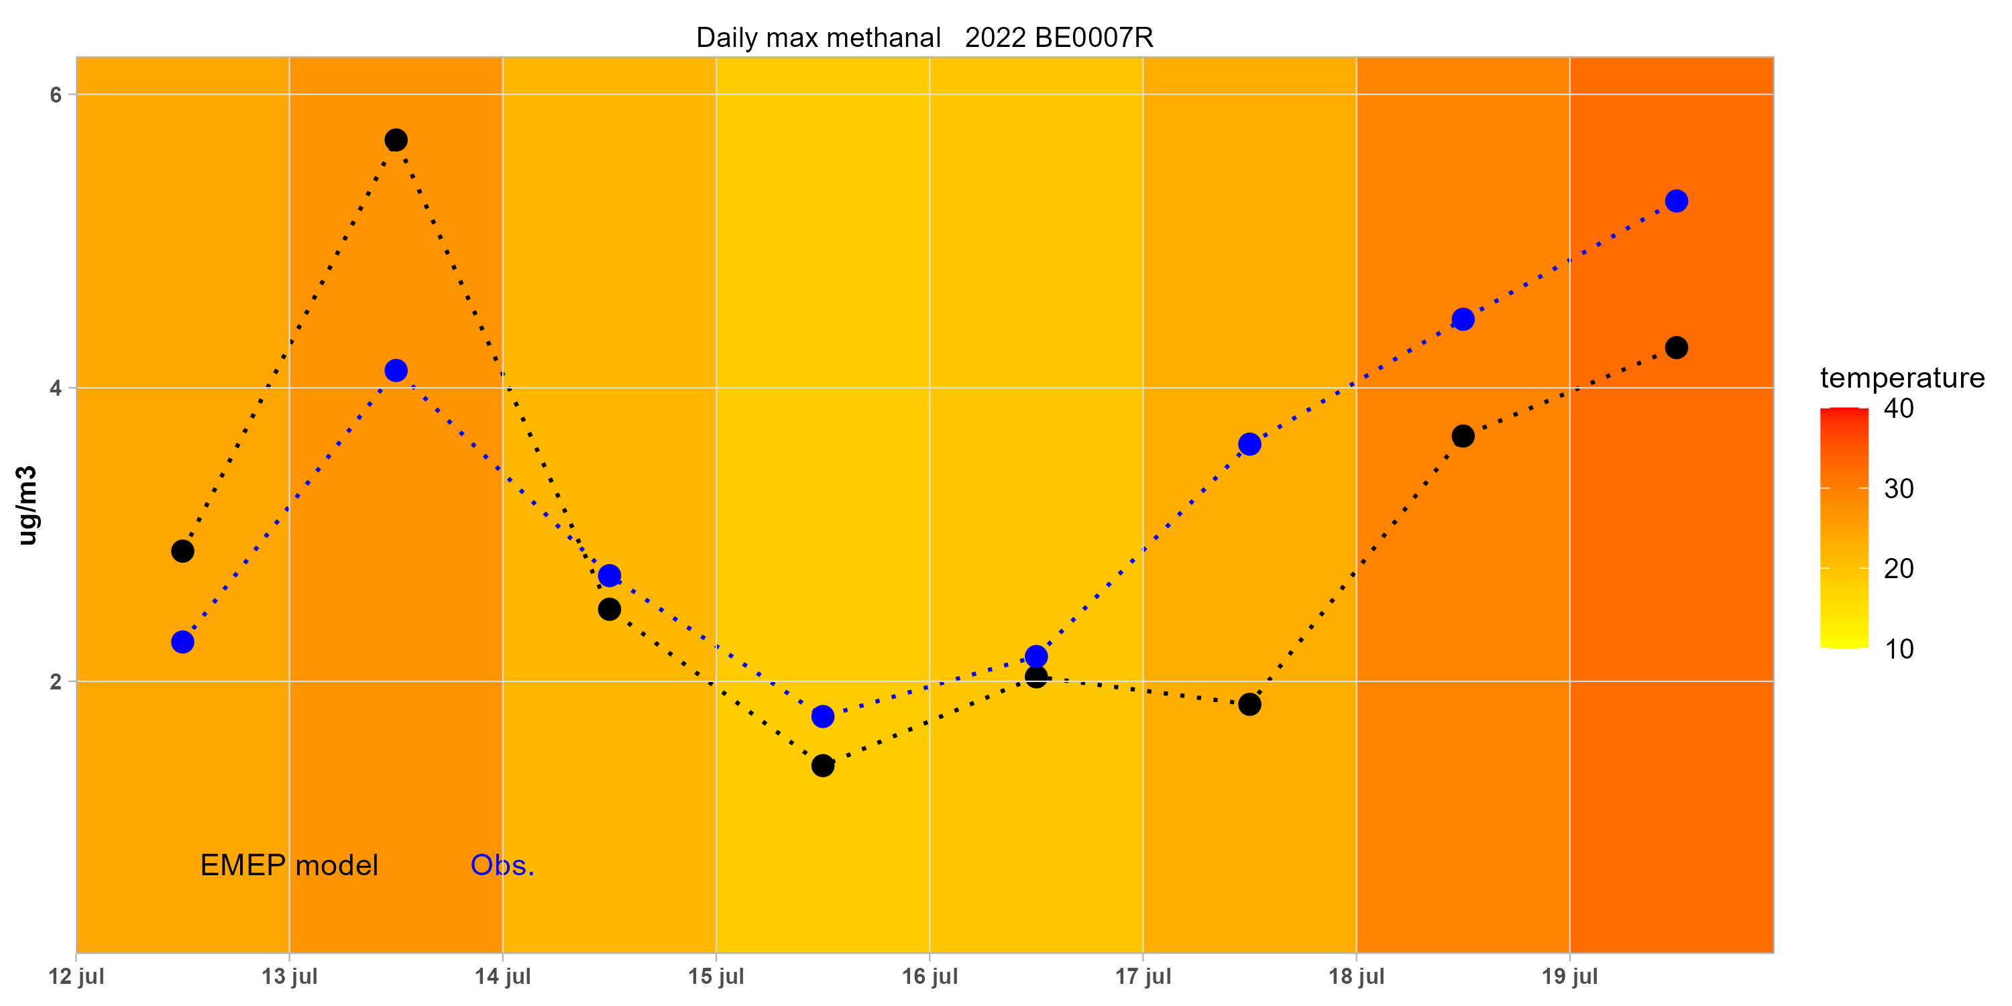
Figure 10: Daily max temperature (colored) together with the daily observed (blue line) and modeled (black line) formaldehyde levels in µg m⁻³ during the campaign period 12-19 July 2022.

Long-term trends in VOC
According to the official emission data, there have been marked reductions in anthropogenic emissions of VOCs during the last decades in Europe. Overview tables with reported emission trends for individual countries have been published on the CEIP website at https://www.ceip.at/. Detailed information on the sectoral level can also be accessed in WebDab.
There are substantial differences in the emission trends between countries and regions. For the area defined as “EMEP-West”, there has been an overall reduction in VOC emissions of more than 40 % for the period 2000-2020 (Fagerli et al., 2022) and for individual countries such as Germany, France, UK, Italy, Spain, and Poland, the reductions have been 43%, 54%, 56%, 46%, 38% and 17%, respectively, as given in the same report.
For the area defined as “EMEP-East”, however, the emission data including so-called gap-filling indicate a nearly flat development from 2000 to 2020 for NMVOC. As stated in the EMEP Status report (Fagerli et al., 2022), the emission estimates for EMEP-East are, however, much more uncertain than the data for EMEP-West.
Declines in the measured concentrations of hydrocarbons have been reported from suburban/urban sites at several locations. Based on a network of high-frequency continuous monitoring of C2-C8 hydrocarbons in the UK, mostly at urban/suburban locations, Derwent et al. (2014) found substantial declines in concentrations with recent levels close to an order of magnitude below the levels in the early 1990s. They estimated exponential declines in concentrations of the order of -11% y-1 to -22% y-1 for the period 1994-2012. They also found a marked difference between ethane and propane on one side which showed relatively stable levels, while other alkanes showed pronounced declines.
Long-term monitoring data from an urban network in Switzerland (Hüglin, pers. comm.) also show strong declines in the concentrations of NMHC and OVOC from the start of the 1990s to the present.
Various trend studies have been carried out for VOC-data from EMEP rural sites as well. Sauvage et al. (2009) and Waked et al. (2016) found clear decreases at the French EMEP sites of most NMHCs. Ethane was an exception to this and showed more stable levels.
Analyses of the twenty years NMHC monitoring at the EMEP/GAW site Pallas in Northern Finland revealed a significant downward trend only for ethyne (Hellen et al., 2015). They concluded that other source regions than the EU were dominating the NMHC levels at the site. Based on source area estimates, they found that the Eastern parts of the continent were the main source regions for high concentrations at Pallas.
A simple 1:1 relationship between observed VOC concentrations at rural background sites and the overall European emission numbers is not to be expected. Interannual variations in atmospheric transport patterns, vertical mixing, photochemical oxidation as well as spatial differences in emission reductions complicate the analyses.
Furthermore, various procedures for trend analyses in terms of mathematical method, selection of time periods and stations etc. could give different results. In previous VOC annual reports (Solberg et al., 2022) daily measurements of selected VOCs at five EMEP sites were analyzed with two separate statistical methods: The method used for trace gases in the AGAGE project (Simmonds et al., 2006) as well as best-fit seasonal trend curves calculated by non-linear least squares fit using a standard statistical package (Markwardt, 2009). In addition to these two methods the Mann-Kendall/Theil-Sen’s slope methodology (MK) was applied to the annual median concentrations (Bronaugh and Werner, 2019; Sen, 1968).
In the present report a GAM (generalized additive model) has been used based on the AirGAM model (Walker et al., 2023). This is an air quality trend and prediction model developed at NILU in cooperation with the European Environment Agency (EEA). AirGAM is based on nonlinear regression and is capable of estimating trends in daily measured pollutant concentrations at air quality monitoring stations, discounting for the effects of trends and time variations in corresponding meteorological data.
AirGAM has been applied to daily levels of hydrocarbons measured at Hohenpeissenberg (DE0043) during the period 2003-2022 together with daily values of temperature, humidity, wind speed, wind direction, and mixing height as compiled from ECMWF met data in the same way as described in Walker et al. (2023). The same model set-up as used for NO₂ (Solberg et al., 2021) was used for these hydrocarbons, implying that daily mean values of all the meteorological covariates were used in the regression and furthermore, that a log-based approach was assumed, i.e. the logarithm of the daily hydrocarbon levels was used as the dependent variable.
The trend during 2003-2022 in the relative concentration levels of the NMHCs with 2003 being the reference year is shown in Figure 11 while Figure 12 shows the daily mean levels in 2022 as observed and predicted with the AirGAM model.

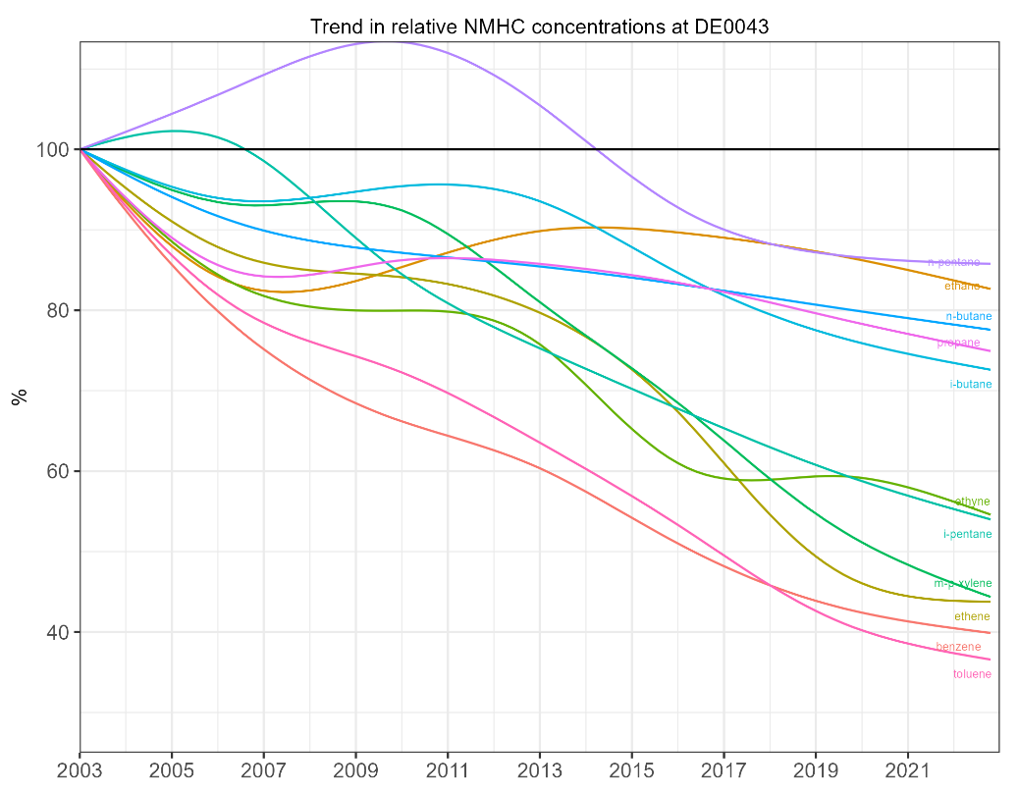
Figure 11: Meteorological adjusted trend in relative concentrations of NMHCs at Hohenpeissenberg 2003-2022 as calculated by the AirGAM model (Walker et al., 2023).

The results shown in Figure 11 indicate a substantial reduction in the NMHCs measured at DE0043 and, furthermore, significant differences in the trends for the various species. Strongest declines are found for benzene, toluene, ethene, and m-p-xylene which in 2022 are seen at levels only 35-45% of that in 2003 meaning a drop of the order of 55-65 % since 2003. Next to this, ethyne and i-pentane have dropped around 45% since 2003 based on the AirGAM model. The other NMHC have dropped to around 70-90% of the 2003 levels meaning a reduction of 10-30% during this 20year period.
These marked reductions in observed NMHC levels in Europe since 2000 are in line with the emission data from the EMEP-West region as mentioned above. A quantitative comparison species by species could not be done since the EMEP emission data are given for NMHC as a whole and not for individual substances.
The reliability of the AirGAM model could be judged from Figure 12 showing the agreement between the observed and modelled daily mean values during 2022 for 10 anthropogenic NMHCs from ethane to toluene plus isoprene. It is important to keep in mind that AirGAM is a statistical model (or tool) that is based purely on observed relationships between air quality data and meteorological parameters without any parameterization of physical processes. This makes it well suited for analysing historical data while the model could of course not be used for predicting the effects of emission changes. The results in Figure 12 show a close agreement between observed and predicted daily values in 2022 although some spikes in the observed data are not reproduced by AirGAM.

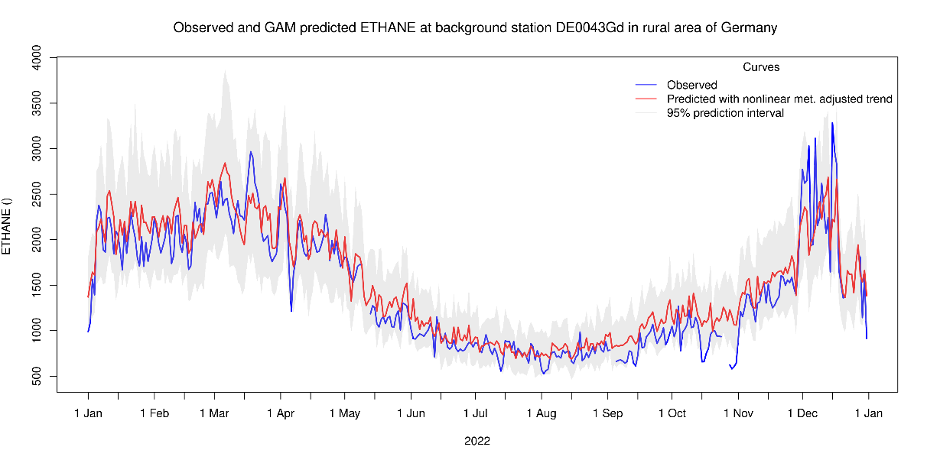
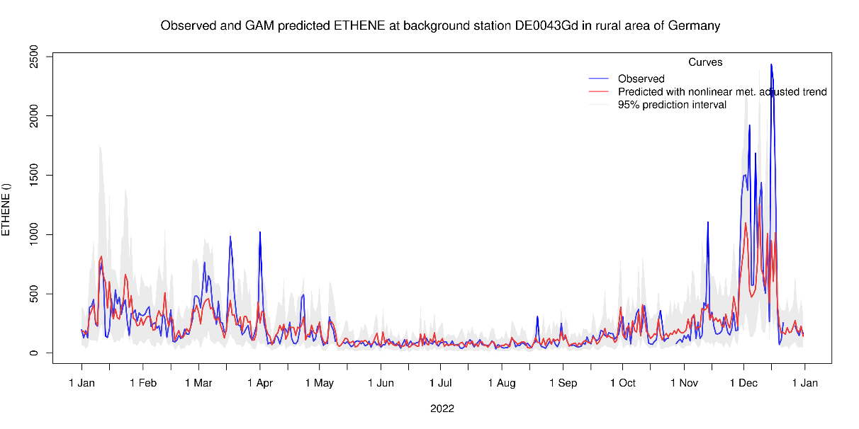
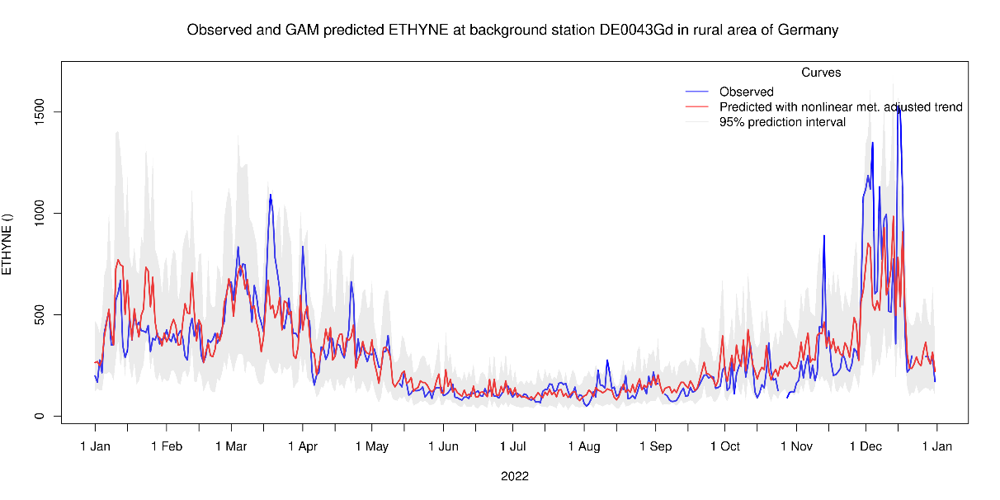
Figure 12: Daily concentrations of selected NMHCs as observed (blue) and modelled by AirGAM (red) at Hohenpeissenberg in 2022.
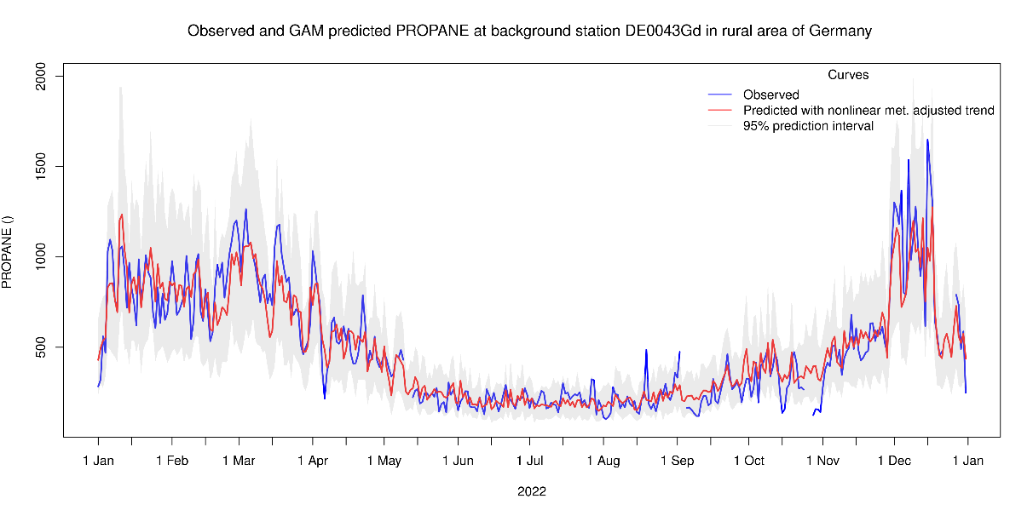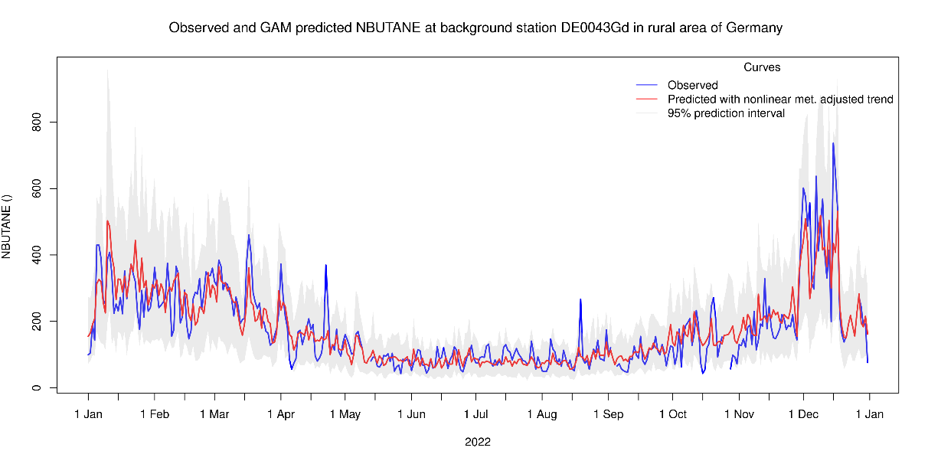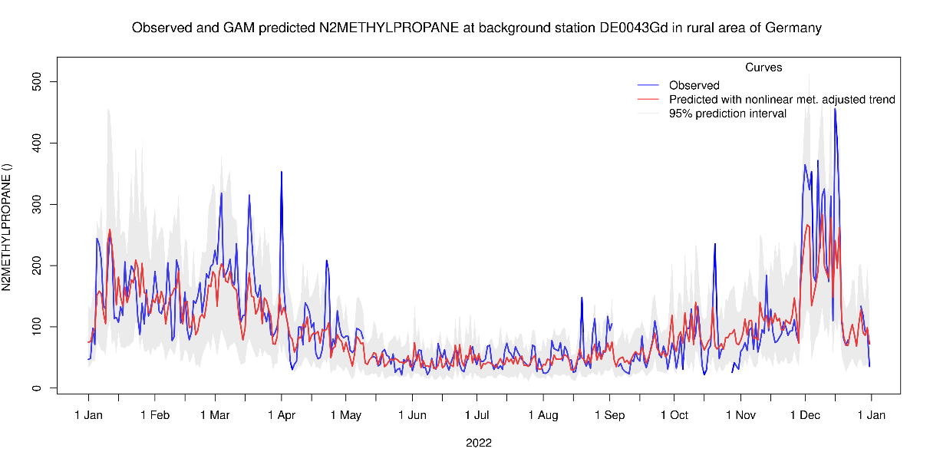
Figure 12 (cont.).

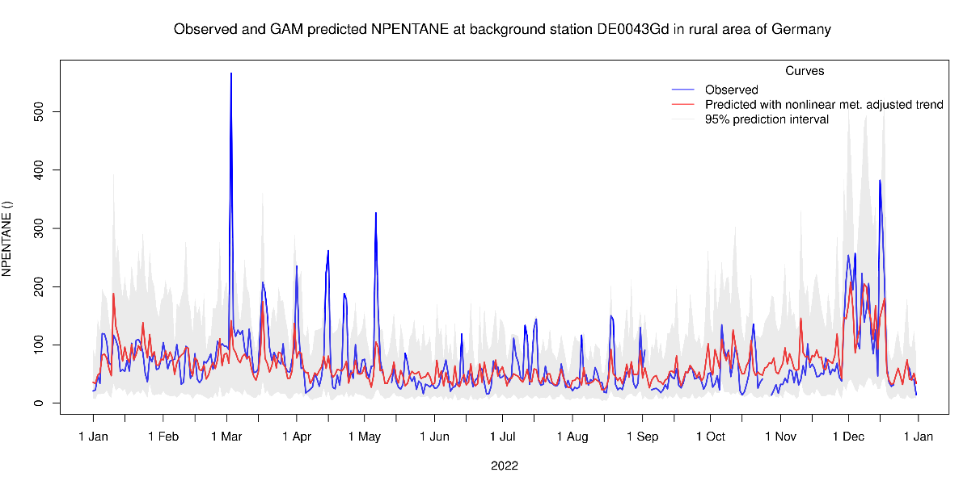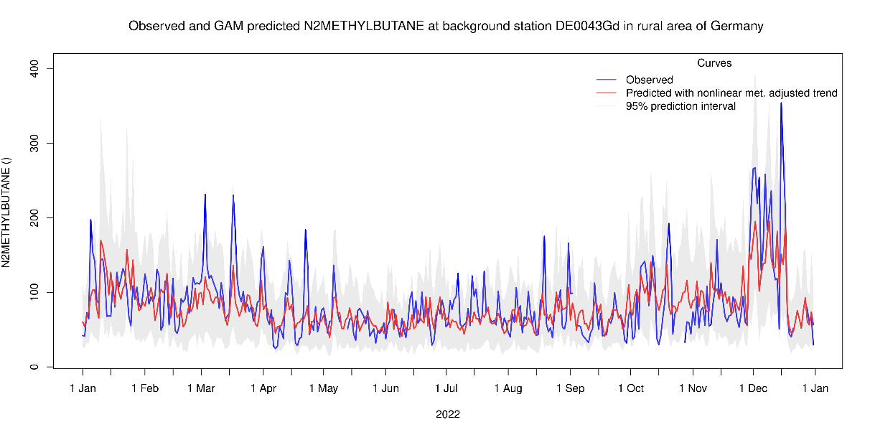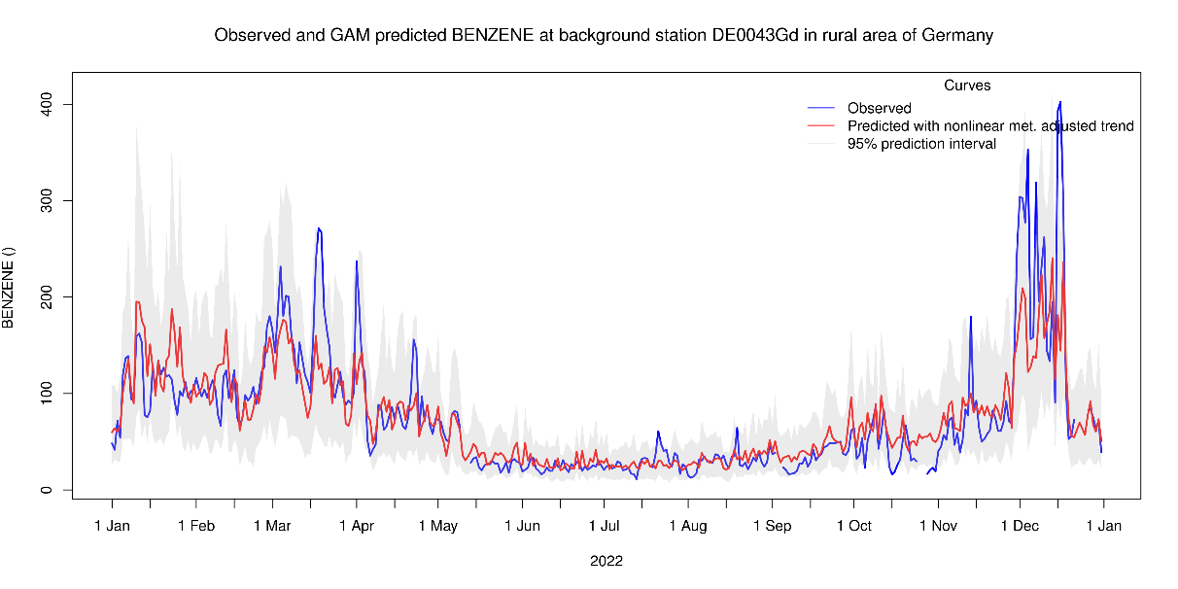
Figure 12 (cont.).

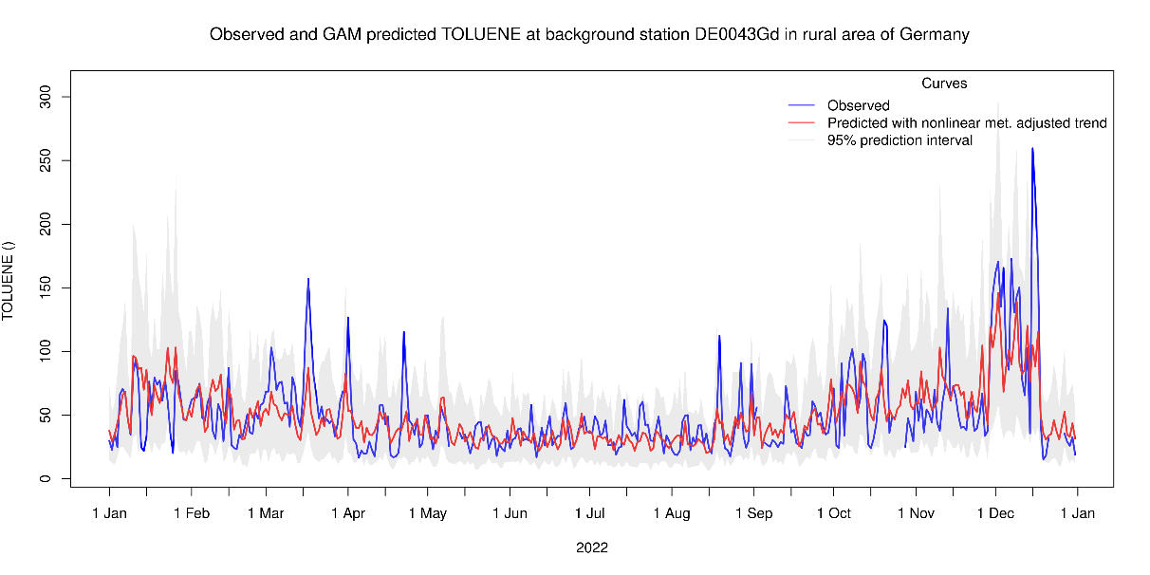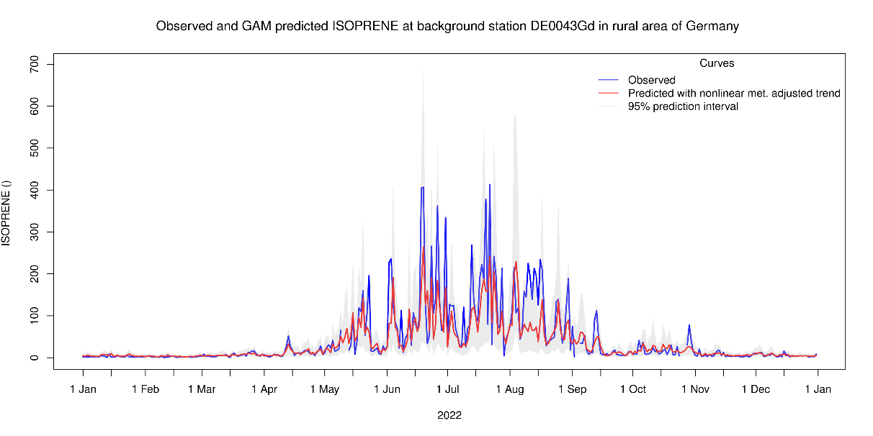
Figure 12 (cont.).

Acknowledgement
Data originators for individual datasets can be found as part of the metadata by visiting http://ebas.nilu.no. A special thanks to the providers of data for 2022: Heidi Hellen (FMI), Ilona Ylivinkka (UHEL), Jitka Privoznikova (CHMI), James Dernier (Ricardo), Bryan Hellack (UBA), Therese Salameh (IMT), Norbert Schmidbauer (NILU), Arduini Jgor (UU), Fernandez Monistrol Jose Antonio (MMA) as well as to all individuals taking part in the EIMP campaign 12-19 July 2022.

References
Bronaugh, D. and Werner, A. (2019) zyp: Zhang + Yue-Pilon Trends Package. URL: https://CRAN.R-project.org/package=zyp, r package version 0.10-1.1, 2019.
Derwent, R. G., Dernie, J. I. R., Dollard, G. J., Dumitrean, P., Mitchell, R. F., Murrells, T. P., Telling, S. P., Field, R. A. (2014) Twenty years of continuous high time resolution volatile organic compound monitoring in the United Kingdom from 1993 to 2012. Atmos. Environ., 99, 239-247.
EMEP/CCC (1990) EMEP workshop on measurement of hydrocarbons/VOC. Lindau, Federal Republic of Germany. Lillestrøm, NILU (EMEP/CCC Report 3/90).
EMEP/CCC (2014) Manual for sampling and chemical analysis. Kjeller, NILU (EMEP/CCC-Report 1/2014).
Fagerli, H., Benedictow, A.M.K., van Caspel, W., Gauss, M., Ge, Y., Jonson, J. E., Klein, H., Nyiri, A., Simpson, D. Tsyro, S., Valdebenito Bustamante, A.M., Wind, P., Aas, W., Hjellbrekke, A.-G., Solberg, S., Tørseth, K., Yttri, K.E., Matthews, B., Schindlbacher, S., Ullrich, B., Wankmüller, R., Klimont, Z., Scheuschner, T., Kuenen, J., Hellen, H., Jaffrezo, J.-L., Tusha, D., Mothes, F., Salameh, T., van Droge, B. L., Wegener, R. (2023) Transboundary particulate matter, photo-oxidants, acidifying and eutrophying components. Status report 2022. Oslo, Norwegian Meteorological Institute (EMEP Report 1/2023).
Hakola, H., Hellén, H., Laurila, T. (2006) Ten years of light hydrocarbons (C2 C6) concentration measurements in background air in Finland. Atmos. Environ., 40, 3621-3630.
Hellén, H., Kouznetsov, R., Anttila, P., Hakol, H. (2015) Increasing influence of easterly air masses on NMHC concentrations at the Pallas-Sodankylä GAW station. Boreal Env. Res., 20, 542-552.
Hoerger, C. C., Claude, A., Plass-Duelmer, C., Reimann, S., Eckart, E., Steinbrecher, R., Aalto, J., Arduini, J., Bonnaire, N., Cape, J. N., Colomb, A., Connolly, R., Diskova, J., Dumitrean, P., Ehlers, C., Gros, V., Hakola, H., Hill, M., Hopkins, J. R., Jaeger, J., Junek, R., Kajos, M. K., Klemp, D., Leuchner, M., Lewis, A. C., Locoge, N., Maione, M., Martin,D., Michl, K., Nemitz, E., O’Doherty, S., Perez Ballesta, P., Ruuskanen, T. M., Sauvage, S., Schmidbauer, N., Spain, T. G., Straube, E., Vana, M., Vollmer, M. K., Wegener, R., Wenger, A. (2015). ACTRIS non-methane hydrocarbon intercomparison experiment in Europe to support WMO GAW and EMEP observation networks. Atmos. Meas. Tech., 8, 2715-2736, doi:10.5194/amt-8-2715-2015.
Malley, C. S. Braban, C. F., Dumitrean, P., Cape, J. N., Heal, M. R. (2015) The impact of speciated VOCs on regional ozone increment derived from measurements at the UK EMEP supersites between 1999 and 2012. Atmos. Chem. Phys., 15, 8361-8380, doi:10.5194/acp-15-8361-2015.
Markwardt, C. B. (2009) Non-linear least squares fitting in IDL with MPFIT. In: Astronomical Data Analysis Software and Systems XVIII. Proceedings of a workshop held at Hotel Loews Le Concorde, Quebec City, QC, Canada, 2-5 November 2008. Ed. by: Bohlender, D., Dowler, P. & Durand, D. San Francisco, Astronomical Society of the Pacific (ASP Conference Series, Vol. 411). pp. 251-254.
Plass-Dülmer, C., Michl, K., Ruf, R., Berresheim, H. (2002) C2-C8 hydrocarbon measurement and quality control procedures at the Global Atmosphere Watch Observatory Hohenpeissenberg. J. Chromatogr., 953, 175-197.
Plass-Dülmer, C., Schmidbauer, N., Slemr, J., Slemr, F., D’Souza, H. (2006) European hydrocarbon intercomparison experiment AMOHA part 4: Canister sampling of ambient air. J. Geophys. Res., 111D, 4306, doi:10.1029/2005jd006351.
Sauvage S., Plaisance, H, Locoge, N., Wroblewski, A., Coddeville, P., Galloo, J. (2009) Long term measurement and source apportionment of non-methane hydrocarbons in three French rural areas. Atmos. Environ., 43, 2430-2441.
Simmonds, P. G., Manning, A. J., Cunnold, D. M., McCulloch, A., O’Doherty, S., Derwent, R. G., Krummel, P. B., Fraser, P. J., Dunse, B., Porter, L. W., Wang, R. H. J., Greally, B. R., Miller, B. R., Salameh, P., Weiss, R. F., and Prinn, R. G. (2006) Global trends, seasonal cycles, and European emissions of dichloromethane, trichloroethene, and tetrachloroethene from the AGAGE observations at Mace Head, Ireland, and Cape Grim, Tasmania, J. Geophys. Res., 111, D18304, doi:10.1029/2006JD007082.
Solberg, S., Dye, C., Schmidbauer, N., Herzog, A., Gehrig, R. (1996) Carbonyls and nonmethane hydrocarbons at rural European sites from the Mediterranean to the Arctic. J. Atmos. Chem., 25, 33-66.
Solberg, S., Dye, C., Walker, S.-E., Simpson, D. (2001) Long-term measurements and model calculations of formaldehyde at rural European monitoring sites. Atmos. Environ., 35, 195-207.
Solberg, S., Walker, S.-E., Schneider, P., and Guerreiro, C. (2021) Quantifying the Impact of the Covid-19 Lockdown Measures on Nitrogen Dioxide Levels throughout Europe. Atmosphere, 12, 131, doi:10.3390/atmos12020131.
Solberg, S., Claude, A., Reiman, S., Sauvage, S., Walker, S.-E. (2022) VOC measurements 2020. Kjeller, NILU (EMEP/CCC-Report 4/2022).
Tørseth, K., Aas, W., Breivik, K., Fjæraa, A.M., Fiebig, M., Hjellbrekke, A. G., Lund Myhre, C., Solberg, S., Yttri, K. E. (2012) Introduction to the European Monitoring and Evaluation Programme (EMEP) and observed atmospheric composition change during 1972–2009. Atmos. Chem. Phys., 12, 5447-5481, doi:10.5194/acp-12-5447-2012.
Walker, S.-E., Solberg, S., Schneider, P., and Guerreiro, C.: The AirGAM 2022r1 air quality trend and prediction model. Geosci. Model Dev., 16, 573–595, doi:d10.5194/gmd-16-573-2023, 2023.
Waked, A., Sauvage, S., Borbon, A., Gauduin, J., Pallares, C., Vagnot, M. P., Thierry, L., and Locoge, N. (2016) Multi-year levels and trends of non-methane hydrocarbon concentrations observed in ambient air in France. Atmos. Environ., 141, 263-275, doi:10.1016/j.atmosenv.2016.06.059.
Worton, D. R., Sturges, W. T., Reeves, C. E., Newland, M. J., Penkett, S. A, Atlas, E., Stroud, V., Johnson, K., Schmidbauer, N., Solberg, S. (2012) Evidence from firn air for recent decreases in non-methane hydrocarbons and a 20th century increase in nitrogen oxides in the northern hemisphere. Atmos. Environ., 54, 592-602.

Appendix 1
Time series of daily means of VOCs measured in 2022

